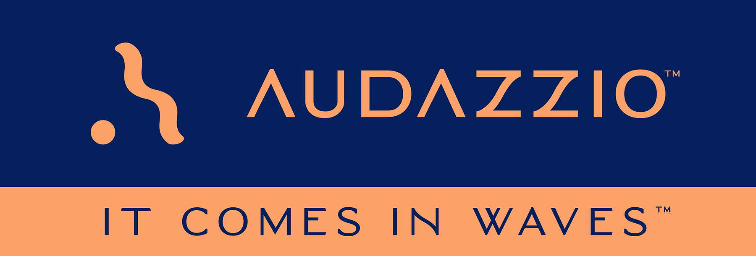

FOR IMMEDIATE RELEASE

Audazzio™ Named to The Tech Tribune’s list of ten best tech startups in San Antonio

As part of an annual survey of tech-focused companies based in different markets around the country, The Tech Tribune has named Audazzio™ to its San Antonio list

The Audazzio™ flagship technology, Live QR™, leverages ultrasonic, data-encoded sound waves to instantly create valuable second-screen opportunities on viewer phones and tablets fully coordinated with the event they are watching, with benefits for broadcasters, sponsors and consumers alike

San Antonio, TX (November 4, 2022): Audazzio™, an innovative software startup and finalist in Comcast NBCUniversal’s SportsTech Accelerator program, has been named to a list of the top ten best tech startups based in San Antonio, Texas. The list was compiled by The Tech Tribune and can be accessed here. The Audazzio flagship technology is Live QR™, which leverages ultrasonic, data-encoded sound waves to instantly connect to viewers and fans while creating valuable second-screen opportunities on their phones and tablets.

Danny Abelson, Audazzio Chief Operating Officer, remarks, “We are thrilled to be named to The Tech Tribune’s annual list of the best startups in San Antonio. We have been working very hard on the ongoing rollout of Live QR, and we see very big things on the horizon for our company and its proprietary technologies. We thank The Tech Tribune for taking note of our hard work and including us on this year’s list.”

Roy Terracina, Audazzio Chairman of the Board/CEO, adds, “We are so honored to be recognized by The Tech Tribune and happy for our investors who have trusted us to continue to develop this new and exciting technology that will revolutionize how we use our second-screens – phones or tablets!”

The Audazzio Live QR solution encodes data as sound that is inaudible to the human ear but perfectly discernable by mobile devices – opening the door to a whole world of applications for savvy broadcasters, sports rights holders, venues, sponsors, betting operators and beyond. Audazzio provides clients with tools that enable focused messaging directly to their fans in real time, either at home or in a stadium or arena.

For more information on Audazzio, please visit www.audazzio.com.
For a video primer on Live QR technology from Audazzio, visit www.audazzio.com/explainer.

Photo file: Audazzio_SecondScreen.JPG
Photo caption: The Audazzio™ flagship technology, Live QR™, leverages ultrasonic, data-encoded sound waves to instantly create valuable second-screen opportunities on viewer phones and tablets.

FOR MORE INFORMATION PLEASE CONTACT:
Robert Clyne | Clyne Media, Inc. | 615.662.1616 | robert@clynemedia.com
Michele Klumb | Audazzio | Vice President of Marketing | 855.697.6627 | michele@audazzio.com

About Audazzio™
Audazzio™ is an innovative media company that was a recent participant in the Comcast NBCUniversal’s SportsTech Accelerator program. Based in San Antonio, TX, Audazzio delivers groundbreaking technologies that enable broadcasters and event producers to seamlessly change the content on a fan’s mobile device, in real time, fully coordinated with their broadcast or event. In much the same way that a QR code graphic provides a unique digital fingerprint for a variety of uses, the Live QR™ algorithm from Audazzio encodes data as high-frequency sound that is inaudible to the human ear, but perfectly discernable by mobile devices. By leveraging Live QR™ technology, marketers have access to an entirely new channel to reach consumers’ mobile devices, at critical moments in an event or broadcast, when they crave more information and storytelling. Audazzio can deliver any web page, at any time, to any device within range of the Live QR signaling, opening the door to a whole new world of applications for savvy broadcasters, sponsors and beyond.

