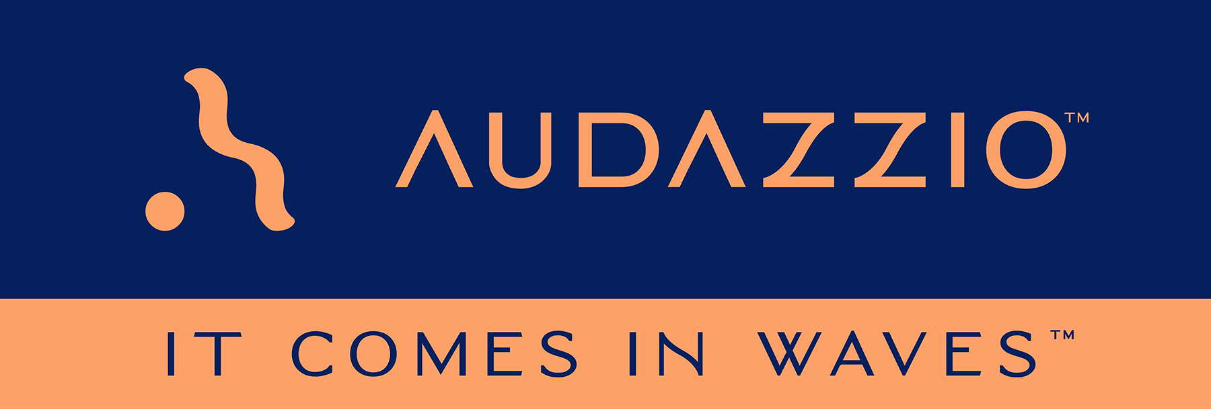

FOR IMMEDIATE RELEASE

Audazzio™ has strong presence at 16th annual Sports Video Group Summit

Audazzio™ served as the lead sponsor for the “OTT, Streaming, and Digital Workshop” program, which took place on the afternoon of day 1 of the summit

San Antonio, TX, and Boulder, CO (January 19, 2023): Audazzio™, an innovative software startup and finalist in Comcast NBCUniversal’s SportsTech Accelerator program, recently had a strong presence at the 16th Annual Sports Video Group (SVG) Summit, which took place December 12-13, 2022, in New York City. The SVG Summit is the sports broadcasting industry’s biggest gathering as the top engineering and production professionals meet to discuss, debate and direct the future of sports broadcasting. Audazzio served as a sponsor for the event, which brought together more than 1,200 sports-production professionals at the New York Hilton Midtown hotel for two days of informational panels and workshops, cutting-edge technology showcases, and, most important, plenty of opportunities for attendees to network face-to-face and catch up with friends old and new.

Participating in the summit were key members of Audazzio’s management team, including Danny Abelson, Chief Operating Officer; Michele Klumb, Vice President of Marketing; Frank Garland, Head of Revenue; and Roger Charlesworth, Chief Technical Liaison. Abelson presented opening remarks at the beginning of the Day 1 program, and later that afternoon he contributed to the panel “Streaming and OTT: What’s Next in Tech?” alongside other thought leaders from Wildmoka, ATEME and Zixi. Subscription streaming services and platforms continue to offer new ways to present live content and drive interactivity with sports brands. In this panel, Abelson and his co-panelists broke down their thoughts on what strategies need to be considered (or accelerating) and the technology obstacles that remain.

Abelson remarks, “As Audazzio continues its rollout, we have targeted sports broadcasting as a critical market that our technology is well suited for. We recognize Sports Video Group as the preeminent professional technical organization in sports broadcasting, so this summit was an obvious choice for us as an event to help sponsor and an occasion to present our technology and unique expertise to others in the industry. Audazzio has big, cutting-edge things coming, and we made that known to all those in attendance. In addition, we got to hear from a number of other organizations and startups in this space, which gave us a chance to learn about other emerging technologies.”

The Audazzio Live QR™ solution embeds micro-signaling into a broadcast audio stream to seamlessly deliver content on a phone or tablet, fully coordinated with the broadcast – opening the door to a whole world of applications for savvy broadcasters, sports rights holders, venues, sponsors, betting operators and beyond. Audazzio provides clients with tools that enable focused messaging directly to their fans in real time, either at home or in a stadium or arena.

For more information on Audazzio, please visit www.audazzio.com.
For a video primer on Live QR technology from Audazzio, visit www.audazzio.com/explainer.

Photo file 1: SVG_Panel_Abelson.JPG
Photo caption 1: Danny Abelson, Audazzio™ Chief Operating Officer (second from left) contributes to the panel “Streaming and OTT: What’s Next in Tech?” at the 16th Annual Sports Video Group (SVG) Summit, December 12, 2022, in New York City. Photo courtesy of Sports Video Group.

Photo file 2: SVG_Audazzio_Sponsor.JPG
Photo caption 2: Audazzio™ served as lead sponsor for the “Streaming and OTT: What’s Next in Tech?” program at the 16th Annual Sports Video Group (SVG) Summit, which took place December 12-13, 2022, in New York City, where Audazzio shared its video primer on Live QR technology. Photo courtesy of Sports Video Group.

Photo file 3: Audazzio_SecondScreen.JPG
Photo caption 3: The Audazzio™ flagship technology, Live QR™, leverages ultrasonic, data-encoded sound waves to instantly create valuable second-screen opportunities on viewer phones and tablets.

FOR MORE INFORMATION PLEASE CONTACT:
Robert Clyne | Clyne Media, Inc. | 615.662.1616 | robert@clynemedia.com
Michele Klumb | Audazzio | Vice President of Marketing | 855.697.6627 | michele@audazzio.com

About Audazzio™
Audazzio™ is an innovative media company that was a recent participant in the Comcast NBCUniversal’s SportsTech Accelerator program. Based in San Antonio, TX, and Boulder, CO, Audazzio delivers groundbreaking technologies that enable broadcasters and event producers to seamlessly change the content on a fan’s mobile device, in real time, fully coordinated with their broadcast or event. In much the same way that a QR code graphic provides a unique digital fingerprint for a variety of uses, the Live QR™ algorithm from Audazzio embeds micro-signaling into a broadcast audio stream to seamlessly deliver content on a phone or tablet. By leveraging Live QR™ technology, marketers have access to an entirely new channel to reach consumers’ mobile devices, at critical moments in an event or broadcast, when they crave more information and storytelling. Audazzio can deliver any web page, at any time, to any device within range of the Live QR signaling, opening the door to a whole new world of applications for savvy broadcasters, sponsors and beyond.

