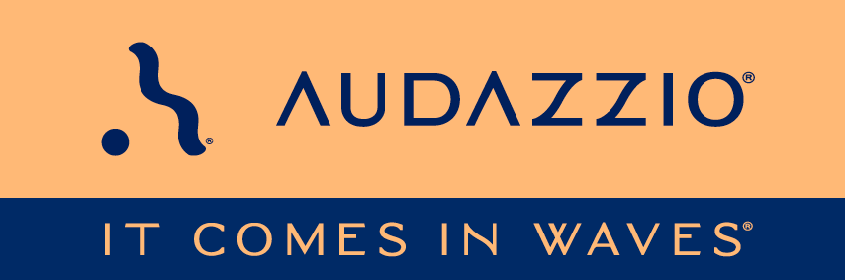

FOR IMMEDIATE RELEASE

Audazzio® honored at SPORTEL Monaco

At the event’s Pitch Perfect session, Audazzio®’s Live QR™ technology received runner-up honors

San Antonio, TX (November 16, 2023): Audazzio®, an innovative software startup and finalist in Comcast NBCUniversal’s SportsTech Accelerator program, recently took part in the Pitch Perfect session at SPORTEL Monaco (Oct. 23-25), a sports business industry event featuring international decision makers in sports media rights, broadcast solutions, TV networks, international federations, e-sports, OTT, sports tech, sports media, sports marketing and communication. The Pitch Perfect session, which took place on Monday, Oct. 23, featured first-time exhibitors, who were given just three minutes of presentation time and two minutes of Q&A to impress the audience and an expert panel of judges, who scored them on their presentation style, innovative approach and market need.

Audazzio’s COO Danny Abelson pitched the session’s audience and judges on the company’s proprietary Live QR™ technology. The audience and judges panel were impressed, and Audazzio Live QR was given runner-up honors at the session.

In his pitch, Abelson remarked, “Sports broadcasters, are you frustrated knowing most of your viewers are using a mobile device during your broadcast, but you can’t reach it? You’ve tried using QR codes, but QR’s ineffectiveness only added to your frustration. The Audazzio Live QR™ second screen solution seamlessly eliminates that frustration, by providing a frictionless solution to deliver content. Audazzio embeds micro-signaling into the audio stream of your broadcast, that when heard by a mobile device, instantly delivers web content to the viewer’s device in about one second. And all that content is sponsorable – creating new revenue streams for broadcasters and rights holders.”

The Audazzio Live QR™ solution embeds micro-signaling into a broadcast audio stream to seamlessly deliver content on a phone or tablet, fully coordinated with the broadcast – opening the door to a whole world of applications for savvy broadcasters, sports rights holders, venues, sponsors, betting operators and beyond. Audazzio provides clients with tools that enable focused messaging directly to their fans in real time, either at home or in a stadium or arena.

For more information on Audazzio, please visit www.audazzio.com.
For a video primer on Live QR™ technology from Audazzio, visit www.audazzio.com/explainer.

Photo file 1: Audazzio_Sportel_Abelson_Krishna.JPG
Photo caption 1: Audazzio® COO Danny Abelson and Magnifi CRO Meghna Krishna (a member of the judges panel for SPORTEL Monaco’s Pitch Perfect session), pictured with Audazzio’s Runner Up honors certificate on Monday, Oct. 23, 2023.

Photo file 2: Audazzio_Sportel_Abelson.JPG
Photo caption 2: Audazzio® COO Danny Abelson addresses the audience and judges at SPORTEL Monaco’s Pitch Perfect session on Monday, Oct. 23, 2023.

FOR MORE INFORMATION PLEASE CONTACT:
Robert Clyne | Clyne Media, Inc. | 615.662.1616 | robert@clynemedia.com
Michele Klumb | Audazzio | Vice President of Marketing | 855.697.6627 | michele@audazzio.com

About Audazzio®
Audazzio® is an innovative media company that was a recent participant in the Comcast NBCUniversal’s SportsTech Accelerator program. Based in San Antonio, TX, Audazzio delivers groundbreaking technologies that enable broadcasters and event producers to seamlessly change the content on a fan’s mobile device, in real time, fully coordinated with their broadcast or event. In much the same way that a QR code graphic provides a unique digital fingerprint for a variety of uses, the Live QR™ algorithm from Audazzio embeds micro-signaling into a broadcast audio stream to seamlessly deliver content on a phone or tablet. By leveraging Live QR™ technology, marketers have access to an entirely new channel to reach consumers’ mobile devices, at critical moments in an event or broadcast, when they crave more information and storytelling. Audazzio can deliver any web page, at any time, to any device within range of the Live QR signaling, opening the door to a whole new world of applications for savvy broadcasters, sponsors and beyond.

