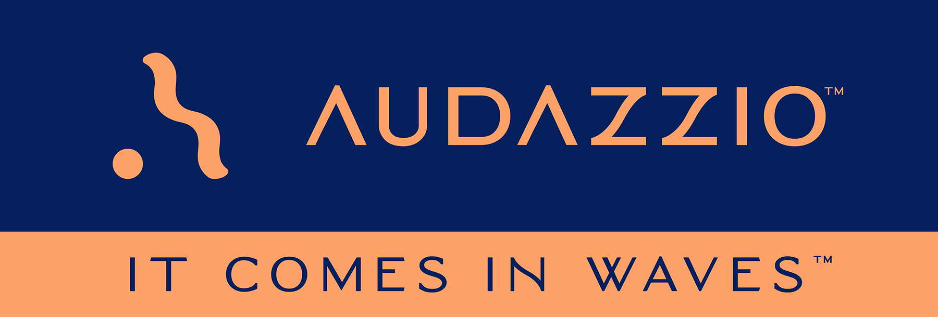

FOR IMMEDIATE RELEASE

Audazzio Announces Partnership with The Sports Playmaker

Company engages The Sports Playmaker, a London-based global sales, consultancy and investment agency that helps innovative technology companies successfully expand into the sports industry, to help drive awareness and adoption of propriety Audazzio technologies for broadcasters, sports right holders, and betting operators in the UK and mainland Europe

Audazzio Live QR™ technology leverages ultrasonic, data-encoded sound waves to instantly create valuable second-screen opportunities on viewer phones and tablets fully coordinated with the event they are watching, with benefits for broadcasters, sponsors and consumers alike

San Antonio, TX (October 3, 2022): Audazzio, an innovative software startup and finalist in Comcast NBCUniversal’s SportsTech Accelerator program, announces that it has retained the services of The Sports Playmaker, a London-based global sales, consultancy and investment agency that helps innovative technology companies successfully expand into the sports industry. The announcement was made by Danny Abelson, Audazzio Chief Operating Officer, and further underscores the company’s ongoing strategic business plan as it continues the rollout of its proprietary Live QR™ technology, which leverages ultrasonic, data-encoded sound waves to instantly create valuable second-screen opportunities on viewer phones and tablets.

“We have hired The Sports Playmaker to serve as business development consultants for Audazzio as we seek to expand into the sports market in the UK and mainland Europe,” stated Danny Abelson. “Jay Greene, Founder and Managing Director at The Sports Playmaker, recognizes Audazzio as a business with a unique set of tools to offer the sports, media and entertainment industry; and we are excited to work together to really expand the geographical scope of where Audazzio is currently doing business. The Sports Playmaker team have an extensive knowledge and experience in bringing new technologies to the sports sector. Our partnership is the next step in the expansion of the Audazzio brand outside of the United States.”

Jay Greene agreed, remarking that “The Sports Playmaker is dedicated to using our expertise to raise awareness and to build growth for Audazzio in the European sports market. There are many differences between how the sports industry operates in the U.S. compared to the UK and mainland Europe, and we are here to help them navigate this territory. Decision-makers in the industry need to understand the tremendous amount of opportunities that Audazzio offers, in terms of being able to increase content and engagement of fans while offering the ability to monetize this new marketing channel. We will be able to communicate that to them clearly and effectively. There is strategy involved here, and The Sports Playmaker is here to get everyone on the same page so all parties can benefit.”

The Audazzio Live QR™ solution encodes data as sound that is inaudible to the human ear but perfectly discernable by mobile devices – opening the door to a whole world of applications for savvy broadcasters, sports rights holders, venues, sponsors, betting operators and beyond. Audazzio provides clients with tools that enable focused messaging directly to their fans in real time, either at home or in a stadium or arena. And crucially, Audazzio can provide clients the ability to understand exactly who is engaged with a game or event.

For more information on Audazzio, please visit www.audazzio.com.
For a video primer on Audazzio Live QR™ technology, visit www.audazzio.com/explainer.
For more information on The Sports Playmaker, please visit www.thesportsplaymaker.com.

Photo file 1: Greene_Abelson2.JPG
Photo caption 1: Jay Greene (left), Founder and Managing Director at The Sports Playmaker, and Danny Abelson (right), Audazzio Chief Operating Officer, get together in London to formalize the relationship between the two organizations.

Photo file 2: Audazzio_SecondScreen.JPG
Photo caption 2: Audazzio Live QR™ technology leverages ultrasonic, data-encoded sound waves to instantly create valuable second-screen opportunities on viewer phones and tablets.

FOR MORE INFORMATION PLEASE CONTACT:
Robert Clyne | Clyne Media, Inc. | 615.662.1616 | robert@clynemedia.com
Michele Klumb | Audazzio | Vice President of Marketing | 855.697.6627 | michele@audazzio.com

About Audazzio
Audazzio is an innovative media company that was a recent participant in the Comcast NBCUniversal’s SportsTech Accelerator program. Based in San Antonio, TX, Audazzio delivers groundbreaking technologies that enable broadcasters and event producers to seamlessly change the content on a fan’s mobile device, in real time, fully coordinated with their broadcast or event. In much the same way that a QR code graphic provides a unique digital fingerprint for a variety of uses, the Audazzio Live QR™ algorithm encodes data as high-frequency sound that is inaudible to the human ear, but perfectly discernable by mobile devices. By leveraging Live QR™ technology, marketers have access to an entirely new channel to reach consumers’ mobile devices, at critical moments in an event or broadcast, when they crave more information and storytelling. Audazzio can deliver any web page, at any time, to any device within range of the Live QR™ signaling, while giving clients access to the information on exactly who is engaged with a game or event – opening the door to a whole new world of applications for savvy broadcasters, sponsors and beyond.

About The Sports Playmaker:
The Sports Playmaker is a London-based global business, consultancy and investment agency focusing on innovative sports technologies. Drawing on its team’s extensive knowledge and experience in bringing new technologies to the sports sector, the agency offers a boutique approach based on its clients’ unique needs. It encourages growth by supporting sales and marketing through its extensive network within the sports industry. The firm helps identify revenue streams for clients new to the sector and shapes market entry and product development through the provision of market intelligence and advisory services. Additionally, its brokering service enables companies to tap into funding sources when capital injection is necessary.

