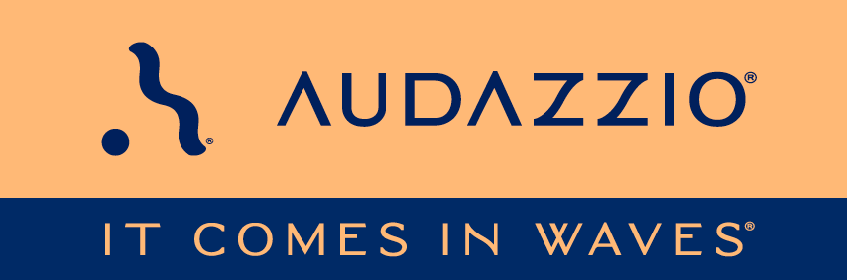

FOR IMMEDIATE RELEASE

Audazzio® engages audience of USA Swimming Olympic Trials with real-time, interactive content

By deploying the Audazzio Live QR™ technology, NBC Sports and USA Swimming were able to seamlessly deliver content on home audiences’ mobile devices, delivering a range of real-time interactive campaigns and informative record holders and times fully synchronized with the broadcast, and creating invaluable data for these organizations as a result

San Antonio, TX (June 15, 2024): Audazzio®, an up-and-coming audience engagement technology, was recently employed as part of the broadcasts of the 2024 U.S. Olympic Team Trials – Swimming, presented by Lilly, held at Lucas Oil Stadium in Indianapolis, Indiana. Turning a football field into three pools was an epic feat, but USA Swimming was ready to push the boundaries not only of Lucas Oil Stadium but also of their connection to swimming fans nationwide with Audazzio.

The Audazzio groundbreaking technology enables content creators to seamlessly change the content on a mobile device, in real time, fully coordinated with a broadcast or live event. The Audazzio Live QR™ algorithm encodes data as high-frequency sound that is inaudible to the human ear but perfectly discernable by mobile devices. For example, Audazzio allowed the USA Swimming creative teams to deliver relevant storytelling content at key moments in the broadcast, including biographical information, athlete milestones, and more.

The event, which ran for nine days, saw the successful end-to-end execution of Audazzio technology for second-screen engagement deployed exclusively for the national broadcast audiences on USA Network and Peacock. To assist in audience understanding, the Audazzio technology was announced during the NBC Sports broadcasts, inviting fans to simply download or open the USA Swimming app to begin the experience.

As a result, Audazzio was able to provide valuable data and insights for USA Swimming. The platform tracked user engagement and preferences, providing insights into the content that resonated most with the audience. As the event progressed, USA Swimming digested this information and modified its content based on this feedback.

“We were thrilled to partner with USA Swimming and NBC Sports to deliver our real-time, fully event synced, fan engaging service at the Olympic Swimming Trials,” said Audazzio CEO and Chairman of the Board Roy Terracina. “Our tech provided fans with an immersive and interactive experience, allowing them to engage with the event in a new and exciting way. Instead of wondering ‘who holds the record for the 200m butterfly and what is that time?’, fans were delivered this content in anticipation of their need.”

“Integrating the Audazzio technology is critical to deepening fan engagement and offers seamless delivery of race data and athlete storylines,” said Jacob Grosser, USA Swimming’s Senior Director of Marketing and Communications. “Supplemental information that previously required multiple online searches is now available automatically and without user input directly in the USA Swimming app.”

“We know that a large part of our audience is enjoying a second screen experience while watching the trials. Audazzio gives us the opportunity to engage on that second screen in a meaningful way that enhances the content, allows for promotion of similar programming and will eventually provide a point of connection for our partners. It’s a step in creating a better viewer environment,” stated Jim Thompson, NBC Sports Olympics Coordinating Producer.

For more information on Audazzio, please visit www.audazzio.com.
For a video primer on Live QR™ technology from Audazzio, visit www.audazzio.com/explainer.

Photo file 1: Audazzio_USASwimming.JPG
Photo caption 1: USA Swimming Deploys Audazzio During Olympic Trials to Engage Home Audience

FOR MORE INFORMATION PLEASE CONTACT:
Robert Clyne | Clyne Media, Inc. | 615.662.1616 | robert@clynemedia.com
Michele Klumb | Audazzio | Vice President of Marketing | 855.697.6627 | michele@audazzio.com

About Audazzio®
Audazzio® is an innovative media company that was a recent participant in the Comcast NBCUniversal’s SportsTech Accelerator program. Based in San Antonio, TX, Audazzio delivers groundbreaking technologies that enable broadcasters and event producers to seamlessly change the content on a fan’s mobile device, in real time, fully coordinated with their broadcast or event. In much the same way that a QR code graphic provides a unique digital fingerprint for a variety of uses, the Live QR™ algorithm from Audazzio embeds micro-signaling into an audio stream to seamlessly deliver content on a phone or tablet. By leveraging Live QR™ technology, marketers have access to an entirely new channel to reach consumers’ mobile devices, at critical moments in an event or broadcast, when they crave more information and storytelling. Audazzio can deliver any web page, at any time, to any device within range of the Live QR signaling, opening the door to a whole new world of applications for savvy broadcasters, sponsors and beyond.

