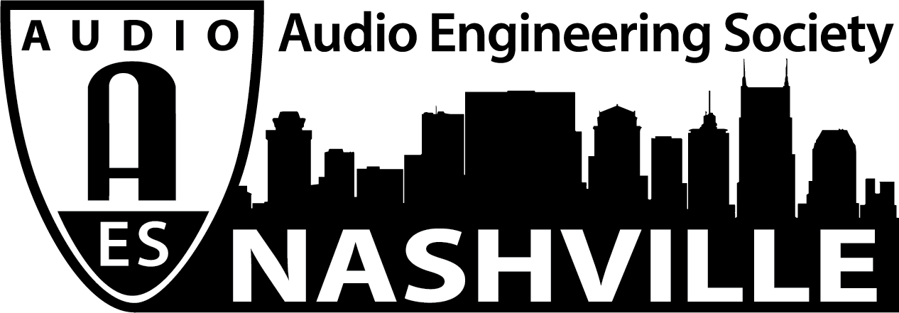

FOR IMMEDIATE RELEASE

AudioMasters Nashville Golf Tournament Opens Registration for Biggest Event Yet – May 14 and 15, 2020

Nashville, TN, January 7, 2020 — Known as the most anticipated social event of the Nashville audio community, each year, the AudioMasters Nashville Golf Tournament is set to return to Harpeth Hills Golf Course in Nashville, TN, May 14 and 15, 2020 and golfers can register their teams, now, at audiomastersnashville.com. Serving as the primary funding mechanism for the local 501(c)(3) non-profit Nashville Engineer Relief Fund (NERF), the event has raised thousands of dollars which has provided financial assistance for individuals in the greater Nashville audio engineering community who, through illness and tragic circumstances, are unable to practice their profession or face other serious problems. Now in its 23rd year, the tournament continues to grow in its mission – in recent years, featuring both the DiGiCo AudioMasters Live (May 14) and the “Studio Day” (May 15) - while providing a memorable experience for all involved.

The tournament is produced by the Nashville AES Section with AudioMasters Nashville 2020 event coordinator Karen Dunn and her company, KMD Productions, who will provide a full day of golf and networking activities, each day, from breakfast on the driving range, to the catered awards banquet, dubbed “the 19th hole.” Every course hole is sponsored by an array of area studios, live sound providers, service and sales companies, industry organizations, manufacturers and others with ties to the Nashville audio community, with activities at every tee, ranging from food and beverage, to swag, competitions and more. A limited number of sponsorship opportunities are also available, ranging from hole sponsors, to drink carts, banquet sponsorship opportunities and more.

Register now at audiomastersnashville.com and follow us on Instagram, Facebook, and Twitter for the latest updates and information.

...ends 272 words

Photo File1: AMN2020_Logo.JPG

For more information, contact Karen Dunn: karen@kmdpro.com or (925) 728-0307

