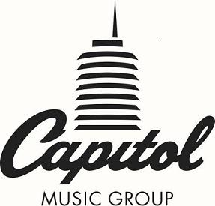

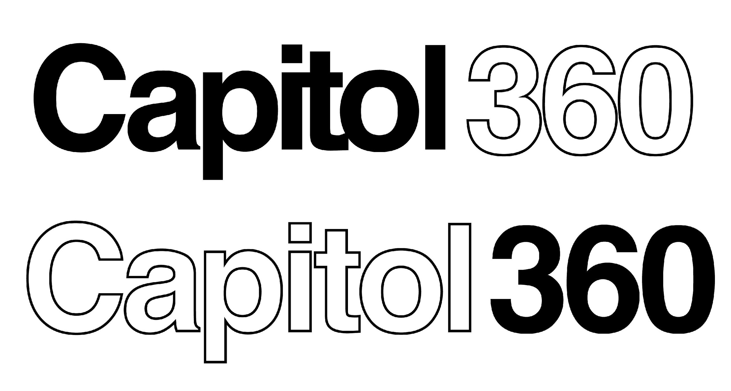
For Immediate Release

Capitol Music Group to Host Creativity and Innovation Marathon, “Capitol Royale,” on December 1 – 2

Event At Legendary Capitol Studios Brings Together Creators, Coders, Designers, And Startups To Re-Imagine The Future State Of Music Consumption, Including A Hackathon Live-Streamed On Twitch

November 16, 2018 — (Hollywood, CA) — Signaling its commitment to being a pioneer in the music and tech crossover space, Capitol Music Group is hosting Capitol Royale — a creativity and innovation marathon that will take place at the legendary Capitol Studios in Hollywood on December 1st and 2nd. The two-day conference will bring together the music and tech industries’ leading creatives, coders, designers, and startups to highlight innovations that disrupt the music industry, including a hackathon that will challenge software developers to create products and services that reimagine music consumption and discovery.

Participants in the hackathon will have access to a catalog of roughly 14,000 Universal Music Group and Universal Music Publishing Group pre-cleared audio streaming tracks, as well as never-before-seen original content and mentorship from veteran industry leaders and UMG’s technical partners, including the Capitol360 Innovation Center’s founding partners, Verizon, Twitch, Cloudinary, and ConsenSys’ blockchain music platform Ujo. Other partners include: Spotify, TiVo, 7digital, Roland, Unity, Qloo, LyricFind, Havas. The hackathon will be exclusively live streamed on Twitch for 24 hours and broadcasted via Cinedigm digital-first WHAM Network on December 1-2.

In addition to the hackathon, Capitol is teaming up with startup accelerator gener8tor to host a Startup Garden with curated, one-on-one pitch sessions between selected startups and venture capitalists and innovation executives from participating companies, breakout panels and workshops, partner exhibits, and artist performances.

“With the Capitol Royale event, CMG has a unique opportunity to bring our artists first access to new platforms, products, and apps to connect with fans and share their music in new and innovative ways,” says Capitol Music Group COO Michelle Jubelirer. “We are committed to breaking boundaries and investing in the future by trailblazing new ground in music experiences and discovery.”

Other Capitol Royale highlights include:

- Motown recording artists JAMESDAVIS and Verizon, with the help of the app developers participating the hackathon, will partner to re-imagine what music videos could look like in the future.

Verizon’s RYOT, the immersive media and premium entertainment studio, will host select participants two days prior to the event at the RYOT 5G Lab to explore the future state of music videos using augmented reality and motion capture animation.

- During the event, Twitch, the leading service and community for multiplayer entertainment, will conduct a challenge that will task software developers to create products and services that reimagine music consumption, interactivity, and discovery through Twitch Extensions.

- gBETA Musictech Demo Day — a celebration of Capitol’s inaugural class of startups focused on music technology sponsored by gener8tor.

- The Spotlight Stage featuring performances from JAMESDAVIS and other Capitol Music Group artists, as well as presentations from the hackathon finalists.

- Speakers and judges will include Michelle Jubelirer (Capital Music Group), Larry Marcus (Walden & Marcy Venture Partners), McBurney Burrus (Jimmy Kimmel Live), Bill Gagnon (Universal Music Group), Daniel Miller (Unity), Marc Byers (Motown), Rishi Patel (Plus 8 Equity), Romain Reveillere (Havas/Station F), and more.

For more information, please visit the Capitol Royale website

Or contact: MacKenzie Reynolds / MacKenzie.Reynolds@umusic.com

For tickets: Eventbrite

http://www.capitolmusic360.com/
https://www.gener8tor.com/

###

Photo file: CapitolRoyaleEventbriteGENER8TORLOGO.jpg
Photo caption: Signaling its commitment to being a pioneer in the music and tech crossover space, Capitol Music Group is hosting Capitol Royale — a creativity and innovation marathon that will take place at the legendary Capitol Studios in Hollywood on December 1st and 2nd

