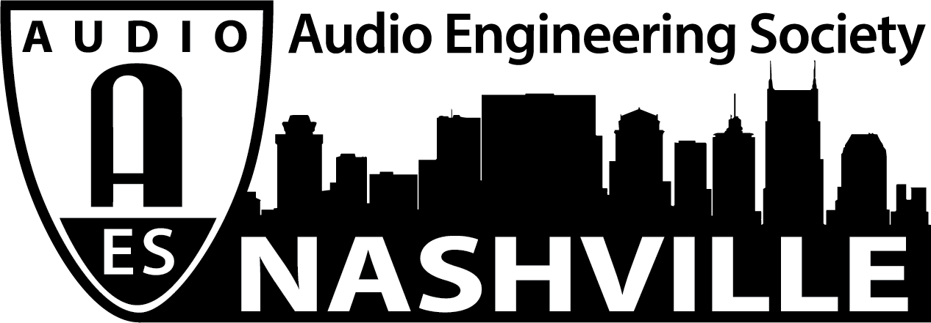

FOR IMMEDIATE RELEASE

AES Nashville Lines Up Spring Training Exhibition 2021 Live Sound Event

— The AES Nashville Section is hosting live sound professionals and leading manufacturers for an in-person exhibition and training day on March 31 —

Nashville, TN, March 2, 2021 — The AES Nashville Section presents Spring Training Exhibition 2021, an in-person live sound training and exhibition, March 31, 2021, at SoundCheck Nashville. On-hand will be leading professional audio manufacturers Allen & Heath, d&b audiotechnik, DiGiCo, DirectOut, Klang, L-Acoustics, Meyer Sound, Multipoint, Shure and Whirlwind.

“As live sound pros prepare to take to the road again, it’s time to get back in the game,” says Ken Porter (Spectrum Sound), lead on the event planning team. “While gearing up for the initial resumption of live event production, audio engineers and sound company management are looking to learn the capabilities and operational considerations of new and updated hardware and software. Spring Training Exhibition 2021 is designed to provide that knowledge.”

Spring Training exhibitors will each host a demonstration area to share their latest innovations and answer attendees’ questions. Premier sponsors d&b audiotechnik, L-Acoustics and Meyer Sound will equip rooms for training and presentations. Informative sessions led by expert presenters will cover the latest live sound tools and techniques with an emphasis on emerging immersive sound applications.

The exhibition area will be open from 9AM to 7PM on March 31, with training sessions running from 10AM through 6PM. Registration is free but limited so as to responsibly comply with Metro Nashville’s pandemic social distancing requirements. Face masks will be mandatory; Spring Training exhibitor Shure will provide masks onsite. Advance registration is available now for both the exhibition and for individual training sessions. Advance registration not only lets attendees secure their position in the line-up, but it also makes pre-registered attendees eligible for prize drawings. Food trucks will be on hand midday.

Visit the event page at http://aesnashville.org/spring-training/.
Register for Spring Training Exhibition 2021, including individual sessions, at http://bit.ly/AESBNA.
For more information on Soundcheck Nashville, visit http://soundchecknashville.com/.

www.aesnashville.org

...ends 293 words

Photo 1: spring training logo 1.png
Photo 1 caption: The AES Nashville Section’s Spring Training Exhibition 2021, March 31, will prep live sound professionals for the upcoming tour season

