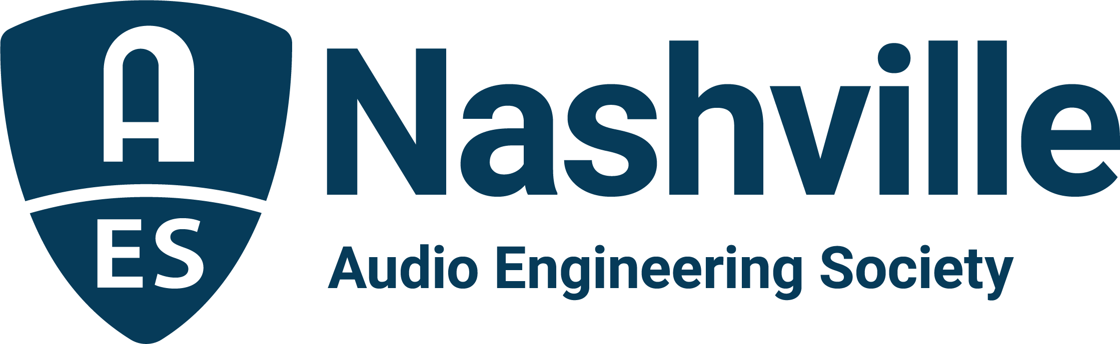

FOR IMMEDIATE RELEASE

AudioMasters Nashville Benefit Golf Tournament Coming Up May 9 and 10

— All are invited to join-in as players and sponsors for the 26th annual tournament benefitting the Nashville Engineer Relief Fund, May 9 and 10, 2024, at the Harpeth Hills Golf Course —

Nashville, TN, April 29, 2024 — The 26th annual AudioMasters Benefit Golf Tournament is only a week away, as players and sponsors make plans to gather in support of the Nashville Engineer Relief Fund (NERF). Offering two days of golfing fun, frivolity and fellowship, this year’s returning AudioMasters title sponsors are DiGiCo on “Live Day,” Thursday, May 9 and Audio-Technica on “Studio Day,” Friday, May 10, joined by personnel from a myriad of top audio brands, facilities and service providers stationed throughout the course on both days of play. Additionally, recently announced VIP’s for 2024 will be live sound FOH engineer Jim Yakabuski (Van Halen, Peter Frampton, Journey, Gwen Stefani) and recording engineer/educator/technologist Mike Porter (Sound Stage, Woodland Sound Studios, Sony, Mitsubishi, CLASP, SADiE, Channel D Solutions) who will be making their way around the course on their respective days to meet and greet with players and participants.

Hosted by AES Nashville Section, the AudioMasters draws professionals from the Nashville audio community and beyond, the players including audio engineers, producers, students, musicians, and more, along with sponsors variously offering swag, complimentary food and beverage options, contests, and causal networking opportunities while uniquely showcasing their brands and products throughout the course. Each day concludes with a “19th Hole” reception, dinner, and awards ceremony, along with prize giveaways for several competition holes stationed around the course.

On-course sponsors for the 26th AudioMasters Nashville Benefit Golf Tournament include API, the Audio Engineering Society, AES Nashville Section, Asterope, Audio-Technica, Audiomovers, Autra, Blackbird Studio, Black River Entertainment, Clair Global, CTS, Clyne Media, CRAS, Design Technik, DiGiCo, Empirical Labs, ErgoLab/Stealth Chairs, Focusrite, Froggy’s Fog, Genelec, MIX Magazine, Lawo, Loeb & Loeb, Nashville Recording Supply, PRG, QSC, The Recording Academy® Producers & Engineers Wing®, The Recording Studio Insurance Program, Russ Berger Design Group, Solotech, Sound Emporium, Sound Image, Spectrum Sound, Teegarden Audio, Transaudio Group, Vision 2 Marketing, VEVA Collect, Wave Distro and Welcome to 1979 Studios. Further supporting sponsors include Corky’s Ribs and BBQ of Brentwood and Trew Audio.

“From the beginning, our goal with the Nashville Engineer Relief Fund has been to provide a hand-up to members of our Nashville audio engineering community in times of need,” states NERF board chair, Jim Kaiser. ”NERF has been able to deliver on that goal. What we’ve built over the past 26 years is something dear and important to our community. As a side benefit, these two days of fundraising are truly among the highlights of our year for us. The boost of camaraderie amongst players, sponsors, volunteers, VIP’s, and organizers helps solidify our community and it's an amazing two days of fun!”

Single-player and foursome registrations are still available, as are select sponsorship opportunities. All levels of golfers are encouraged to join us (first-timers may have the most fun!), with single-player registration of $175 and foursome registration of $700.

The AudioMasters Nashville Benefit Golf Tournament is the primary funding mechanism for the home-grown 501(c)(3) non-profit Nashville Engineer Relief Fund, founded to support local audio professionals in times of crisis. The tournament is produced by the AES Nashville Section with event coordinator Karen Dunn of KMD Productions.

...ends 512 words

Link: AudioMasters Benefit Golf Tournament

Photo File 1: AudioMasters_2024_logo.JPG

Photo File 2: AM23_Driving_Range.JPG
Photo Caption 2: Golfers enjoy the playful spirit of the annual AudioMasters Benefit Golf Tournament in Nashville, TN.
For more information about sponsorships and play for AudioMasters 2024, contact Karen Dunn: karen@kmdpro.com or (925) 708-0307.

