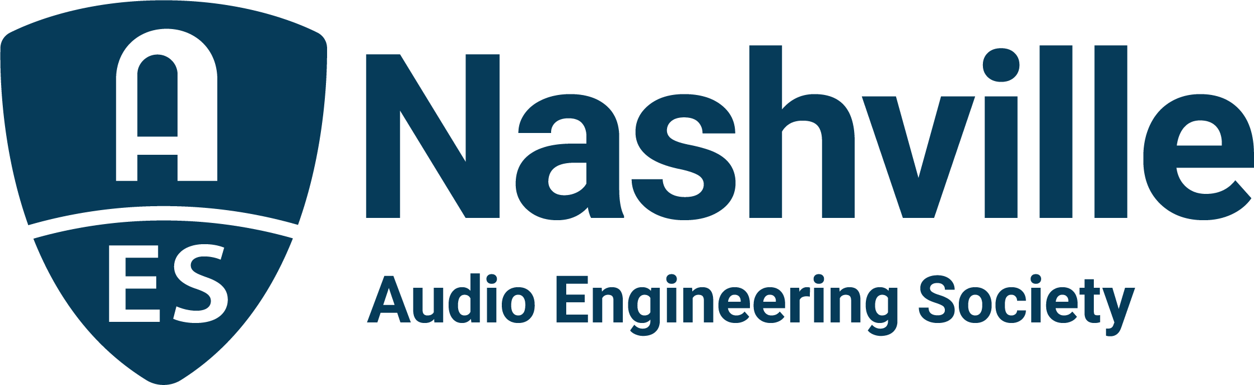

FOR IMMEDIATE RELEASE

Audio-Technica and DiGiCo Announced as Title Sponsors for 25th AudioMasters Nashville Golf Tournament Benefiting the Nashville Engineer Relief Fund

— AudioMasters Benefit Golf Tournament once again attracts national roster of sponsors for the Nashville audio community’s most anticipated annual event —

Nashville, TN, May 18, 2023 — With the AudioMasters Nashville 25th Annual Benefit Golf Tournament just days away, excitement builds for the Nashville audio community to gather for a day on the links in benefit of the Nashville Engineer Relief Fund (NERF). Hosted by the AES Nashville Section, the event spans two days: Thursday, May 18 will see the return of title sponsor DiGiCo for the “Live Day” of play, with returning sponsor Audio-Technica serving as title sponsor for “Studio Day,” Friday, May 19. Golfers will enjoy a bevy of opportunities to meet with sponsor brands while partaking in a relaxed day of play on the course, complete with numerous complimentary food and beverage options, contests and games, swag and camaraderie with peers and pros from around the industry. Additional highlights include each day’s designated special VIP guest, with veteran live sound pro Chris Taylor making his way around the course on day one and recording engineer, producer and educator Mark Rubel on day two. Both days of play, taking place at Harpeth Hills Golf Course, will begin with breakfast on the driving range and a “19th Hole” dinner and awards reception. This year’s tournament will pay special tribute to “Dr.” Bil VornDick, a co-founder of NERF and of the AudioMasters tourney, as well as a beloved member of the Nashville audio community.

The growing list of additional sponsors include returning supporters API, the Audio Engineering Society, Black River Entertainment, Blackbird Studios, Clair Global, Clyne Media, Corky’s Ribs and BBQ of Brentwood, DPA Microphones, Design Technik, Earthworks Audio, ErgoLab/Stealth Chairs, Froggy’s Fog, Genelec, Live Sound International, Loeb & Loeb, Mix Magazine, The NAMM Show, Nashville Recording Supply, RF Venue, The Recording Academy® Producers and Engineers Wing®, The Recording Studio Insurance Program, Shure, Solotech, Sound Emporium, Sound Image, Trew Audio, Teegarden Audio, VEVA Collect, Vision 2 Marketing (HARMAN), and Welcome to 1979 Studios, with new sponsors Carl Tatz Design, PRG (Production Resource Group) and QSC also supporting the Nashville audio community and feting players around the course. Limited additional sponsorship opportunities are still available here.

About the AudioMasters Nashville Benefit Golf Tournament
The AudioMasters Nashville Benefit Golf Tournament serves as the primary funding mechanism for the home-grown 501(c)(3) non-profit Nashville Engineer Relief Fund, founded to support local audio professionals in times of crisis. The tournament is produced by the AES Nashville Section with event coordinator Karen Dunn of KMD Productions. Complete details, player registration and sponsor opportunities are available online with the latest updates available by following the AudioMasters Nashville on Instagram, Facebook and Twitter.

...ends 418 words

Photo File 1: AudioMasters_2023.JPG
Photo Caption1: Title sponsors for the AudioMasters Nashville 25th Annual Benefit Golf Tournament are DiGiCo on “Live Day,” Thursday, May 18, and Audio-Technica for “Studio Day,” Friday, May 19.

Photo File 2: AudioMasters_golfers.JPG
Photo Caption 2: Golfers enjoy a casual day of play and camaraderie on the links during the 2022 AudioMasters Nashville Benefit Golf Tournament at Harpeth Hills Golf Course.

For more information, contact Karen Dunn: karen@kmdpro.com or (925) 708-0307.

