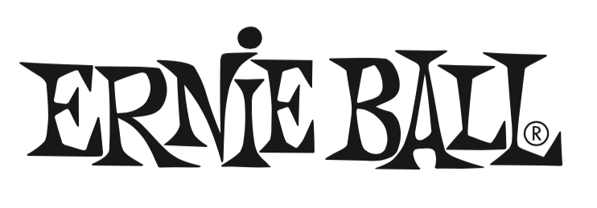

FOR IMMEDIATE RELEASE

Ernie Ball Introduces New Ukulele Strings

(The NAMM Show, Anaheim, CA – January 24, 2019) – Ernie Ball (Booth 4320, D5), the world's premier manufacturer of guitar strings, musical instrument accessories and volume pedals, has introduced its new line of ukulele strings.

Made from nylon monofilament, these strings are offered in either a traditional clear resin for a bright, balanced tone with excellent projection, or a black resin for a warm, rich tone with percussive attack. Uniquely the strings feature ball-end construction for easy installation and enhanced tuning stability (a benefit over most brands, which require tie-end tuning). Gauges are .028, .032, .040, .028", suited for concert and soprano ukes.

Both sets of Ernie Ball ukulele strings will be available in March 2019. U.S. pricing: $5.49.

Photo file 1: EB_Uke_clear.JPG
Photo caption 1: Ernie Ball ukulele strings (clear)

Photo file 2: EB_Uke_black.JPG
Photo caption 2: Ernie Ball ukulele strings (black)

About Ernie Ball:
In 1962, veteran player and teacher Ernie Ball created Slinkys®, the iconic light gauge electric guitar strings widely revered by hundreds of guitar greats including Eric Clapton, Keith Richards, Jimmy Page, Paul McCartney, Metallica, Brad Paisley, Slash, John Petrucci, The Edge and John Mayer. In addition to industry-standard strings, as well as hand-crafted high-end Music Man® guitars and basses, Ernie Ball Inc. offers state-of-the-art instrument accessories that are carried in more than 6,000 stores in the U.S. and 120 countries worldwide. The family-run company maintains its founder's dedication to preserving the musician's playing experience and delivering superior sound quality through the development of new products, such as Cobalt Slinkys, M-Steel, Earthwood and the revolutionary Element Shield Packaging, keeping each set as fresh as the day they were made. The company also fosters artist development through musician-focused programs such as the world's largest and longest running Battle of the Bands, where unsigned bands compete each year for the chance to play live on national tours, festivals and events. Visit them online at www.ernieball.com and www.music-man.com.

FOR PRESS INQUIRIES, PLEASE CONTACT:
Clyne Media, Inc. / info@clynemedia.com

FOR PRODUCT INFORMATION, PLEASE CONTACT:
Ernie Ball Customer Service / customerservice@ernieball.com

Ernie Ball/Music Man is exhibiting at Booth 4320, D5 at the 2019 NAMM Show in Anaheim, California.

