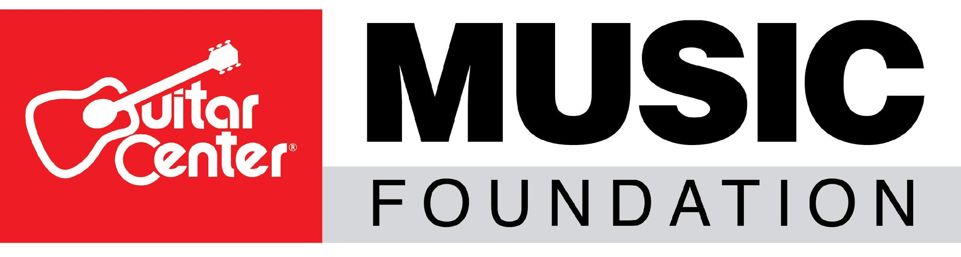
Guitar Center Music Foundation Names David A. Helfant Chairman of the Board

Industry veteran’s experience as an executive and legal counsel, as well as his rich history in the nonprofit world, will help the Guitar Center Music Foundation in its ongoing expansion

Westlake Village, CA (October 2, 2018) – The Guitar Center Music Foundation, a non-profit organization focused on granting instruments and other musician services to various music education non-profit organizations, announces the appointment of industry veteran David A. Helfant as Chairman of the Board for the Foundation. The announcement was made by the Foundation’s Board of Directors and reflects the organization’s goal of growing its charitable initiatives.

As both legal counsel and an executive, Helfant has been a part of some of the most powerful entities in music, film, television and beyond. His experience representing record producers, recording artists and record and publishing companies – together with his specialized expertise in counseling major motion picture studios and television, film and video production companies – has enabled him to lead, direct and counsel a wide variety of corporations, artists and above-the-line talent in their transactional and new media needs. His involvement with charitable causes has had a consistent presence in his career, including work on the Board of Governors for the Society of Singers, which put on The Ella Award annually, as well as on the Board of Governors for the Los Angeles Chapter of The Recording Academy, the Board of the Children's Hospital L.A. Inaugural Sports & Entertainment Leadership Council and the Board of the Southwestern Law School Alumni Association.

Helfant’s rich history in the entertainment industry and philanthropic experience will help him reach more individuals on behalf of the Guitar Center Music Foundation, to join their efforts to support even more music education programs across the country.

“I am pleased to join the team of the Guitar Center Music Foundation. Guitar Center is one of the most recognizable brands in both retail and the music industry, and drawing on that prominence, we have the opportunity to make a difference on a large scale with the Foundation and its amazing initiatives. I look forward to working toward these goals together with the rest of the professionals and Board Members on behalf of the Guitar Center Music Foundation,” said Helfant.

The Guitar Center Music Foundation’s mission is to offer as many individuals as possible the invaluable experience of learning and playing a musical instrument. Since its original founding in 2005, the foundation‘s charitable efforts have put instruments in the hands of over 300,000 persons nationwide during its rich history of supporting musicians through music education, music therapy programs and other music-centric non-profits. Recent activities have included instrument grants to 14 youth programs providing services such as lessons on instruments, music production, voice and performance. Two programs are taking place within the “Philadelphia Free Library System”, providing incentives for participants to enjoy the benefits of both music lessons and access to other educational resources.

“David’s history in the nonprofit world is a real asset for our organization,” stated Lynn Robison, Executive Director of Guitar Center Foundation. “We are on a path of growth in the scope and the range of our charitable activities, and we look forward to all that David can help contribute.”

To learn more, visit https://guitarcenterfoundation.org/ and follow @GuitarCenterFoundation for more news or discover ways to support the Guitar Center Music Foundation.

###
Photo file: DavidHelfant.JPG
Photo caption: David Helfant, Chairman of the Board for the Guitar Center Music Foundation

About Guitar Center:
Guitar Center is the world’s largest retailer of guitars, amplifiers, drums, keyboards, recording, live sound, DJ and lighting equipment. With more than 280 stores across the U.S. and one of the top direct sales websites in the industry, Guitar Center has helped people make music for more than 50 years. Guitar Center also provides customers with various musician based services, including Guitar Center Lessons, where musicians of all ages and skill levels can learn to play a variety of instruments in many music genres; GC Repairs, an on-site maintenance and repairs service; and GC Rentals, a program offering easy rentals of instruments and other sound reinforcement gear. Additionally, Guitar Center’s sister brands include Music & Arts, which operates more than 150 stores specializing in band & orchestral instruments for sale and rental, serving teachers, band directors, college professors and students, and Musician’s Friend, a leading direct marketer of musical instruments in the United States. With an unrivalled in-store experience, an industry-leading online presence and passionate commitment to making gear easy-to-buy, Guitar Center is all about enabling musicians and non-musicians alike to experience the almost indescribable joy that comes from playing an instrument. For more information about Guitar Center, please visit www.guitarcenter.com.

About the Guitar Center Music Foundation:
The Guitar Center Music Foundation was founded in 2005 by Larry Thomas, then former CEO of Guitar Center. Since its inception, the foundation has put instruments in the hands of over 300,000 persons nationwide through donations to qualifying music education and music therapy programs. The foundation’s mission is to support music education programs nationally by providing those in need with instruments and by advocating the benefits of music education. For more information about the Guitar Center Music Foundation, please visit https://guitarcenterfoundation.org/.

FOR MORE INFORMATION PLEASE CONTACT:
Clyne Media | 615.662.1616 | pr@clynemedia.com
Edelman PR | GuitarCenter@edelman.com
Guitar Center | 818.735.8800| media@guitarcenter.com

