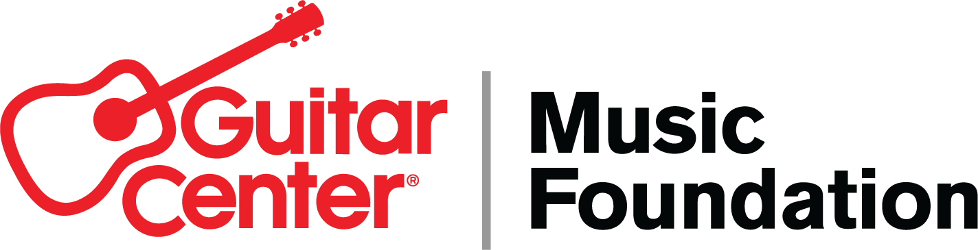
*** TIP SHEET FOR FRIDAY, SEPTEMBER 30, 2022 ***

Guitar Center Music Foundation Replaces Instruments for Marrero Middle School Band

-- On Friday, Sept. 30, Guitar Center Music Foundation, in partnership with Save the Music Foundation and Mr. Holland’s Opus Foundation, will present Marrero Middle School Band in Jefferson Parish with a variety of instruments to replace those lost or damaged due to Hurricane Ida last year --

WHO: The Guitar Center Music Foundation (GCMF), in partnership with Mr. Holland’s Opus Foundation and Save the Music Foundation, will be presenting a large number of musical instruments to the music program at Marrero Middle School in Jefferson Parish. Interested press are invited to attend and/or provide coverage of this event. The celebration will also feature a performance from the legendary Preservation Hall Jazz Band.

WHAT: A year ago, Hurricane Ida destroyed all the musical instruments at Marrero Middle School Band in Jefferson Parish. Three different organizations came to answer the call: Mr. Holland’s Opus Foundation, Save the Music Foundation, and Guitar Center Music Foundation (GCMF). GCMF is providing a brand-new drum line, various brass instruments, and much-needed storage components; Music Rising (Mr. Holland’s Opus natural relief fund) and Save the Music Foundation are providing several dozen additional instruments. The instruments will be presented to the school on Friday, Sept. 30, 2022. Marrero MS band director Jeremy Williams will accept the donations on behalf of the program and will be available to speak with any interested press.

Local artist Josh Wingerter began fundraising efforts for the program last year (just one of multiple private fundraising campaigns spearheaded by community members), and though he was successful and raised a considerable amount of funding, he reached out to GCMF for additional assistance and got the ball rolling. Friday’s ceremony represents the culmination of these grassroots efforts and the successful partnership with GCMF and the other organizations.

WHERE/WHEN: Friday, September 30, 2022 from 1:30-2:10 pm CDT
L.H. Marrero Middle School
4100 7th St, Marrero, LA 70072

More about these organizations:
The Guitar Center Music Foundation (GCMF) is a non-profit charity organization focused on granting instruments and equipment to musicians and music education and music therapy programs. GCMF supports music education programs nationally by providing those in need with instruments and by advocating the benefits of music education. Since its inception in 2005, the foundation has put instruments in the hands of over 300,000 persons nationwide through donations to qualifying music education and music therapy programs.

Save The Music Foundation is a 501(c)(3) music education nonprofit that helps students, schools, and communities reach their full potential through the power of making music. For 25 years, Save The Music (STM) has addressed the systemic inequities in music education by investing in culturally rich communities across the US. Since its inception, STM has donated $68M worth of instruments and technology to over 2,500 schools – impacting millions of students' lives in hundreds of communities nationwide. And we’re just getting started! Learn more at savethemusic.org.

The Mr. Holland’s Opus Foundation keeps music alive in our schools by providing vital support services to school districts, and new musical instruments to underfunded music programs nationwide, giving under-represented youth access to the many benefits of music education, leading them to success in school, and inspiring creativity and expression through playing music.

FOR MORE INFORMATION, CONTACT:
Myka Miller, Guitar Center Music Foundation / myka.miller@GuitarCenterFoundation.org
On-site contact: Myka Miller / 323-573-0568
PR contact: Robert Clyne, Clyne Media Inc. / robert@clynemedia.com / 615-300-4666

