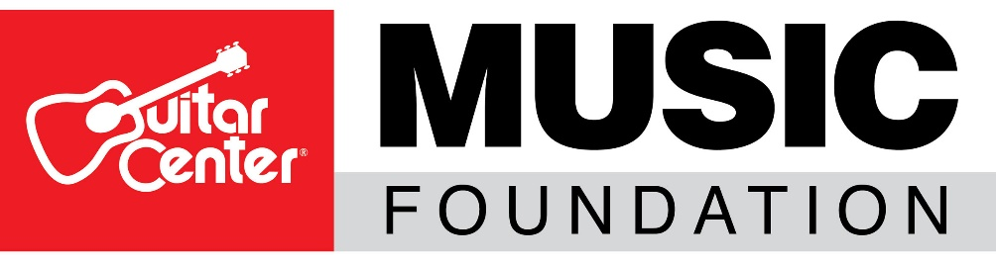
Guitar Center® Music Foundation Launches Relief 4 Musicians Online Fundraiser Event Series
Fundraising events kick off with Shelia E. on June 23, with all proceeds going to musicians and music programs in need
WESTLAKE VILLAGE, Calif., June 15, 2020 – In an effort to provide needed funding relief to musicians and music programs suffering loss of resources as a result of the COVID-19 pandemic, the Guitar Center Music Foundation (GCMF), a non-profit charity organization focused on granting instruments and equipment to musicians and music education and music therapy programs, announces the launch of Relief 4 Musicians, its first-ever streaming event series fundraiser. The series will begin on June 23 with GRAMMY® Award-winning recording artist, producer and philanthropist Sheila E.

These online events will be free with an opportunity for viewers to make donations during each event as well as bid on collectible artist-signed items. Throughout the series, 100 percent of the funds donated will go to support musicians in need and struggling music education and music therapy programs. Additionally, funds raised through donations and auction items will help these programs with the much-needed funding for musical instruments and gear, remote learning capabilities, scholarships and more.

Each event will feature a known artist who is passionate about music, music education and music therapy. The first event on June 23 will stream at 5:00 pm PST via Sheila E.’s Facebook page and will be moderated by drummer and keynote speaker Rob Shanahan.

The events will also include a question-and-answer session, performance, auction item signings and discussion on issues relevant to the music community. Additional events and artists including Joe Bonamassa, Russ Kunkel and Robbie Krieger, among others, will be announced as the series progresses.

Viewers will be able to donate to the Relief 4 Musicians fund directly through Facebook, as each artist will initiate a donate button for each event. Additionally, text R4MSE20 to 44-321 and Give Lively will also provide fans the opportunity to make donations via smartphone. Prior to the event, fans can use the above info to make donations in advance of the events.

“During challenging times like these, we are all tested and must make decisions that have a positive impact on our community. Our decision to rally on behalf of musicians and music programs speaks to the very core of why our Foundation exists. Music is the universal language that binds us as a society. Helping musicians and music programs in need allows us to help music continue. Witnessing firsthand the support and commitment freely given by the wonderful artists involved in our Relief 4 Musicians events and giving of themselves on behalf of other musicians, is a testament to the importance of this effort,” said David Helfant, Chairman of the Board of the Guitar Center Foundation.
Additionally, auction items available for bidding will include an LP percussion drum set that Sheila E. will be playing and will sign during the event, a Cordoba 55SCE Negra classical guitar signed by all of the members of the Gipsy Kings, and much more. BetterWorld will host the auctions. Each auction will close before the next event launches.
Any musicians in need may apply for relief funds generated from this program by applying via the Relief 4 Musicians Grant application, which will be activated via a link posted during each event. Funds raised by the Guitar Center Music Foundation during this event will be available to any working musician as long as funds are available, who may be struggling to maintain their livelihood due to loss of income as a result of the Coronavirus Pandemic.

For more information about this event or the Guitar Center Music Foundation, visit www.guitarcenterfoundation.org.

ABOUT THE GUITAR CENTER MUSIC FOUNDATION
The Guitar Center Music Foundation was founded as a 501(c)(3) in 2005. Since its inception, the Foundation has placed instruments in the hands of over 300,000 persons nationwide through grants to qualifying music education and music therapy programs. The Foundation’s mission is to support music education programs nationally by providing those in need with instruments and by advocating the benefits of music education and music therapy. For more information about The Guitar Center Music Foundation, please visit http://guitarcenterfoundation.org/

FOR MORE INFORMATION PLEASE CONTACT:

Lynn Robison
Guitar Center Music Foundation
info@GuitarCenterFoundation.org

Syvetril Perryman
Guitar Center Inc.
media@guitarcenter.com

