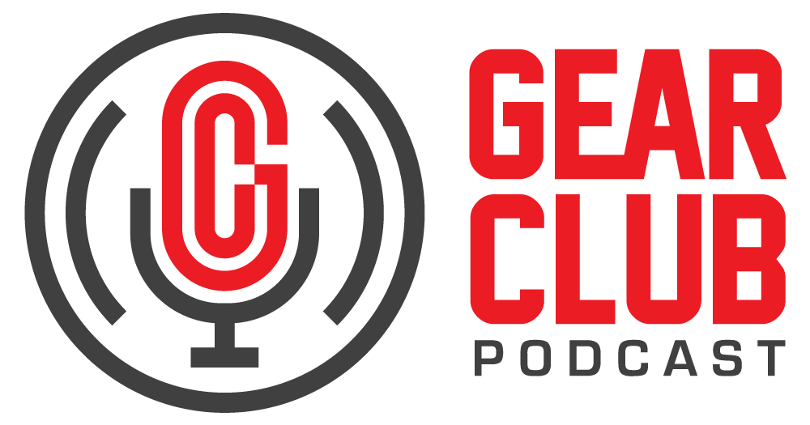

Press Release
Contact: Frank Wells
frank.wells@clynemedia.com
Tel: (615) 585-0597

FOR IMMEDIATE RELEASE

Gear Club Podcast #82 Features Conversation with Steve Vai

— “Lair of the Hydra with Steve Vai (part 1)” is the first portion of a two-part conversation with the legendary guitarist —

New York, NY, February 14, 2022 — The latest episode of Gear Club Podcast, “Episode 82: Lair of the Hydra with Steve Vai (part 1),” is now live online at https://www.gear-club.net/episodes/2022/1/20/82-steve-vai, where you’ll also find a playlist of iconic recordings Vai has played on.

Steve Vai is a GRAMMY® Award-winning musician, composer, producer, and inventor of the Hydra: a three-neck, 36-string beast of a guitar with a steam-punk attitude and endless possibilities. Vai shows just what the instrument is capable of on his newly released album, Inviolate. In this episode, Gear Club hosts Stewart Lerman and John Agnello chat with Vai about his creative process, his fantastic new record, and the inspiration and design behind the Hydra. This is part one of a two-part interview.

Vai will be on tour in the US in support of Inviolate from September 28th through December 3rd, 2022. Head over to vai.com for tickets and more info. Stay tuned for the second part of Vai’s interview, which will go in-depth on his inspiration, motivation, and philosophy in music and more.

Gear Club Podcast provides an in-depth, and sometimes irreverent, look into the world of audio recording with stories told by leading practitioners of the art. The podcast is sponsored by Eventide.

Hosting Gear Club are Stewart Lerman and John Agnello. Lerman is a two-time GRAMMY®-winning music producer and recording engineer based in New York City. His music credits include Elvis Costello, Shawn Colvin, Neko Case, Sharon Van Etten, Patti Smith, The Roches, St. Vincent, Antony and the Johnsons, and David Byrne. His TV and film credits include The Life Aquatic with Steve Zissou, The Royal Tenenbaums, The Marvelous Mrs. Maisel, The Aviator, Vinyl, Cafe Society, Grey Gardens and Boardwalk Empire. Agnello’s career started at the Record Plant in New York City, where he was able to work on some legendary 80s albums by Cyndi Lauper, Aerosmith and John Mellencamp. Since then, he has worked with alt rock legends Dinosaur Jr, Sonic Youth, Son Volt and Patti Smith, and up-and-comers such as Phosphorescent, Kurt Vile and Twin Peaks.

For the complete, ever-expanding catalog of Gear Club Podcasts, featuring timeless interviews with leading artists, engineers, producers and studio pros that have drawn 50,000 subscribers, visit https://www.gear-club.net/. GearClub Podcast episodes are also available on most podcast apps including Apple Podcasts, Google Podcasts, Spotify, Soundcloud and YouTube.

...ends 382 words

Photo File: GearClubPodcast_Episode82_SteveVai.jpeg
Photo Caption: The latest episode of Gear Club Podcast, “Episode 82: Lair of the Hydra with Steve Vai (part 1),” is now live online.

Clyne Media
Email: frank.wells@clynemedia.com
Tel: 615-662-1616, Mob: 615-585-0597
Clyne Media, Inc.,
169-B Belle Forest Circle, Nashville, TN 37221;
Web: http://www.clynemedia.com

