OUT TODAY: new album Skin In The Game from revered supergroup The Immediate Family

Danny Kortchmar, Waddy Wachtel, Leland Sklar, Russ Kunkel and Steve Postell deliver timeless rock and roll on their second studio album

Watch the video for the latest single/title track “Skin In The Game”

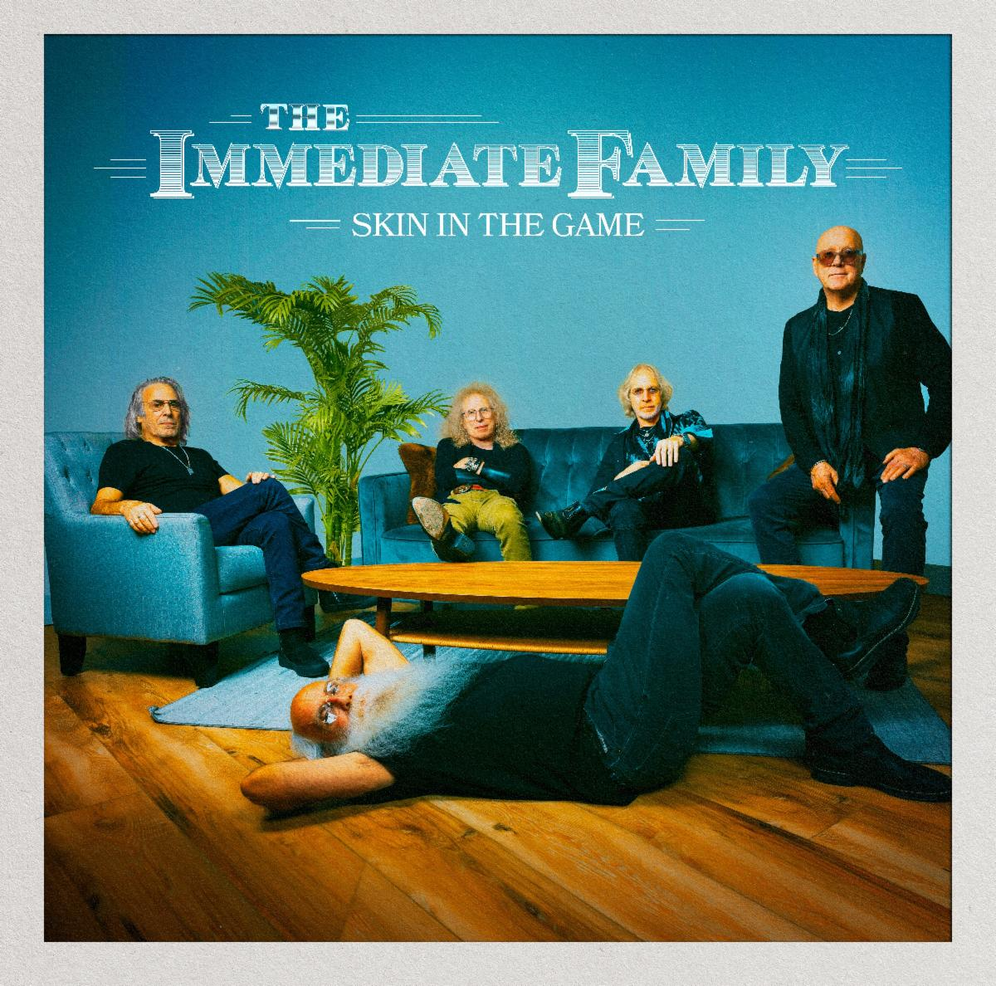

Download cover art: photo by Jay Gilbert/Chris Schmitt – artwork by Brian Porizek

STREAM/DOWNLOAD THE ALBUM
credits/bio/photos

“Most of these songs are original compositions and several qualify immediately as stone classics. There’s a whole lotta rock and roll here for sure.” – Relix

Immediate Family documentary out now
New York Times, Los Angeles Times, The Guardian, Billboard

February 16, 2024 – The Immediate Family’s much-anticipated new studio album, Skin In The Game, is out today via Quarto Valley Records. The legendary musicians’ second full-length studio album is a skillful blend of power, precision, fun and introspection, featuring soaring harmonies and a burst of R&B with the pure essence of rock and roll. Produced by the band themselves, the album includes fourteen tracks that showcase the remarkably versatile musical skills possessed by all five members of The Immediate Family: acclaimed singer/songwriter/guitarists Danny Kortchmar, Waddy Wachtel and Steve Postell, and one of the most renowned rhythm sections in rock history, Russ Kunkel and Leland Sklar.

Launching with the raucous opening track “Whole Lotta Rock and Roll,” the album’s thirteen original songs exuberantly careen from funky rockers such as “24/7/365” and “Lost in the Shuffle,” to gentler numbers, such as “Fragile Heart” and “Catch You on the Other Side.” On “Looking Away,” they effortlessly build the emotional drama by shifting from restrained acoustic guitars to a blast of electric guitar fury. Similarly, the band’s satiric edge can slide from the dark side on “Party at the Graveyard” to the lighter-hearted fun of “High Maintenance Girlfriend.” Sklar and Kunkel’s subtly profound ways of building and holding down a song’s foundation are present throughout Skin In The Game. The album’s title track begins with Kunkel’s drumbeat, complemented by Sklar’s sonorous bass. Together, they bring a gravitas that supports the song’s message that life isn’t just about the money; you need to have heart, soul, pride, and be willing to risk everything – “skin in the game.”

The first single from Skin In The Game is its only cover tune: an arresting reimagining of Sparks’ “The Toughest Girl in Town.” Guitar Player Magazine hailed The Immediate Family’s rendition: “’The Toughest Girl in Town’ is transformed from eccentric synth-pop gem to ax-centric masterpiece.” The second single, the album’s title track “Skin In The Game” (and its accompanying video) is a searing, insightful rocker demonstrating what it means to be fully committed to craft and creativity and willing to risk it all without fear of failure. It’s a hard-earned philosophy that the unique quintet has gained from decades of being among rock’s most revered musicians.

Sporting a resume unrivaled in rock history, this tight-knit quintet has collaborated with many of music’s biggest names, including Keith Richards, Linda Ronstadt, James Taylor, Carole King, Jackson Browne, Stevie Nicks, Don Henley, Billy Joel, David Crosby, Neil Young and Joni Mitchell, to name a few. However, Skin In The Game gloriously reveals that their best collaborators are each other.

The new album follows the release of the universally praised documentary Immediate Family, directed by Denny Tedesco (The Wrecking Crew). Immediate Family has been featured by major media outlets such as the New York Times, Rolling Stone, Chicago Sun-Times and Los Angeles Times, which proclaimed, “its glimpse of the last great era of live-in-studio recording is an enjoyable, personality-rich one.” Variety raved about the Magnolia Pictures release as the “ultimate liner-note movie,” while the Hollywood Reporter hailed it as “time well spent with delightful subjects who played crucial roles in shaping the popular music of a ground-shifting era.”

The film tracks the rise and collaborations of this group of legendary studio musicians, Danny Kortchmar, Waddy Wachtel, Russ Kunkel and Leland Sklar, through the 1970s and onward, spotlighting their prestigious partnerships and their indelible mark that helped define the sound of a generation. Immediate Family is a backstage tour of rock history, featuring intimate interviews with the band members and memorable stories from some of music’s most iconic performers.

A Magnolia Pictures release, Immediate Family is available now on streaming platforms everywhere.

Watch the Official Trailer:
https://www.immediatefamilyfilm.com/

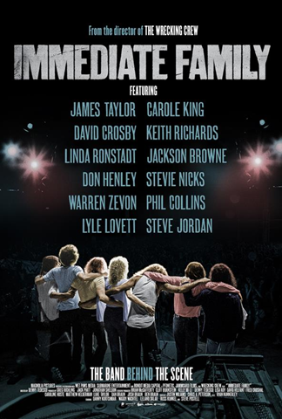

The band recently announced their February tour dates, beginning with a sold-out show at The Mint in Los Angeles. This month’s shows will feature guest guitarist Elliot Easton, a friend of the band and key member of Rock and Roll Hall of Fame inductees The Cars, who will be filling in for Waddy Wachtel, who is out on tour serving as long-time musical director and lead guitarist for Stevie Nicks.

February 2024 Tour Dates

- 2/13/24: Los Angeles, CA @ The Mint – SOLD OUT
- 2/14/24: Santa Barbara, CA @ Lobero Theatre – SOLD OUT
- 2/16/24: Livermore, CA @ Livermore Valley Arts Center
- 2/17/24: Saratoga, CA @ Montalvo Arts Center
- 2/22-2/26/24: Miami, FL @ Rock Legends Cruise
- 2/27/24: Ft. Pierce, FL @ Sunrise Theatre
- 2/28/24: Hallandale Beach, FL @ Sport of Kings Theater

Contact:
Lucy Sabini - lucy.sabini@luciamediagroup.com - 917-864-0060
Robert Clyne - robert@clynemedia.com - 615-300-4666

All photos by Jay Gilbert/Chris Schmitt

Follow The Immediate Family on social media:
Website Facebook Twitter.X Instagram Spotify

About The Immediate Family
The Immediate Family (the modern iteration of a legendary studio ensemble known as "The Section") is a unique group of iconic musicians composed of four of the most recorded, respected, and sought-after players in modern music: Danny Kortchmar (guitar and vocals), Waddy Wachtel (guitar and vocals), Leland Sklar (bass), Russ Kunkel (drums) and the addition of prominent touring, session guitarist and songwriter Steve Postell (guitar and vocals). Frequent collaborators both in the studio and on stage, their work can be heard on albums from Jackson Browne, James Taylor, Linda Ronstadt, Stevie Nicks, Keith Richards, Warren Zevon, Graham Nash, Neil Young, David Crosby, and many, many more. Kortchmar, Sklar, and Kunkel have worked together since the early '70s and made up three-quarters of The Section, best known for both their studio and live work in support of some of the top-selling singer/songwriters and solo singers in the history of music, as well as their acclaimed instrumental albums. (By the mid-70s, they were later joined by Wachtel). Collectively, these musicians helped define the sound of a generation.

About Quarto Valley Records
Founded by tech entrepreneur Bruce Quarto, the California-based independent label Quarto Valley Records represents Rock, Blues, Jazz and Americana genres with an impressive artist roster featuring legacy musicians Paul Rodgers, GRAMMY® award-winning Edgar Winter and Savoy Brown as well as the legendary talent that comprises The Immediate Family, GRAMMY® award-winning producer and renowned drummer and songwriter Tom Hambridge, GRAMMY® award-winning producer and percussionist Narada Michael Walden, blues-rock artist Sean Chambers, British blues sensation Bonham-Bullick, Wings member Denny Seiwell, acclaimed Americana singer-songwriter Al Staehely, the esteemed and soulful Richard T. Bear, and emerging artist Dominic Quarto. https://quartovalleyrecords.com

Visit Quarto Valley Records on its social media pages:
Facebook Twitter Instagram

Photo file 1: SKIN_IN_THE_GAME_COVER.JPG
Photo caption 1: Cover art for Skin In The Game. Photo by Jay Gilbert/Chris Schmitt. Cover artwork by Brian Porizek

Photo file 2: IF_DocumentaryPosterGraphic.JPG
Photo caption 2: Promotional graphic for the new documentary Immediate Family

