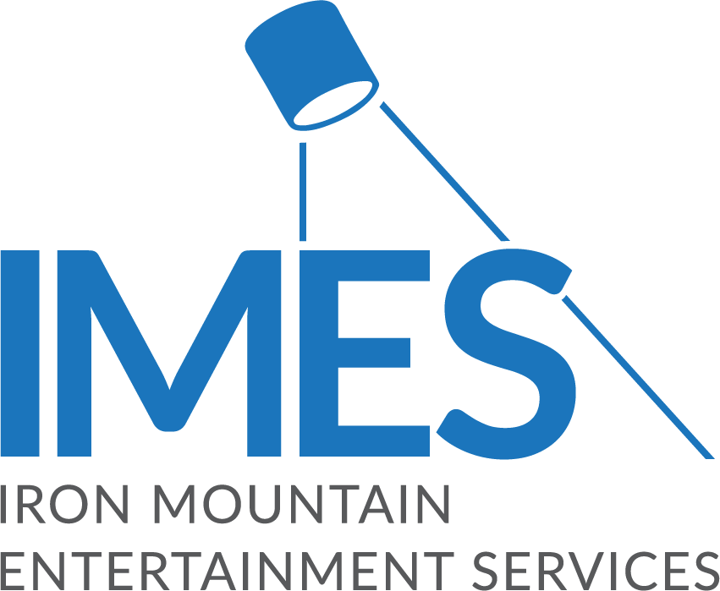

Iron Mountain Entertainment Services Offering Assistance to Those Affected by Nashville Floods

IMES is offering comprehensive relief services for artists, engineers and producers that were victims of the recent severe weather events in the Nashville area, to help preserve their archives and get their recording lives back to normal

BOSTON, March 29, 2021 – The team at Iron Mountain Incorporated®’s Entertainment Services division (IMES), known as the industry’s entertainment content and asset preservation experts, is coordinating a comprehensive relief effort to help those affected by the recent floods in Nashville and the rest of Middle Tennessee.
IMES is offering to conduct free appraisals of media assets, such as audio or video master recordings, that were damaged in the recent floods. If these appraisals are used for insurance purposes, once the claims have been processed, IMES can help coordinate and provide any remediation or restoration services necessary in its L.A. and New Jersey studio facilities. Additionally, IMES is offering free storage at its Nashville facility for up to 60 days for studio equipment, musical instruments, or media that have been displaced by the storms, while cleanup takes place.
Also, for anyone who has sustained damage to their fine art, IMES will work with its Crozier Fine Arts division to help access damage and offer advice on insurance claims, restoration, etc. The Crozier Fine Arts division is a storage, logistics and transportation firm for high-value paintings, photographs and other types of art belonging to individual collectors, galleries and art museums.
"Our customers and the music community have been severely challenged by these floods, and we're offering our specialists, capabilities and facilities to help however we can with the community's recovery,” stated Lance Podell, SVP and GM of Iron Mountain Entertainment Services.
For further information, or to speak to someone about storage, restoration or insurance claims, please contact Beth Greve, IMES Global Head of Sales, beth.greve@ironmountain.com, (310) 344-7780.
To learn more about Iron Mountain Entertainment Services, please visit https://www.imes.media.

About Iron Mountain Entertainment Services
Iron Mountain Entertainment Services (IMES), the media and entertainment division of Iron Mountain Incorporated®, is the go-to physical and digital media archiving service for the media and entertainment industries. IMES partners with clients ranging from the broadcast, film, music and sports sectors to brand archives and individual artists' collections and estates, to protect and activate media archives to preserve our collective cultural heritage. A global leader in media preservation, restoration and archive management, IMES offers industry-leading archive, storage, chain-of-custody processes and physical and digital content preservation solutions to ensure the complete protection of some of the world’s most treasured and iconic assets. Visit https://www.imes.media for more information.

About Iron Mountain
Iron Mountain Incorporated (NYSE: IRM), founded in 1951, is the global leader for storage and information management services. Trusted by more than 225,000 organizations around the world, and with a real estate network of more than 90 million square feet across more than 1,480 facilities in over 50 countries, Iron Mountain stores and protects billions of valued assets, including critical business information, highly sensitive data, and cultural and historical artifacts. Providing solutions that include information management, digital transformation, secure storage, secure destruction, as well as data centers, cloud services and art storage and logistics, Iron Mountain helps customers lower cost and risk, comply with regulations, recover from disaster, and enable a digital way of working. Visit http://www.ironmountain.com for more information.

###

Media Contacts
Meg Travis / Iron Mountain Entertainment Services / 617-535-8366 / Margaret.Travis@ironmountain.com
Robert Clyne / Clyne Media, Inc. / 615.662.1616 / robert@clynemedia.com
Lisa Roy / Rock & Roy / 310.463.1563 / lisaroyaudio@mac.com

