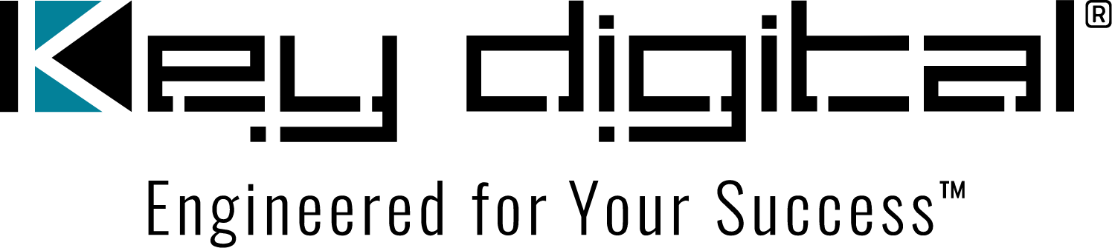

Contacts:

Key Digital

Masha Lakhter, COO

917.701.3238

masha@keydigital.com

Clyne Media, Inc.

Frank Wells, Senior Account Manager

615.585.0597

frank.wells@clynemedia.com

Key Digital celebrates the 12 Days of Christmas with daily discounts

— Each weekday, December 4 – 19, Key Digital will focus on one product from its award-winning catalog of innovative AV solutions, offering unprecedented 10% – 12% discounts on the daily featured product —

MOUNT VERNON, NY, November 29, 2023 – Key Digital, an award-winning developer and manufacturer of leading-edge digital video processing and AV signal distribution solutions, is celebrating a successful 2023 with its annual 12 Days of Christmas event, focusing on a different Key Digital product each weekday, December 4 through December 19. This year’s event offers Key Digital customers a one-day 10% discount on the day’s featured product. That discount goes up to 12% if 12 or more units are ordered on a product’s sale day.

“Our customer’s success is our first priority, says Mike Tsinberg, Key Digital Founder and President. “We are committed to developing and delivering innovative, reliable and affordably priced products, promptly shipped, that meet their needs, along with providing unparalleled support to ensure that every installation goes smoothly and ends with customer satisfaction. We highly value the relationships we’ve built with an ever-expanding list of loyal customers. The 12 Days of Christmas discounts are a thank you to those customers and a welcome to new friends.”

In the latest edition of the video series “Key Digital Live,” hosts DeWayne Rains (VP of sales) and Jonathon Ferry (VP of product education and experience) give an overview of each of the products featured in the 12 Days of Christmas, including details on extensions of the discounts to companion products with select models.

The 2023 Key Digital 12 Days of Christmas featured products:

KD-X444SP HDMI Extender Kit Monday, December 04
KD-BYOD4K Wireless Presentation Gateway Tuesday, December 05
KD-DA1x2DC HDMI Distribution Amp Wednesday, December 06
KD-Pro4x1X-2 HDMI Switcher Thursday, December 07
KD-WP8-2 IP Wall Controller Friday, December 08
KD-CAMUSB PTZ Camera Monday, December 11
KD-XWPS HDMI/USBC Wall Plate Switcher Tuesday, December 12
KD-4KWHCEX 4K HDMI Wireless Extender Kit Wednesday, December 13
KD-FIX418A-2 HDMI Connectivity Fixer Thursday, December 14
KD-XPS22U 2x1HDMI Switcher Extender Kit Friday, December 15
KD-MLV4x4Pro Multiview Presentation Switcher Monday, December 18
KD-VW4x4ProK Video Wall Processor Tuesday, December 19

For more information:
Key Digital: keydigital.com
Key Digital 12 Days of Christmas video: https://www.youtube.com/watch?v=WueNMyaIZTA
Key Digital 12 Days of Christmas Promotion PDF: https://keydigital.org/literature/12-Days-of-Christmas-2023.pdf

…ends 339 words

Photo File 1: 12-Days-Promo.jpg
Photo Caption 1: Key Digital’s 12 Days of Christmas event, focusing on a different product each weekday December 4 through December 19 with a daily discount, kicks off with the KD-X444SP HDMI Extender Kit

About Key Digital:
Established in 1999, Key Digital® designs and engineers intuitive digital A/V connectivity and control solutions that embody excellence. Key Digital delivers reliable, superior-quality, easily-implemented, versatile, high-performance products for corporate, education, government, house-of-worship, bar & restaurant, digital signage and residential A/V applications.

Founded by innovator Mike Tsinberg, holder of over 40 digital video and HDTV patents, Key Digital designs and engineers its products in-house at its USA headquarters in Mount Vernon, New York. The result of meticulous research, development and testing, Key Digital products showcase the company’s extensive, unparalleled technical knowledge and expertise, as well as its market-driven approach, serving as a partner to consultants, designers, and system integration firms in the A/V industry. Key Digital works as its clients’ extended engineering team, developing customized solutions for specific applications. Key Digital is an lnfoComm, CEDIA, CES, and NAHB award-winning manufacturer.

Key Digital®, Engineered for Your Success™

For more information, visit our webpage at www.keydigital.com.

Follow Key Digital on social media:

