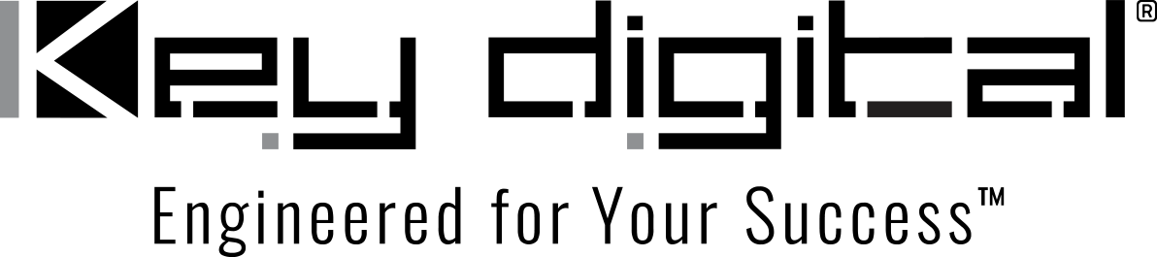

Contacts:

Key Digital

Masha Lakhter, COO

917.701.3238

masha@keydigital.com

Clyne Media, Inc.

Frank Wells, Senior Account Manager

615.585.0597

frank.wells@clynemedia.com

Key Digital to exhibit at CEDIA Tech Summit in Toronto

— Key Digital will demonstrate its comprehensive line of AV over IP, presentation, digital video processing, switcher and connectivity solutions during the September 28 trade event —

MOUNT VERNON, NY, September 12, 2023 – Key Digital, an award-winning developer and manufacturer of leading-edge digital video processing and video signal distribution solutions, will be exhibiting at the CEDIA Tech Summit Toronto, a trade-only one-day event being held Thursday, September 28, at the Parkview Manor in Toronto, Canada.

Key Digital VP of Sales DeWayne Rains and VP of Product Education & Experience Jonathon Ferry will be on hand during the event to demonstrate and discuss Key Digital’s comprehensive range of AV over IP, presentation, digital video processing, switcher and connectivity solutions that deliver industry-leading quality, performance and reliability for residential, corporate, bar and restaurant, digital signage, education, government and house-of-worship applications.

Sponsored by area independent manufacturers’ reps, the summit offers a personal experience for quality connections in Toronto through presentations by smart home tech and business thought leaders as well as an exhibition area featuring leading manufacturers. Registration for the event is free.

“We are looking forward to speaking with our Canadian customers and potential customers during the Tech Summit and updating them on the latest Key Digital solutions for their AV needs,” says Rains.

CEDIA Tech Summit Toronto free registration: https://cedia.net/connection/tech-summits/tech-summit-toronto#reg-form

For more information:
Key Digital
CEDIA Tech Summit Toronto
…ends 195 words

Photo File 1: toronto_tech_summit.jpg
Photo Caption 1: Key Digital will demonstrate its comprehensive line of AV over IP, presentation, digital video processing, switcher and connectivity solutions during the CEDIA Tech Summit, Toronto, September 28, 2023.

About Key Digital:
Established in 1999, Key Digital® designs and engineers intuitive digital A/V connectivity and control solutions that embody excellence. Key Digital delivers reliable, superior-quality, easily-implemented, versatile, high-performance products for corporate, education, government, house-of-worship, bar & restaurant, digital signage and residential A/V applications.

Founded by innovator Mike Tsinberg, holder of over 40 digital video and HDTV patents, Key Digital designs and engineers its products in-house at its USA headquarters in Mount Vernon, New York. The result of meticulous research, development and testing, Key Digital products showcase the company’s extensive, unparalleled technical knowledge and expertise, as well as its market-driven approach, serving as a partner to consultants, designers, and system integration firms in the A/V industry. Key Digital works as its clients’ extended engineering team, developing customized solutions for specific applications. Key Digital is an lnfoComm, CEDIA, CES, and NAHB award-winning manufacturer.

Key Digital, Engineered For Your Success™

For more information, visit our webpage at www.keydigital.com.

Follow Key Digital on social media:

