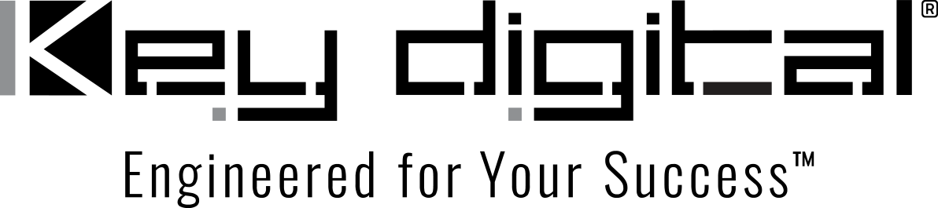

Contacts:

Key Digital

Masha Lakhter, COO

917.701.3238

masha@keydigital.com

Clyne Media, Inc.

Frank Wells, Senior Account Manager

615.585.0597

frank.wells@clynemedia.com

Key Digital® simplifies collaboration with KD-BYOD4K wireless presentation solution

— The innovative Key Digital® KD-BYOD4K Wireless Presentation Gateway allows easy yet sophisticated Wi-Fi content casting from laptops, tablets and smartphones, ideal for the return of in-person meetings —

ISE, Barcelona, January 31, 2023 – The KD-BYOD4K Wireless Presentation Gateway from Key Digital® – a leading manufacturer of professional distributed video and control system equipment – is an affordable, simple-to-operate, all-in-one device that facilitates collaborative business meetings, presentations and seminars – in-person or hybrid – and streamlines interactive education in classroom, auditorium, learning lab, and other educational environments. The innovative KD-BYOD4K is a complete, single-chassis Bring-Your-Own-Device (BYOD) collaboration solution, allowing participants and guests to cast content contact-free to any designated display or projector via Wi-Fi from laptops, tablets and smartphones for big-screen presentation and markup. The KD-BYOD4K readily accommodates a high-definition wireless connection from all major operating platforms – Windows and Mac OS via the dedicated KDPlay™ system application, from Chromebooks via Google Chromecast software, from Android via Chromecast software or the KDPlay app and from iOS devices via Apple AirPlay.

Multiple participants may present and cast content simultaneously without the hassle of wires, effectively breaking down the barriers previously encountered when switching between and incorporating multiple formats and operating systems. Up to four presenters may share content simultaneously using the automatically-adjusting screen layout. Remote participation can be accommodated by dedicating a laptop to perform as a bridge from Zoom, Microsoft Teams or other similar software platforms. The KD-BYOD4K features annotation, moderator management, and touchscreen and mouse control for a true interactive experience. Overlay tools are employed on the annotation and white board screens for real-time collaboration featuring screen captures that are downloadable via QR codes or through the unit’s web browser GUI.

The KD-BYOD4K’s simplified initial setup can be completed in under 10 minutes. The KDPlay™ app can be quickly loaded onto participants’ laptops from the KD-BYOD4K unit’s web page or by simply plugging in the included KDPlay Flash™ USB drive for auto launch. The KDPlay Android app is a fast download away from content casting for Android devices not supporting Chromecast, and the KD-BYOD4K offers direct native support for AirPlay and Chromecast.

Moderator management allows a designated team member to start and stop casting from selected devices via the convenient, collapsible KDPlay dock on the side of their laptop display, which features content thumbnail previews and names of paired devices. Utilizing touchscreen and mouse forwarding features, the KD-BYOD4K allows a connection by USB to the unit for point-and-click functionality for the desired casted content – this feature also works with up to four presenters at once.

“The KD-BYOD4K is a compact, single-chassis solution that improves meeting flow and efficiency and encourages content sharing by simplifying the process of connecting and switching between multiple meeting members in a business setting, or between students and instructors in an education application,” said Masha Lakhter, Key Digital COO. “Whatever device participants carry into a meeting or classroom can be handled wirelessly and reliably with excellent video resolution for even the most detailed content such as reports and spreadsheets. Dual internet connections allow a simultaneous connection from public and internally protected networks to maintain security while also allowing internet connectivity. And the KD-BYOD4K is remarkably affordable.”

Web GUI administration allows access via LAN to the unit setup, moderator, and security tools on the web browser interface. Support documents and app downloads are also all available through this administrator web GUI. With POE the device may be powered using its POE supported LAN port. Audio of the casted devices is de-embedded at the unit’s analog L/R audio connector for ease of integration with audio amplification and mixing systems.

If extended capabilities are needed in an installation, the KD-BYOD4K is part of Key Digital’s comprehensive hardware and software ecosystem of Presentation Solutions – a product family including presentation switchers, multi-format video switchers with HDBaseT extender transmitters, HDBaseT receivers with multi-format video outputs and audio de-embedding, video tiling processors and USB cameras.

The KD-BYOD4K complete wireless presentation solution is priced at $741 (U.S.) MSRP and is available in-stock from Key Digital and authorized resellers.

Visit the KD-BYOD4K product page.

…ends 657 words

Photo File 1: KD-BYOD4K_front.jpg
Photo Caption 1: The Key Digital KD-BYOD4K Wireless Presentation Gateway front panel

Photo File 2: KD-BYOD4K_rear. jpg
Photo Caption 2: The Key Digital KD-BYOD4K Wireless Presentation Gateway rear panel

Photo File 3: KD-BYOD4K_Corporate. jpg
Photo Caption 3: From board room to huddle space, the Key Digital KD-BYOD4K streamlines wireless content casting across all major device operating systems

Photo File 4: KD-BYOD4K_OnScreenMarkUp. jpg
Photo Caption 4: The Key Digital KD-BYOD4K Wireless Presentation Gateway allows on-screen annotation and markup though mouse and touchscreen support for up to four users simultaneously

Photo File 5: KD-BYOD4K_QuadMod. jpg
Photo Caption 5: The Key Digital KD-BYOD4K Wireless Presentation Gateway allows up to four participants to cast content with its automatically-adjusting screen layout

About Key Digital:
Established in 1999, Key Digital® designs and engineers intuitive digital A/V connectivity and control solutions that embody excellence. Key Digital delivers reliable, superior-quality, easily-implemented, versatile, high-performance products for corporate, education, government, house-of-worship, bar & restaurant, digital signage and residential A/V applications.

Founded by innovator Mike Tsinberg, holder of over 40 digital video and HDTV patents, Key Digital designs and engineers its products in-house at its USA headquarters in Mount Vernon, New York. The result of meticulous research, development and testing, Key Digital products showcase the company’s extensive, unparalleled technical knowledge and expertise, as well as its market-driven approach, serving as a partner to consultants, designers, and system integration firms in the A/V industry. Key Digital works as its clients’ extended engineering team, developing customized solutions for specific applications. Key Digital is an lnfoComm, CEDIA, CES, and NAHB award-winning manufacturer.

Key Digital, Engineered For Your Success™

For more information, visit our webpage at www.keydigital.com

Follow Key Digital on social media:

