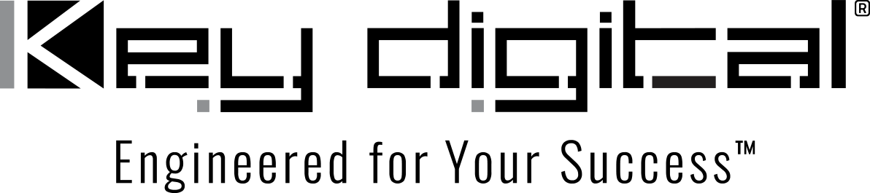

Contacts:

Key Digital

Masha Lakhter, COO

917.701.3238

masha@keydigital.com

Clyne Media, Inc.

Frank Wells, Senior Account Manager

615.585.0597

frank.wells@clynemedia.com

Key Digital® appoints Lavoro as newest distributor for the GCC region

ISE, Barcelona, January 31, 2023 – Key Digital®, an award-winning developer and manufacturer of leading-edge digital video processing and AV signal distribution solutions, has appointed the Dubai-based firm Lavoro as its newest distributor for the Gulf Cooperation Council (GCC) region comprising Bahrain, Kuwait, Oman, Qatar, Saudi Arabia and the seven member states which make up the United Arab Emirates (UAE), which includes Dubai. The announcement was made by DeWayne Rains, Key Digital Vice President of Sales, and represents the brand’s ongoing initiative to expand its international distribution.

Lavoro’s long-term business partnerships with leading manufacturers, along with applying its expertise in on-line marketing and promotion to convey product information to customers and potential customers, allows the firm to open the GCC market to new brands. Key Digital will have a leading role in the Pro AV division of Lavoro’s roster of brands.

“Key Digital has amazingly featured products that give an installation all that is needed and more – and they are priced to sell,” says Lavoro’s Sales Director Andrey Kulikov. “Lavoro is constantly expanding its dealer network all over the GCC. We have the product inventory of Key Digital gear and skilled technical support – which includes extended warranties, rapid after-sales service and complimentary training programs – to make our Key Digital dealers well-equipped and truly competitive.”

“Lavoro has proven to be an effective partner in the introduction of Key Digital products into the UAE market,” says Rains. “Now, as our only stocking distributor in the region, they are poised to build on that performance by expanding Key Digital’s presence throughout the GCC, connecting new dealers and integrators with our video and control solutions. They have the expertise to develop the regional customer base while providing the technological support to see projects through to completion – and bring those customers back for more. We’re delighted to be working with Andrey and entire Lavoro team.”

For more information:
Key Digital
Lavoro
Lavoro on Instagram

…ends 313 words

Photo File 1: Nikolay-Rusanov_Andrey-Kulikov.jpg
Photo Caption 1: Marketing Director Nikolay Rusanov (left) and Sales Director Andrey Kulikov of Lavoro, Key Digital’s new stocking distributor for the GCC region, Lavoro

File 2: lavoro_office_video_wall.png
Photo Caption 2: A rolling Key Digital-enabled video wall used for demos at Lavoro’s Dubai headquarters

Photo File 3: lavoro_le_solarium.png
Photo Caption 3: Lavoro now distributes Key Digital products throughout the GCC region from its Dubai headquarters in the Le Solarium building

About Key Digital:
Established in 1999, Key Digital® designs and engineers intuitive digital A/V connectivity and control solutions that embody excellence. Key Digital delivers reliable, superior-quality, easily-implemented, versatile, high-performance products for corporate, education, government, house-of-worship, bar & restaurant, digital signage and residential A/V applications.

Founded by innovator Mike Tsinberg, holder of over 40 digital video and HDTV patents, Key Digital designs and engineers its products in-house at its USA headquarters in Mount Vernon, New York. The result of meticulous research, development and testing, Key Digital products showcase the company’s extensive, unparalleled technical knowledge and expertise, as well as its market-driven approach, serving as a partner to consultants, designers, and system integration firms in the A/V industry. Key Digital works as its clients’ extended engineering team, developing customized solutions for specific applications. Key Digital is an lnfoComm, CEDIA, CES, and NAHB award-winning manufacturer.

Key Digital, Engineered For Your Success™

For more information, visit our webpage at www.keydigital.com

Follow Key Digital on social media:

