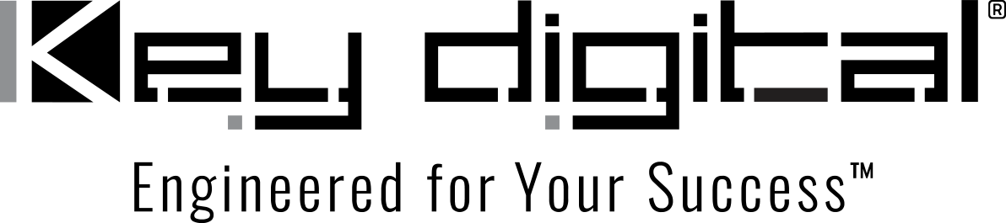

Contacts:

Key Digital

Masha Lakhter, COO

917.701.3238

masha@keydigital.com

Clyne Media, Inc.

Frank Wells, Senior Account Manager

615.585.0597

frank.wells@clynemedia.com

Key Digital shares AV solutions at ISE 2023

— ISE 2023 in Barcelona was busy and productive for Key Digital® staff, on hand to demonstrate the company’s comprehensive range of AV solutions —

MOUNT VERNON, NY, February 9, 2023 – Key Digital, an award-winning developer and manufacturer of leading-edge digital video processing and video signal distribution solutions, traveled to Barcelona at the end of January to demonstrate its comprehensive range of solutions for unified communications and collaboration, AV over IP, digital video processing and switching, connectivity and control at ISE 2023.

With more than 58,000 attendees representing 155 countries at ISE 2023, “We were able to connect face-to-face with our existing distribution partners from throughout the world while building new relationships and launching new partnerships with integrators, distributors and clients from education and government,” said DeWayne Rains, Key Digital VP of Sales. “A truly gratifying highlight of ISE for us was receiving high praise for our product quality, performance and reliability from the partners who have just begun working with our colleagues from the Key Digital Europe office.”

“What most impressed attendees,” said Key Digital’s Jonathon Ferry, VP of Product Education & Experience, “was our ability as a hardware and software company to truly integrate and unify an installation by delivering ease of control and further enhancing the capabilities of our systems.”

“ISE attendees were invited to bring their own devices,” Ferry elaborated, “and were able to present their content either through the wired connectivity of the KD-X4x1WUTx and KD-3x1WUTx wall plate- or desktop box-mount switcher / HDBaseT transmitters, the KD-UPS52U Wireless Presentation Switcher or, without cables, using the KD-BYOD4K Wireless Presentation Gateway. Within moments, users shared content and accessed the KD-CAMUSB 1080P PTZ USB camera for interface with their meeting software of choice, such as Zoom or Teams.” The KD-BYOD4K was further used to connect the booth staff’s own devices and wirelessly cast video case studies of notable and compelling AV over IP, multi-view and control installations for their ISE visitors.

Key Digital’s wide range of control choices were demonstrated at ISE by way of an onsite Compass Control Pro-managed LeCAMbio Conferencing System and the KD-WP8-2 8-Button Programmable IP, RS-232, IR Control, wall plate Keypad. “ISE booth guests were impressed by the LeCAMbio system’s ability to automatically both track a speaker’s voice with the eight-mic array in development partner TOA’s Compass Control compatible Lenubio soundbar and use data from the Lenubio’s mic tracking to direct the KD-CAMUSB camera in the speaker’s direction,” says Ferry.

“Equally impressive,” adds Rains, “was how simple and intuitive it is for an end user to press a single button on the KD-WP8-2 wall plate controller and launch a string of easily, code-free programmed commands to completely reconfigure a system. An additional control option demonstrated was the free iOS KD-App which raised eyebrows with its sophisticated yet end-user friendly capabilities.”

Rains concludes, “Being able to strengthen relationships with existing customers and show a host of potential new customers how Key Digital solutions can cost-effectively solve problems and reduce both install time and support calls made ISE an extremely productive show.”

For more information:
Key Digital
Key Digital news from ISE 2023

Key Digital ISE videos on YouTube:
- Day One at ISE showcasing LeCambio and KD-VW4x4ProK, Video Wall
- Day Two at ISE showcasing KD-MLV4x4Pro and WP8-2
- Day Three at ISE showcasing XPS22U and X444SP/LP
- Day Four at ISE showcasing BYOD4k, UPS52U, PS42
- LeCambio Conferencing Systems at ISE 2023

…ends 532 words

Photo File 1: KeyDigital_ISE2023.jpg
Photo Caption 1: It was smiles all around as Key Digital’s Jonathon Ferry, VP of Product Education & Experience (center), demonstrated Key Digital systems’ capabilities to booth visitors during ISE 2023

About Key Digital:
Established in 1999, Key Digital® designs and engineers intuitive digital A/V connectivity and control solutions that embody excellence. Key Digital delivers reliable, superior-quality, easily-implemented, versatile, high-performance products for corporate, education, government, house-of-worship, bar & restaurant, digital signage and residential A/V applications.

Founded by innovator Mike Tsinberg, holder of over 40 digital video and HDTV patents, Key Digital designs and engineers its products in-house at its USA headquarters in Mount Vernon, New York. The result of meticulous research, development and testing, Key Digital products showcase the company’s extensive, unparalleled technical knowledge and expertise, as well as its market-driven approach, serving as a partner to consultants, designers, and system integration firms in the A/V industry. Key Digital works as its clients’ extended engineering team, developing customized solutions for specific applications. Key Digital is an lnfoComm, CEDIA, CES, and NAHB award-winning manufacturer.

Key Digital, Engineered For Your Success™

For more information, visit our webpage at www.keydigital.com.

Follow Key Digital on social media:

