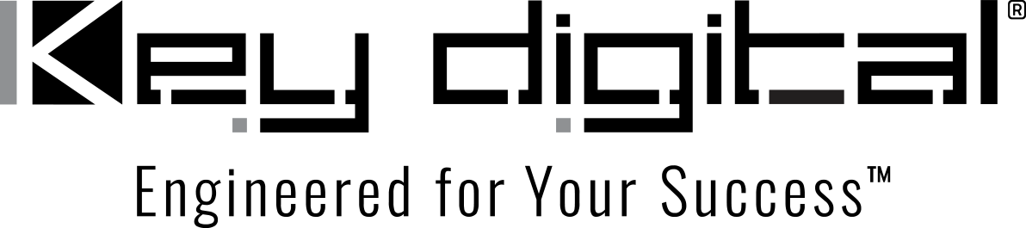

Contacts:

Key Digital

Masha Lakhter, COO

917.701.3238

masha@keydigital.com

Clyne Media, Inc.

Frank Wells, Senior Account Manager

615.585.0597

frank.wells@clynemedia.com

Key Digital® offers KD-XPS22U 4K 18G Smart Extender Kit

— Bundling the KD-PS22UTx Switcher / Transmitter and KD-X100MRx Receiver, the KD-XPS22U kit provides users with UHD/4K AV signal extension up to 328 feet along with connectivity and control unparalleled by other extender sets —

InfoComm, Orlando, FL, June 14, 2023 – The KD-XPS22U 4K 18G Smart Extender Kit bundles a complimentary collection of select AV over IP solutions from leading innovator Key Digital®. For installations where a display or projector is distanced from HDMI sources, the KD-XPS22U delivers uncompromised signal extension along with full-featured system control by bundling together the KD-PS22UTx Switcher / Transmitter – with integral HDBaseT signal transmission capabilities – and the KD-X100MRx Receiver. The KD-XPS22U is suited for applications in conference, training and lecture rooms, huddle spaces and even in home theaters.

“The KD-XPS22U offers far more than a simple signal extension,” says Key Digital VP of sales DeWayne Rains. “It conveniently packages two products frequently paired by our customers to provide 2 x HDMI input switching, mirrored dual-format outputs, UHD 4K with HDR video quality, camera/keyboard/mouse connectivity via USB 2.0, IP control from iOS (via the free KD App) and Windows (via the also free Key Digital Management Software™ Pro), and IR & RS-232 control extension. For a wide range of applications, the KD-XPS22U is a complete system solution.”

HDBaseT provides the bandwidth for delivery of uncompressed 10.2Gbps signals, which the KD-XPS22U extends with visually lossless compression by way of its 18G enabling technology to UHD signals up to 4096x2160. Key Digital’s soft-codec and KVM enabling system leverages HDBaseT’s bidirectionality to create a connectivity hub for professional USB cameras and microphones, audio DSP, keyboard, mouse or touchscreen display. Displays and projectors can be controlled directly by way of IR and RS-232 extension, or via CEC control of power and volume via the KD App or KDMS Pro software. eARC is supported for HDMI and optical audio, with audio de-embedding. Either unit can be powered from its partner Tx/Rx, increasing flexibility of where the units may be located.

The KD-XPS22U supports an expansive list of content standards, including the HDCP 2.2 anti-piracy protocol; the HDR10 standard for high-dynamic-range video; and EDID management for display recognition. It also offers deep color support up to UHD/4K 30Hz 4:4:4/12-bit or 60Hz 4:4:4/8-bit and has a full buffer system to manage HDCP authentication, EDID control handshakes and TMDS re-clocking / signal re-generation for serial data optimization.

The KD-XPS22U 4K 18G Smart Extender Kit is shipping from stock at a bundle-price of $1399. (MSRP).

For more information:
Key Digital
Key Digital’s KD-XPS22U 4K 18G Smart Extender Kit
…ends 369 words

Photo File 1: KD-XPS22U.jpg
Photo Caption 1: Interconnectivity abounds on Key Digital’s KD-PS22UTx (left) Presentation Switcher / Transmitter and the KD-X100MRx (right) AV over IP HDBaseT receiver which are now paired together in the bundle-priced KD-XPS22U 4K 18G Smart Extender Kit

About Key Digital:
Established in 1999, Key Digital® designs and engineers intuitive digital A/V connectivity and control solutions that embody excellence. Key Digital delivers reliable, superior-quality, easily-implemented, versatile, high-performance products for corporate, education, government, house-of-worship, bar & restaurant, digital signage and residential A/V applications.

Founded by innovator Mike Tsinberg, holder of over 40 digital video and HDTV patents, Key Digital designs and engineers its products in-house at its USA headquarters in Mount Vernon, New York. The result of meticulous research, development and testing, Key Digital products showcase the company’s extensive, unparalleled technical knowledge and expertise, as well as its market-driven approach, serving as a partner to consultants, designers, and system integration firms in the A/V industry. Key Digital works as its clients’ extended engineering team, developing customized solutions for specific applications. Key Digital is an lnfoComm, CEDIA, CES, and NAHB award-winning manufacturer.

Key Digital, Engineered For Your Success™

For more information, visit our webpage at www.keydigital.com

Follow Key Digital on social media:

