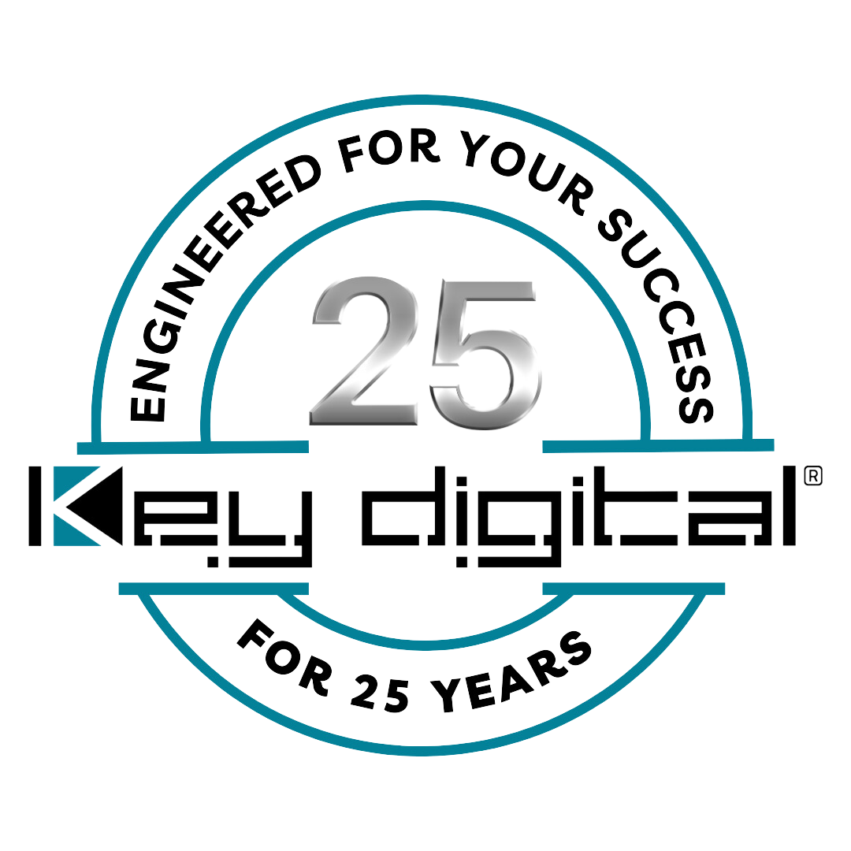

Contacts:

Key Digital

Masha Tsinberg, COO

917.701.3238

masha@keydigital.com

Clyne Media, Inc.

Frank Wells, Senior Account Manager

615.585.0597

frank.wells@clynemedia.com

TPG Communications standardizes on Key Digital AV solutions

— TPG-IP Communications employs scalable Key Digital® AV over IP systems across a broad range of installs with intuitive system management via Compass Control Pro™ iPad software —

InfoComm, Las Vegas, NV, June 12, 2024 – Established in 2002, TPG-IP Communications comprises a skilled group of communication technology professionals focused on crafting and maintaining business networks and audiovisual systems. Under the direction of company founder/president Ralph Quimby, the Belleville, NJ-based systems integrator’s services encompass implementing communication systems and AV over IP installations, overseeing data networks, managing cabling installations, and providing guidance in selecting optimal hardware and software solutions tailored to their clients’ needs. A constant element of Quimby’s installs are components from the award-winning developer and manufacturer of leading-edge digital video processing and video signal distribution solutions, Key Digital (booth C5550), which is celebrating its 25th anniversary this year.

“I spent a long time searching for a vendor that would truly partner with me and care about the projects I was installing,” stated Ralph Quimby. “Not only do their products work time after time, but Key Digital has the support I demand. They’re New York-based, and I have been dealing with them even before AV over IP systems existed. They pre-configure everything that I am installing before we get out in the field. They always have my back and immediately take care of any bugs that might pop up – there’s no wasted time on the job site. Again, they truly care about their product and about me and my customers who will be using the Key Digital gear. And there are no problems after installation. I am not the type of installer who wants to rack up endless billable service calls for programming systems out in the field. I know that works for some companies, but that is not our business model. Key Digital gets it and that speaks volumes for me.”

Most of TPG’s installations employ Key Digital scalable 4K AV over IP systems. which deliver device control with content, intuitively unified in TPG installs by the Key Digital Compass Control Pro integrated iOS-based control system, which can extend iPad control to include a host of Compass Alliance partner systems even beyond the AV network. “You can control each zone in an installation individually, from anywhere in the facility, all from a single iPad running Key Digital’s Compass Control Pro software,” says Quimby. “DirecTV, streaming devices, the audio system – everything. And you can configure the Compass Control Pro software to fit the needs of a facility’s AV design, like limiting access of control using password-protected security.”

Recently, Quimby has also been employing Key Digital’s “absolutely amazing” KD-XWPS HDMI/USBC wall plate switcher-extender kit solution in his installations for HDMI extension over distance. “You can plug right in from a laptop and shoot the signal anywhere else in the facility. It's a really great family of devices.”

In addition to recent AV over IP installs at the Pig Beach BBQ restaurants in Queens, NY, Louisville, KY, and Palm Beach, FL, Quimby is currently working on a large install at a high-end brewing sports bar in Buffalo, NY. The facility will feature two huge 220-inch video walls back to back, along with a host of sources and additional displays interconnected by an expansive Key Digital AV over IP system. An iPad running Compass Control Pro will manage the complete system, including the video wall display.

“Key Digital is one of the best vendor partners I have ever had in my 24 years of business,” Quimby concludes. “They truly understand my clients and my business, they partner with me to help design and implement a system that is going to be intuitive, reliable and work for my clients out in the field and they deliver the products on time, on budget. I love having less to worry about when working on a job”.

For more information:
Key Digital
AV over IP solutions
Compass Control Pro unified iOS control
HDMI over CAT extenders
Key Digital Pig Beach case study video
TPG-IP Communications
…ends 630 words

Photo File 1: PigBeach_Palm_VideoWalls.jpg
Photo Caption 1: The control and processing built into Key Digital AV over IP systems distributes events to dozens of screens at Pig Beach Palm Beach, including managing the massive 4 x 2 video wall behind the bar and the 3 x 3 video wall at the end of the room

Photo File 2: AVoverIP_rack.jpg
Photo Caption 2: Scalable to be perfectly right-sized for any project, with an encoder dedicated to each source and a decoder to each display like these at Pig Beach Queens, modular Key Digital AV over IP systems give TPG the ease of installation, reliability and performance it demands along with end-user pleasing iPad control

Photo File 3: PigBeach_Queens_videowall.jpg
Photo Caption 3: The 3 x 2 video wall behind the courtyard bar at Pig Beach BBQ’s Queens, NY location is the highlight of the venue’s expansive Key Digital-enabled AV over IP system

Photo File 4: PigBeach_Palm_Dining3x3.jpg
Photo Caption 4: TPG relies on Key Digital Compass Control iOS software to let its client’s staff intuitively control video with a few taps and swipes, including video walls as well as independent displays

About Key Digital:
Established in 1999, and celebrating its 25th anniversary this year, Key Digital® designs and engineers intuitive digital A/V connectivity and control solutions that embody excellence. Key Digital delivers reliable, superior-quality, easily-implemented, versatile, high-performance products for corporate, education, government, house-of-worship, bar & restaurant, digital signage and residential A/V applications.

Founded by innovator Mike Tsinberg, holder of over 40 digital video and HDTV patents, Key Digital designs and engineers its products in-house at its USA headquarters in Mount Vernon, New York. The result of meticulous research, development and testing, Key Digital products showcase the company’s extensive, unparalleled technical knowledge and expertise, as well as its market-driven approach, serving as a partner to consultants, designers, and system integration firms in the A/V industry. Key Digital works as its clients’ extended engineering team, developing customized solutions for specific applications. Key Digital is an lnfoComm, CEDIA, CES, and NAHB award-winning manufacturer.

Key Digital®, Engineered for Your Success™

For more information, visit our webpage at www.keydigital.com.

Follow Key Digital on social media:

