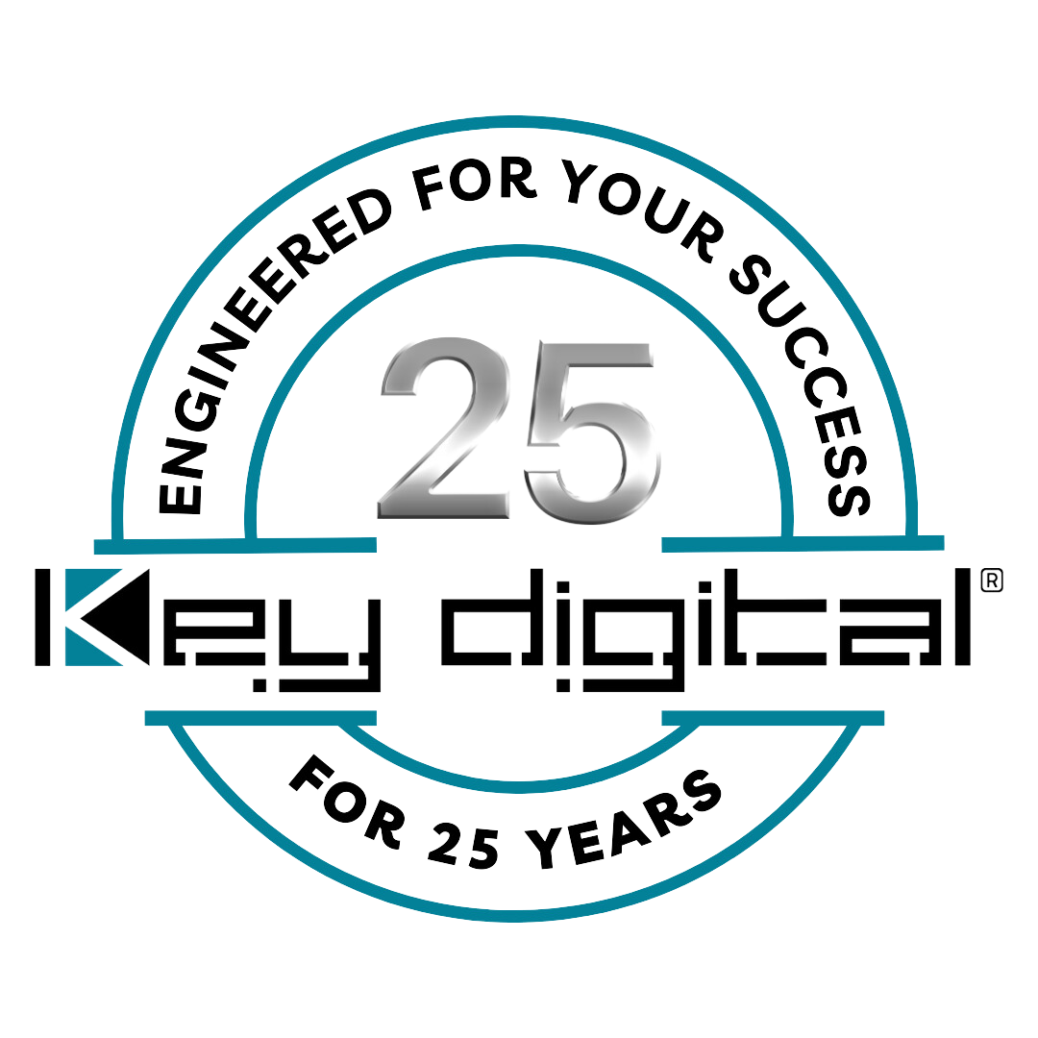

Contacts:

Key Digital

Masha Tsinberg, COO

917.701.3238

masha@keydigital.com

Clyne Media, Inc.

Frank Wells, Senior Account Manager

615.585.0597

frank.wells@clynemedia.com

Key Digital® introduces KD-BYOD4KHub BYOD & BYOM wireless presentation gateway and device hub

— The KD-BYOD4KHub expands the capabilities of the popular and innovative KD-BYOD4K gateway with user-requested support for USB cameras and audio, local HDMI input, dual HDMI outputs and USB capture of output content for mirroring to remote meeting participants, alongside the BYOD4K family’s capabilities of up to 16 local device connections with as many as five participants simultaneously sharing content —

MOUNT VERNON, NY, May 31, 2024 – Key Digital® is introducing its KD-BYOD4KHub BYOD & BYOM wireless presentation and conferencing gateway, a wireless solution for conference and presentation spaces that enables users to bring their own device of any OS and present to a shared display while the hub receives the USB camera, mic and audio in the room for collaboration with local and remote video conference participants.

Building on Key Digital’s successful and innovative KD-BYOD4K wireless presentation gateway, itself ideal for conference room and huddle room touch-free Bring Your Own Device content-sharing and collaboration, the KD-BYOD4KHub’s BYOM (Bring Your Own Meeting) capabilities make it even easier to collaborate in hybrid meetings. “With the KD-BYOD4KHub, we’ve made it easier than ever to integrate the content-sharing capabilities of the KD-BYOD4K into hybrid environments with remote meeting participants,” says Jonathon Ferry, Key Digital VP of product education and experience. “Everything a meeting host needs to interface with conferencing platforms is included in one compact and remarkably affordable device.”

The KD-BYOD4KHub adds an HDMI input for direct input from a dedicated room computer or primary presenter laptop, dual HDMI outputs for mirrored or independent viewing on two connected displays/projectors, and a capture feature to mirror the room’s main or sub display to share in video conferencing software (Zoom, Teams, etc.) and completely immerse video conference participants in multi-presenter meetings, huddles and brainstorming sessions. The KD-BYOD4KHub serves as central connection for USB cameras and audio sources. Audio from the casting device is de-embedded at the unit’s analog L/R audio connector for ease of integration with audio amplification and mixing systems. With CEC and RS-232 room display management, the KD-BYOD4KHub’s customizable home screen and digital signage mode can turn displays into branding canvases between meetings.

As with its predecessor, the KD-BYOD4KHub displays at 4K/UHD for optimal clarity of spreadsheets and data content and delivers a smooth, glitch-free AV experience based on optimizations for video content and 30fps casting. Up to five presenters may share content at the same time with an auto-adjusting screen layout, along with moderator management, annotation, and touchscreen/mouse control capabilities.

Users with Windows, Mac, Chrome, iOS, or Android devices may wirelessly cast content via the KD-BYOD4KHub’s WiFi network. The included KD-BYODFD auto-launching flash drive delivers plug-and-play casting with Windows and Mac OS. Additionally, users may follow the on-screen instructions to download the KDPlay+ app onto their device. KD-BYOD4KHub also boasts native support of Airplay from iOS devices, Chromecast from Chromebooks, and Miracast from Windows and Android OS.

Dual network ports enable the KD-BYOD4KHub to provide internet access via employee and guest network connections. This allows employees to access their network resources during internal meetings while maintaining network security when providing guests with meeting and internet access. The KD-BYOD4KHub may act as the Wireless Access Point or may be accessed by devices via a wireless or wired network connection in WiFi Client or LAN Connection modes. Four-level security includes casting / pairing pin and device-type permission options, AES-256 + RSA-1024 encryption.

The Key Digital KD-BYOD4KHub will be available for preorder in Q3, 2024 at an MSRP of $1541.00. (USD).

For more information:
Key Digital
Key Digital KD-BYOD4KHub
…ends 514 words

Photo file 1: KD_BYOD4KHub.jpg
Photo caption 1: Key Digital’s KD-BYOD4KHub BYOD & BYOM wireless presentation and conferencing gateway solution for conference and presentation spaces (back and front)

Photo file 2: KD_BYOD4KHUB_SIDE.jpg
Photo caption 2: A side view of the KD-BYOD4KHub BYOD & BYOM wireless presentation and conferencing gateway solution for conference and presentation spaces

About Key Digital:
Established in 1999, and celebrating its 25th anniversary this year, Key Digital® designs and engineers intuitive digital A/V connectivity and control solutions that embody excellence. Key Digital delivers reliable, superior-quality, easily-implemented, versatile, high-performance products for corporate, education, government, house-of-worship, bar & restaurant, digital signage and residential A/V applications.

Founded by innovator Mike Tsinberg, holder of over 40 digital video and HDTV patents, Key Digital designs and engineers its products in-house at its USA headquarters in Mount Vernon, New York. The result of meticulous research, development and testing, Key Digital products showcase the company’s extensive, unparalleled technical knowledge and expertise, as well as its market-driven approach, serving as a partner to consultants, designers, and system integration firms in the A/V industry. Key Digital works as its clients’ extended engineering team, developing customized solutions for specific applications. Key Digital is an lnfoComm, CEDIA, CES, and NAHB award-winning manufacturer.

Key Digital®, Engineered for Your Success™

For more information, visit our webpage at www.keydigital.com.

Follow Key Digital on social media:

