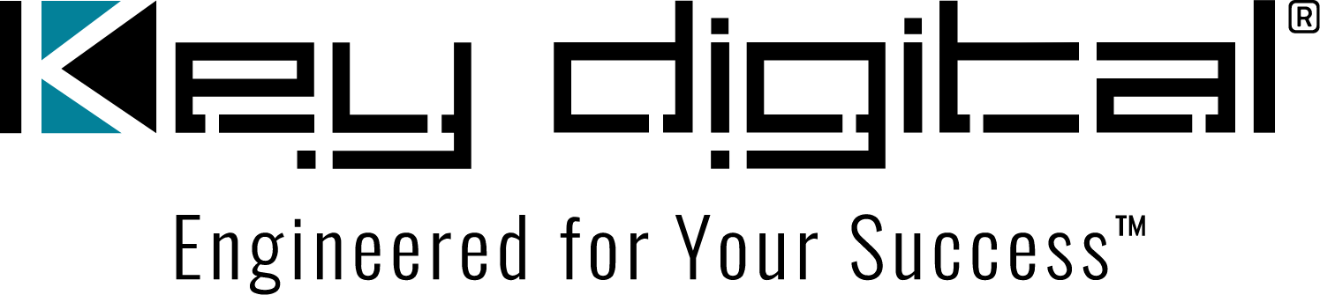

Contacts:

Key Digital

Masha Lakhter, COO

917.701.3238

masha@keydigital.com

Clyne Media, Inc.

Frank Wells, Senior Account Manager

615.585.0597

frank.wells@clynemedia.com

Key Digital® enables DIY AV over IP configuration with System Builder

— Key Digital’s System Builder enhancement to its free Windows PC KDMS™ Pro system configuration and management app streamlines AV over IP system configuration —

MOUNT VERNON, NY, January 16, 2024 – Key Digital®, the award-winning developer and manufacturer of leading-edge digital video processing and AV signal distribution solutions including modular and scalable AV over IP systems, has updated its free Windows PC Key Digital Management Software (KDMS™) Pro system configuration and management app with the addition of System Builder, a streamlined AV over IP system DIY configuration tool that delivers integrators and stocking dealers a powerful tool for rapid, intuitive and simplified setup of a new system install.

KDMS Pro, which automatically scans a connected system’s devices and configuration upon launch, is a proven utility for editing Key Digital AV over IP system and networked device configurations, including system name, video source and display names, and IP addresses. KDMS Pro also auto-populates prebuilt GUI interfaces for companion system control software.

“The DIY option offered by System Builder better meets the needs of our AV over IP system stocking dealers and supports ‘just-in-time’ purchasing trends,” says Key Digital VP of Product Education & Experience Jonathon Ferry. “While we will continue to offer complete factory pre-configuration of our AV over IP systems at no cost, System Builder empowers our customers with additional flexibility.”

The System Builder all-in-one table-based tool allows the programmer/installer to enter the starting parameters of a system, and then the software auto-completes ID and IP address information configuration. System Builder guides the installer through each step of configuration and then, one by one via USB, loads system information into each Key Digital encoder and decoder in use. The pre-configured turnkey system can then be delivered to the job site for final installation, including integration with existing networks.

To support integrator use of System Builder, Key Digital has launched a dedicated, resource-rich webpage that outlines the process and provides links to resources such as concise how-to videos, a setup guide for compatible network switches, KDMS software download, and other pertinent information. System Builder is compatible with all second-generation KD-IP922-II and KD-IP1022-II AV over IP systems, as well as with systems deploying first-generation KD-IP822/922/1022 hardware.

KDMS Pro additionally provides UCC (Unified Communications & Collaboration) capability for control integration of networked Key Digital hardware – such as presentation switchers, PTZ cameras, audio amplifiers, and wall-plate controllers – as well as source control of third-party cable and satellite boxes and media streaming devices and video displays. KDMS Pro can manage multiple systems within a network.

The KDMS Pro download includes the KDMS Control app for a PC-based UI suitable for end-user operation without the ability to edit device or system settings. Further, KDMS Pro GUI windows are automatically ported to the remarkably featured and free KD-App for portable and intuitive swipe and tap system control from iOS devices, and to Key Digital Compass Control® Pro software which can extend iPad control to a host of Compass Alliance partner systems beyond AV including lighting, HVAC, power and security.

KDMS Pro with System Builder is available for immediate download.

For more information:
Key Digital: keydigital.com
KDMS Pro System Builder
KDMS Pro info and download
AV over IP solutions
Unified Communications & Collaboration solutions
…ends 505 words

Photo File 1: SystemBuilder1.jpg
Photo Caption 1: The Key Digital KDMS Pro app’s System Builder all-in-one table-based tool Builder guides the installer through each step of configuration

Photo File 2: SystemBuilder2.jpg
Photo Caption 1: The free Windows PC KDMS Pro system configuration and management app has been enhanced with System Builder, a streamlined AV over IP system DIY configuration tool

About Key Digital:
Established in 1999, Key Digital® designs and engineers intuitive digital A/V connectivity and control solutions that embody excellence. Key Digital delivers reliable, superior-quality, easily-implemented, versatile, high-performance products for corporate, education, government, house-of-worship, bar & restaurant, digital signage and residential A/V applications.

Founded by innovator Mike Tsinberg, holder of over 40 digital video and HDTV patents, Key Digital designs and engineers its products in-house at its USA headquarters in Mount Vernon, New York. The result of meticulous research, development and testing, Key Digital products showcase the company’s extensive, unparalleled technical knowledge and expertise, as well as its market-driven approach, serving as a partner to consultants, designers, and system integration firms in the A/V industry. Key Digital works as its clients’ extended engineering team, developing customized solutions for specific applications. Key Digital is an lnfoComm, CEDIA, CES, and NAHB award-winning manufacturer.

Key Digital®, Engineered for Your Success™

For more information, visit our webpage at www.keydigital.com.

Follow Key Digital on social media:

