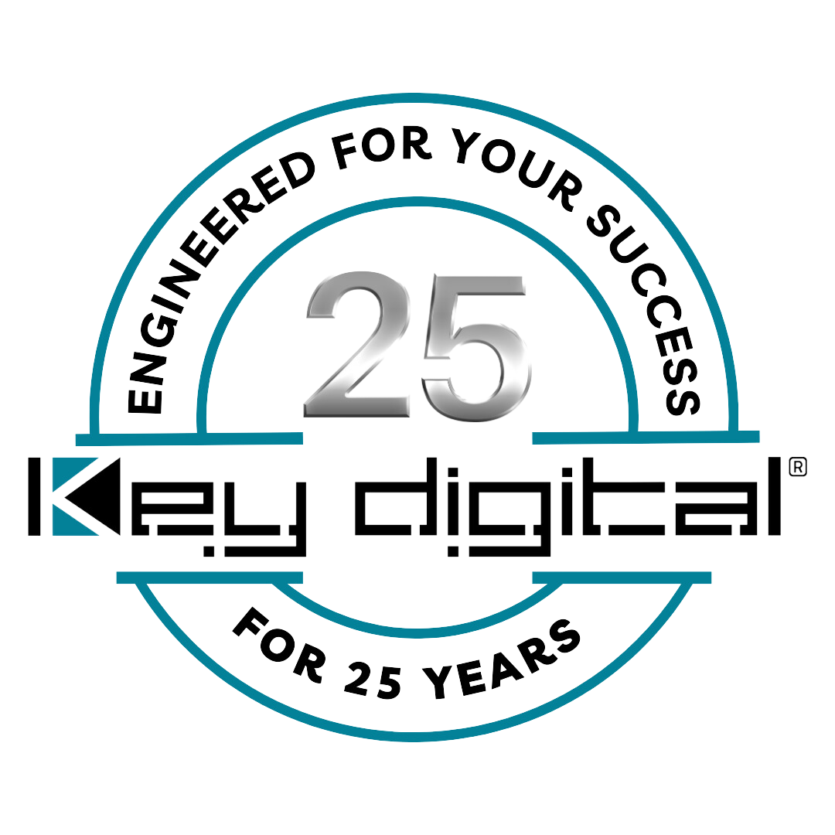

Contacts:

Key Digital

Masha Tsinberg, COO

917.701.3238

masha@keydigital.com

Clyne Media, Inc.

Frank Wells, Senior Account Manager

615.585.0597

frank.wells@clynemedia.com

Key Digital to exhibit at AVL Camp hosted by Sales Force & Associates

– Key Digital will demonstrate its comprehensive line of AV over IP, presentation, digital video processing, switcher and connectivity solutions during AVL Camp, held July 9 in Ft. Lauderdale and July 11 in Orlando –

MOUNT VERNON, NY, June 25, 2024 – Following closely on the heels of the InfoComm Show, Key Digital Systems, an award-winning developer and manufacturer of leading-edge digital video processing and video signal distribution solutions, will be exhibiting at AVL Camp, hosted by Sales Force & Associates on July 9 in Ft. Lauderdale and July 11 in Orlando, Florida. AVL Camp is an exciting and immersive educational event specifically designed for professionals in the audio, video, control, and lighting industries. This year’s AVL Camp features a unique camping theme, transforming the event into an outdoor adventure. Attendees are encouraged to explore the “campsite” and enjoy the various sights and experiences offered by participating manufacturers, like Key Digital Systems.

Key Digital personnel will be on hand during AVL Camp to demonstrate and discuss the brand’s comprehensive range of AV over IP, presentation, digital video processing, switcher and connectivity solutions that deliver industry-leading quality, performance and reliability for corporate, bar and restaurant, digital signage, education, government and house-of-worship applications. “We participated in the AVL Camps in Birmingham, AL, and Charlotte, NC, last year, and they were both very successful events,” says DeWayne Rains, VP of sales at Key Digital. “We love AVL Camp events because they allow us to interact with individuals who are genuinely interested in learning about our products, regardless of their firm’s size, from integrators to large corporations. We’re excited about the upcoming Florida events, where we look forward to making new connections and friends while showcasing our problem-solving, cost-effective and technologically innovative products. We’re especially eager to demonstrate the remarkably powerful KD-WP8-3 third-generation eight-button web-UI-programmable IP control wall plate keypad that fits into a single-gang wall box and is PoE powered, along with the new KD-4KWHCEX HDMI 4K 60Hz wireless extender kit with IR which provides an effortless solution to HDMI extension in installations and where running a wire is not possible.”

AVL Camp is focused on professionals from the A/V community including integrators, resellers, consultants, technology managers and end users from the hospitality, corporate, education and worship fields. Register here for these free events.

AVL Camp, Ft. Lauderdale, FL takes place Jul. 9, 2024, 9:00 AM – 3:00 PM EDT
Courtyard Ft. Lauderdale Airport Cruise, 400 Gulf Stream Way, Dania Beach, FL 33004, USA

AVL Camp, Orlando, FL takes place Jul. 11, 2024, 9:00 AM – 3:00 PM EDT
WholeLife Church, 2800 N Orange Ave, Orlando, FL 32804, USA

For more information:
Key Digital

Photo File 1: KD_4KWHCEX_Front.jpg
Photo Caption 1: At AVL Camp, Key Digital will demonstrate an effortless solution to HDMI extension – the new KD-4KWHCEX HDMI 4K 60Hz wireless extender kit with IR

Photo File 2: KD_WP8_3.jpg
Photo Caption 2: At AVL Camp, Key Digital will demonstrate the newly updated KD-WP8-3 third-generation eight-button, PoE-powered, web-UI-programmable IP control wall plate keypad that fits into a single-gang wall box

About Key Digital:
Established in 1999, and celebrating its 25th anniversary this year, Key Digital® designs and engineers intuitive digital A/V connectivity and control solutions that embody excellence. Key Digital delivers reliable, superior-quality, easily-implemented, versatile, high-performance products for corporate, education, government, house-of-worship, bar & restaurant, digital signage and residential A/V applications.

Founded by innovator Mike Tsinberg, holder of over 40 digital video and HDTV patents, Key Digital designs and engineers its products in-house at its USA headquarters in Mount Vernon, New York. The result of meticulous research, development and testing, Key Digital products showcase the company’s extensive, unparalleled technical knowledge and expertise, as well as its market-driven approach, serving as a partner to consultants, designers, and system integration firms in the A/V industry. Key Digital works as its clients’ extended engineering team, developing customized solutions for specific applications. Key Digital is an lnfoComm, CEDIA, CES, and NAHB award-winning manufacturer.

Key Digital®, Engineered for Your Success™

For more information, visit our webpage at www.keydigital.com.

Follow Key Digital on social media:

