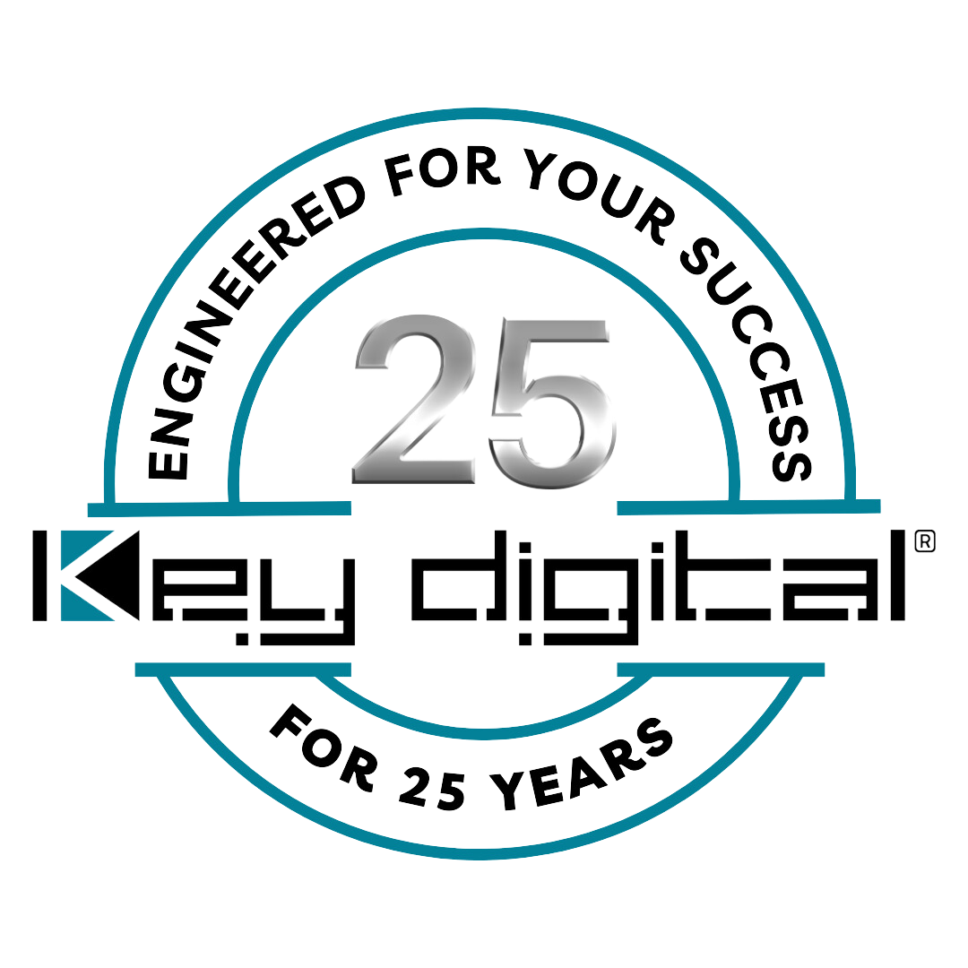

Contacts:

Key Digital

Masha Tsinberg, COO

917.701.3238

masha@keydigital.com

Clyne Media, Inc.

Frank Wells, Senior Account Manager

615.585.0597

frank.wells@clynemedia.com

Key Digital to exhibit at cavlo tradeshow in Nashville, TN

– Key Digital will demonstrate its comprehensive line of AV over IP, presentation, digital video processing, switcher and connectivity solutions during the Nashville-area trade event –

MOUNT VERNON, NY, March 25, 2024 – Key Digital Systems, an award-winning developer and manufacturer of leading-edge digital video processing and video signal distribution solutions, will be exhibiting at cavlo, a trade-only event at Gaylord Opryland in Nashville, TN. cavlo kicks off with a complimentary welcome reception on Tuesday evening, April 2; the trade show and all breakout sessions are on Wednesday, April 3.

Key Digital personnel will be on hand during cavlo to demonstrate and discuss its comprehensive range of AV over IP, presentation, digital video processing, switcher and connectivity solutions that deliver industry-leading quality, performance, and reliability for corporate, bar and restaurant, digital signage, education, government, and house-of-worship applications. “We’ve participated in the cavlo event series in both Nashville and Texas,” says DeWayne Rains, VP of sales at Key Digital. “We love cavlo events because we get to interact with people who really want to learn about our products from firms of all sizes, small to large. We look forward to making new contacts and friends at the upcoming Nashville event and introducing them to our problem-solving, cost-effective, technologically innovative products. We’re especially eager to demonstrate the remarkably powerful KD-WP8-3 third-generation eight-button web-UI-programmable IP control wall plate keypad that fits into a single-gang wall box and is PoE powered, along with the new KD-4KWHCEX HDMI 4K 60Hz wireless extender kit with IR which provides an effortless solution to HDMI extension in installations and where running a wire is not possible.”

cavlo, “The Trade Show for the Rest of US!”, is focused on professionals from the commercial entertainment and communication fields: equipment specifiers, system integrators, event engineers, technicians and end users from the hospitality, corporate, education or worship fields. Registration for the event is free.

cavlo Nashville 2024 is collocated with WAVE (Worship Audio Visual Experience) Spring 2024, which also has a free exhibition component for registered attendees.

cavlo free registration: https://cavlo.tech/attend
WAVE info and registration: https://wave-event.co/conference-spring2024-2/

For more information:
Key Digital

Photo File 1: KD_4KWHCEX_Front.jpg
Photo Caption 1: At cavlo Nashville 2024, Key Digital will demonstrate an effortless solution to HDMI extension – the new KD-4KWHCEX HDMI 4K 60Hz wireless extender kit with IR

Photo File 2: Cavlo_badge.jpg
Photo Caption 2: Key Digital will be exhibiting at cavlo Nashville 2024, a trade-only event at Gaylord Opryland on April 2-3

Photo File 3: KD_WP8_3.jpg
Photo Caption 3: At cavlo Nashville 2024, Key Digital will demonstrate the newly updated KD-WP8-3 third-generation eight-button, PoE-powered, web-UI-programmable IP control wall plate keypad that fits into a single-gang wall box

About Key Digital:
Established in 1999, and celebrating its 25th anniversary this year, Key Digital® designs and engineers intuitive digital A/V connectivity and control solutions that embody excellence. Key Digital delivers reliable, superior-quality, easily-implemented, versatile, high-performance products for corporate, education, government, house-of-worship, bar & restaurant, digital signage and residential A/V applications.

Founded by innovator Mike Tsinberg, holder of over 40 digital video and HDTV patents, Key Digital designs and engineers its products in-house at its USA headquarters in Mount Vernon, New York. The result of meticulous research, development and testing, Key Digital products showcase the company’s extensive, unparalleled technical knowledge and expertise, as well as its market-driven approach, serving as a partner to consultants, designers, and system integration firms in the A/V industry. Key Digital works as its clients’ extended engineering team, developing customized solutions for specific applications. Key Digital is an lnfoComm, CEDIA, CES, and NAHB award-winning manufacturer.

Key Digital®, Engineered for Your Success™

For more information, visit our webpage at www.keydigital.com.

Follow Key Digital on social media:

