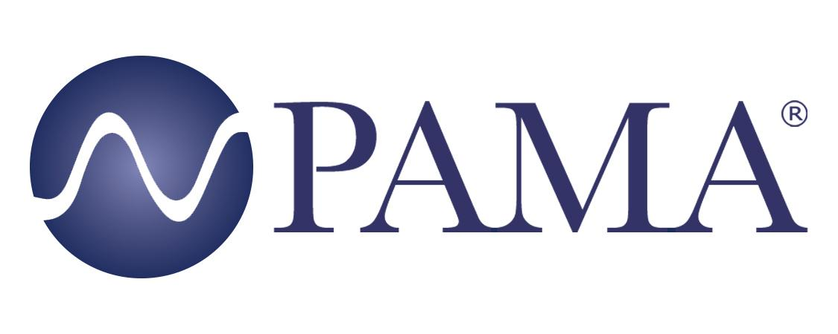

PR Contact:
Robert Clyne
President
Clyne Media, Inc.
T. 615.662.1616
robert@clynemedia.com

PAMA Contact:
Jennifer Shockley, CAE
Executive Director
Professional Audio Manufacturers Alliance
T. 717.614.4271
jennifer@aimanswers.com

For Immediate Release

“Opportunity” Is the Word as PAMA Hosts Industry Career Webinar for Berklee Boston Students

Lemoyne, PA, December 16, 2021 – The Professional Audio Manufacturers Alliance (PAMA) continued its series of student-focused online events with the “Career Opportunities in Pro Audio Manufacturing Companies” session, held for students at the Berklee College of Music, Boston Campus, this fall.

The panels included representatives from five PAMA member companies – Chris Regan, co-founder, CEO and president of RF Venue and the PAMA Board of Directors chair; Kathleen Nieder, senior director, human resources and global talent acquisition with Shure; Cory Schaeffer, Director, alliances and ecosystem at QSC; Kathryn Taub, vertical marketing manager for the corporate and higher education market at Audinate; and Chris Hansen, director of recording and broadcast at Harman – voices with a wide range of experience that reveal a diversity of industry options that students may not have previously considered. As with the previous events in the series, the Berklee panel was coordinated and hosted by Karen Dunn, whose KMD Productions manages high-profile audio industry events.

“If you’re open to creative ways to get into the industry,” shared Regan, “there's a lot to learn and a lot of great people that coach you and help you along in your journey.” A case in point: Schaeffer says she “fell into the industry” through an entry-level job with an audio manufacturer. “It was wonderful. You find people that are just incredibly passionate; you’re constantly learning.” Students were encouraged to embrace opportunity and see where it leads. Schaeffer’s first role was in marketing. “I learned quickly that wasn't really my thing, but it did open up a ton of opportunities for me.”

Similarly, with no audio background, Nieder joined Shure from a manufacturing company in the office products industry. “There was such excitement and passion for the company and what people do. I thought, ‘Well, this would be a great place to work as a recruiter and bring people in; everyone loves it here.’” After 15 years with Shure, she says, “I’ve had a lot of opportunities there to grow my own career.”

Taub, a Berklee film scoring grad, worked for the school post-graduation, where she gained AV experience as manager of all of the studio and classroom equipment for the music production and engineering and electronic production classrooms. “I got a lot of experience designing AV systems,” she says, “working with AV systems and troubleshooting, and that’s how I got into my role at Audinate.”

Also a Berklee graduate, Hansen notes that “there’s a very non-linear path that all of us have traveled in our audio careers.” During his time a Berklee, he recalls, “I needed a job. I started working at Guitar Center.” That led to a promotion within Guitar Center in Los Angeles, which in turn led to his position with Harman, where, he says, “I design products and do product lifecycle management for all the recording products.”

Pandemic-related hiring freezes have relaxed, and several of these companies are actively seeking new talent. “It’s a fantastic time to be looking at positions in the industry, whether they’re internships or they’re entry level because hiring is really a challenge right now.” Get in and be willing to learn and grow is Schaeffer’s advice: “If you have that mindset, then there are tons of opportunities.” Hansen echoes, “There are opportunities along the way that are not boxes you could easily check on a chart.”

“Just say yes to everything,” Regan adds. “Whether you think you can do it or not, just say yes.”

The panelists each shared their personal career path that led to their current executive-level roles with professional audio manufacturers. Students were encouraged to consider various roles in audio industry manufacturing. Insights were offered into the culture, decision-making and career path options, along with how to find job postings and the application and interview process at the panelists’ respective companies.

The series of PAMA student webinars will continue in 2022. The archived webinars may be viewed in the Events section of the PAMA website, along with PAMA membership meeting videos that feature a diverse cross-section of industry experts offering insight into various audio markets.

Upcoming PAMA event listings and an archive of past events can be found at www.pamalliance.org/events.

Learn more about PAMA at www.pamalliance.org.

Photo file 1: PAMA_BERKLEE-BOSTON.png
Photo caption 1: The Berklee Boston Professional Audio Manufacturers Alliance (PAMA) career opportunity webinar panel (clockwise from top left): Karen Dunn, KMD Productions; Chris Regan, RF Venue/PAMA; Kathleen Nieder, Shure; Chris Hansen, Harman International; Cory Schaeffer, QSC; and Kathryn Taub, Audinate

About PAMA:
Founded in 2003, the Professional Audio Manufacturers Alliance (PAMA) is the collective voice and forum for the leading manufacturers of professional audio products and the people who use them. PAMA member companies conduct business worldwide in support of high-quality audio across a wide range of industries – pursuing the state of the art in technology and practice to enable audio professionals to elevate their craft and delight listeners and audiences every day. PAMA’s mission is to promote awareness and appreciation of high-quality professional audio through market leadership, communication and education. Our core customers are pro-audio professionals around the world with an interest in promoting high-quality audio. Learn more at www.pamalliance.org.

