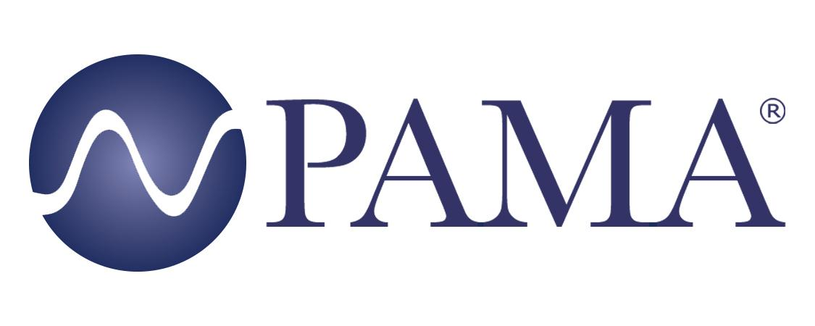

PR Contact:
Robert Clyne
President
Clyne Media, Inc.
T. 615.662.1616
robert@clynemedia.com

PAMA Contact:
Jennifer Shockley, CAE
Executive Director
Professional Audio Manufacturers Alliance
T. 717.614.4271
jennifer@aimanswers.com

For Immediate Release

PAMA Invites Industry to Join August XR Event

Lemoyne, PA, August 16, 2021 – As part of its ongoing commitment to sharing perspectives from knowledgeable and respected industry voices, the Professional Audio Manufacturers Alliance (PAMA) is extending an invitation to the audio community to join its August membership meeting with Tim Messina, Ian Messina and Benjamin Davis from Events United and Studio Lab as the featured guests. The meeting’s presentation will address the potential of eXtended Reality (XR) capabilities for the film and event industries, as well as what it takes to make this new tech possible. The free event will be held online at 2PM EDT, August 20, 2021.

“The concept of virtual production has been around for a while, bringing with it new opportunities and new challenges for many,” shares Ben Davis, Studio Lab’s Director. “Now with the integration of LED video walls, camera tracking and real-time rendering of virtual environments, the technology continues to mature and its future solidify, as studios and production companies worldwide invest in XR space. At Studio Lab and Events United, we’re taking these unique challenges head-on to deliver brand-new experiences for film and live events. This means deep dives into audio, video, lighting, and design to discover what’s already working, and what needs to be improved. Our goal is to take the extremely complex workflow and make the process accessible and easy to use."

Tim Messina is the owner of Events United and Studio Lab, two companies that are pushing the boundaries of what’s possible for film and live events. His vision, drive and willingness to take risks have resulted in worldwide recognition of Events United and Studio Lab for their contributions to virtual events and virtual production. Ian Messina is the Director of Virtual Production at Studio Lab, and in addition to being a skilled storyteller both in front of and behind the camera, he has become among the country’s leading sources on virtual production. As the Director of Studio Lab, Davis oversees all the moving pieces that make Studio Lab a world class facility that drives creativity through community and cutting-edge technology.

In November of 2020, PAMA invited Courtney and Paul Klimson, founders of The Roadie Clinic, to speak during a membership meeting about the creation of their organization and its work supporting the needs of live sound professionals. The moving and inspirational presentation motivated PAMA to extend the guest presenter concept to subsequent meetings that featured a diverse array of industry voices providing compelling industry and business insights.

Subsequent guests included Dr. Chris Kuehl, managing director of the corporate intelligence firm Armada; Chuck Wilson, longtime executive director for NSCA; Michael MacDonald, president of ATK Audiotek; Futuresource Consulting’s James Kirby (market analyst) and Leon Morris (development manager); Michael Ross, vice president, partner marketing, at Sweetwater Sound; and Mike Dias, director of sales for Earthworks Audio, executive director of the In-Ear Monitor International Trade Organization (IEMITO) and PAMA board member.

Video archives of past PAMA membership meetings can be found on the event page of the PAMA website. Also available on the site are videos of PAMA’s student career opportunities series of online sessions.

Free registration is required to attend. Registration is available here and is also linked from the PAMA events page: pamalliance.org/events.

Learn more about PAMA’s advocacy for audio excellence at pamalliance.org

Photo file 1: PAMA_presenters_082021.jpg
Photo caption 1: Tim Messina, Benjamin Davis and Ian Messina from Events United and Studio Lab will discuss the potential of eXtended Reality (XR) capabilities for the film and event industries, and XR’s enabling technologies, during PAMA’s August 20 membership meeting. PAMA has invited audio professionals and students to join the free online event

About PAMA:
Founded in 2003, the Professional Audio Manufacturers Alliance (PAMA) is the collective voice and forum for the leading manufacturers of professional audio products and the people who use them. PAMA member companies conduct business worldwide in support of high-quality audio across a wide range of industries – pursuing the state of the art in technology and practice to enable audio professionals to elevate their craft and delight listeners and audiences every day. PAMA’s mission is to promote awareness and appreciation of high-quality professional audio through market leadership, communication and education. Our core customers are pro-audio professionals around the world with an interest in promoting high-quality audio. Learn more at www.pamalliance.org.

