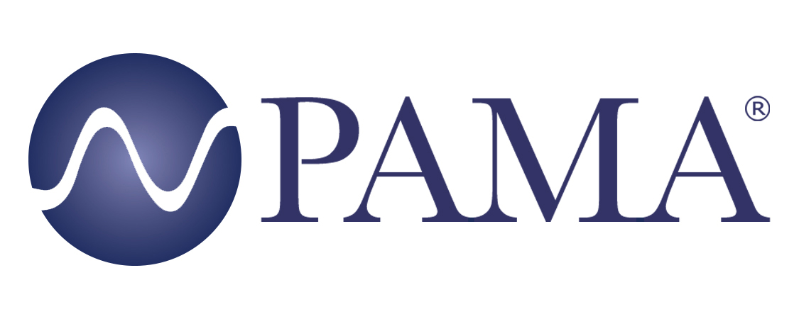

PR Contact:
Robert Clyne
President
Clyne Media, Inc.
T. 615.662.1616
robert@clynemedia.com

PAMA Contact:
Jennifer Shockley, CAE
Executive Director
Professional Audio Manufacturers Alliance
T. 717.614.4271
jennifer@aimanswers.com

For Immediate Release

Professional Audio Manufacturers Alliance (PAMA) Wraps an Eventful 2021

Lemoyne, PA, February 24, 2022 – The Professional Audio Manufacturers Alliance (PAMA) had an eventful 2021, continuing in its mission to promote awareness and appreciation of high-quality professional audio through market leadership, communication and education. Highlights of the year include the following:

PAMA, along with member company Shure, established the Mark Brunner Professional Audio Scholarship, which is offered annually to students worldwide who are pursuing an education in professional audio. Brunner, a long-time Shure executive, PAMA founding member, and leading voice in the audio community, had an unwavering passion for education and mentorship throughout his career. The first two recipients of the scholarship were announced in August: Emma Brooks from Berklee College of Music and Dennis Freeman from Middle Tennessee State University. Individuals and companies interested in supporting the Mark Brunner Professional Audio Scholarship fund may donate via the PAMA website here. PAMA is appreciative of all donations that honor Mark’s legacy and support students pursuing careers in the professional audio industry. More information is available at https://www.pamalliance.org/scholarship.

In June, PAMA released the landmark document “PAMA Recommendations for Neutral Nomenclature in Pro Audio” to address outdated language and terminology issues increasingly identified as discouraging a spirit of inclusivity within the professional audio community. “The intent is for PAMA members to recommend adopting a framework within their organizations for the implementation of unified terminology across the industry, in the spirit of inclusivity and consistency,” explained PAMA Board Chair-Elect and Inclusion Committee member Karam Kaul (Harman). This is a living document that will continue to evolve with ongoing input from the industry at large.

Working closely with KMD Productions principal Karen Dunn, PAMA held three panel discussions specifically for students. These included sessions for Full Sail University and Berklee College of Music’s Valencia Spain campus, and, along with PAMA members from Audinate, Harman, RF Venue, Shure and QSC, a student career opportunity online event was held addressing students from Berklee’s main campus.

Additionally, PAMA maintained a robust itinerary of online events through the year focusing on a wide range of topics and presenters, including Michael Ross, Vice President of Partner Marketing for Sweetwater; Michael MacDonald, President of ATK Audiotek; Futuresource Consulting; PAMA member Mike Dias (In-Ear Monitor International Trade Organization – IEMITO); Tim Messina, Ian Messina and Benjamin Davis from Events United and Studio Lab; Daryl Travis (author of Little Things Big Returns); Patrick Killianey of Audinate; and economist Dr. Chris Kuehl. Each of these online sessions is archived for replay at https://www.pamalliance.org/events.

Throughout 2021, PAMA also lent its voice to professional audio and contracting/installation and house-of-worship technology publications, offering access to member company experts who offered analysis and insights on topics ranging from dealing with the narrowing RF spectrum available for wireless microphone and personal monitors to ongoing pandemic-driven supply chain issues.

“2021 was a great year for PAMA, and we look forward to even more in 2022,” stated Chris Regan, Chair of PAMA’s Board of Directors. “Whether talking shop with fellow manufacturers or sharing insights with the next generation of pro audio professionals, PAMA is an elite forum for ideas, present and future. Thanks to all who have participated in our eventful 2021.”

Learn more about PAMA at pamalliance.org/.

Photo file 1: PAMA_BERKLEE-BOSTON.JPG
Photo caption 1 The Professional Audio Manufacturers Alliance (PAMA) held a host of online events throughout 2021, including three career opportunity webinars for audio students. The Berklee College of Music, Boston campus event in September featured (clockwise from top left): moderator Karen Dunn, KMD Productions; Chris Regan, RF Venue/PAMA; Kathleen Nieder, Shure; Chris Hansen, Harman International; Cory Schaeffer, QSC; and Kathryn Taub, Audinate.

Photo file 2: Chris_Regan.jpg
Photo caption 2: PAMA Board of Directors Chair Chris Regan

Photo file 3: PAMA_Logo.jpg
Photo caption 3: The Professional Audio Manufacturers Alliance (PAMA) had an eventful and event-full 2021, hosting a slate of online informational and educational webinars and presentations for audio professionals and future audio pros.

About PAMA:
Founded in 2003, the Professional Audio Manufacturers Alliance (PAMA) is the collective voice and forum for the leading manufacturers of professional audio products and the people who use them. PAMA member companies conduct business worldwide in support of high-quality audio across a wide range of industries – pursuing the state of the art in technology and practice to enable audio professionals to elevate their craft and delight listeners and audiences every day. PAMA’s mission is to promote awareness and appreciation of high-quality professional audio through market leadership, communication and education. Our core customers are pro-audio professionals around the world with an interest in promoting high-quality audio. Learn more at www.pamalliance.org.

