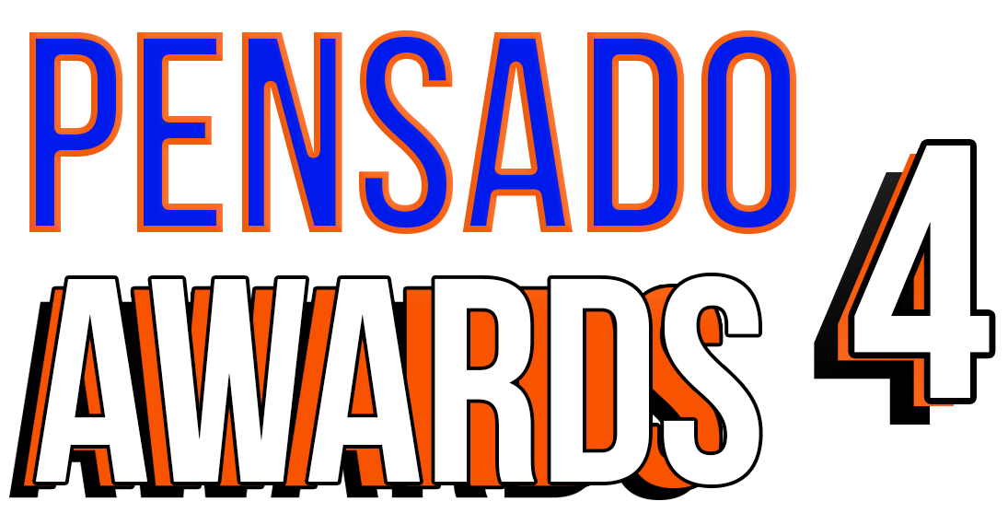

**TIP SHEET FOR SUNDAY, DECEMBER 3, 2017**
Industry Gears Up for Fourth Annual Pensado Awards, on Sunday, December 3, 2017

Some of the recording industry’s most iconic figures gather to “recognize the faces behind the sound”

WHO:
The team behind Pensado’s Place, the acclaimed weekly web series known as the most influential show for audio engineers, mixers and producers, and its co-hosts Herb Trawick and Dave Pensado (Beyoncé, Christina Aguilera, Kelly Clarkson, Mariah Carey, Elton John, Michael Jackson and more), holds the fourth annual Pensado Awards, co-hosted by drummer Samantha Maloney (Hole, Mötley Crüe, Peaches), legendary producer, engineer and mixer Chris Lord-Alge (Pink, Foo Fighters, Avril Lavigne, Green Day) and Kosine of acclaimed production duo Da Internz (Ludacris, Nicki Minaj, John Legend). Hip-hop production collective 1500 or Nothin' serves as the Premier Sponsor, alongside Additional main sponsors The Blackbird Academy, NAMM, Avid, Westlake Pro, Roland, Recording Academy® Producers & Engineers Wing®, Audio-Technica, AFM & SAG-AFTRA, iZotope, The Fab Factory, accusonus, FabFilter, BeatSkillz, Celemony, Tascam, Groove3, IK Multimedia, Indaba Music, LANDR, Heavyocity Media, International Music Software Trade Association (IMSTA) and Music Connection Magazine.

WHAT:
Dubbed by insiders as the must-attend audio event of the year, the Pensado Awards were founded as a means of acknowledging talented music producers, engineers, mixers and their work, serving as a grand opportunity for the best pros, amateurs, brands and press to come together as one community to celebrate the uncelebrated.

Presenters are slated to include 2018 GRAMMY® nominees 1500 or Nothin'; engineer/mixer DJ Swivel (The Chainsmokers, others) and producer/engineer Noah Passovoy (Maroon 5); multi-platinum producer/composer Busbee and Hamilton soundtrack engineer Eboni Smith; music industry legend Miles Copeland; Harry Shearer (of This Is Spinal Tap, The Simpsons and much more) and CJ Vanston (producer, film composer, keyboardist); mastering engineers Eric Boulanger (La La Land, Green Day, Diana Krall) and Jonathan Wyner; Lindsay Rothschild from YouTube and Matt Terrell from Facebook; and more.

WHERE:
Los Angeles’ historic Fonda Theatre, 6126 Hollywood Boulevard, Los Angeles, California 90028

WHEN:
Sunday, December 3, 2017. Doors will open at 6:30 p.m. PST.

Media interested in attending please contact:
Robert Clyne / Clyne Media / 615-300-4666 / Robert@clynemedia.com / www.clynemedia.com/
Lisa Roy / Rock & Roy / 310-463-1563 / lisaroyaudio@mac.com

