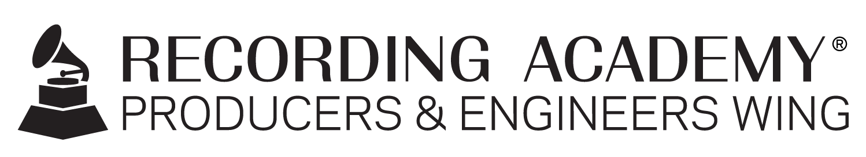

Recording Academy® Producers & Engineers Wing® shares File Management Best Practices FOR MixCon 2022

"Producer Panel: Take Your Workflow to the Next Level! Best practices in music File Management"

Santa Monica, Calif. (nov. 17, 2022) — The Recording Academy® Producers & Engineers Wing® presented "Producer Panel: Take Your Workflow to the Next Level! Best Practices for File Management" on Oct. 11 as part of MixCon 2022. The conversation featured insights from producer/educators Jeff Balding (Dan + Shay, Morgan Wallen, Bailey Zimmerman), Matt Hennessy (Beyoncé, DMX, PJ Morton), George Massenburg (Earth, Wind & Fire, Natasha Bedingfield, The Chicks; Associate Professor of Sound Recording and Director of Video Production at McGill University), Leslie Richter (Ben Folds, George Strait, Kacey Musgraves; Instructor of Audio Engineering at Belmont University), and Paul "Willie Green" Womack (Wiz Khalifa, The Alchemist, The Roots; Vice Chair of New York AES section).

Without smart file management, it doesn’t matter how amazing your mixes are – they'll never make it to the outside world. Attendees gained expertise on how to avoid client emergencies and major headaches. Proper file management, with smart backup and consistent naming conventions, future-proofs sessions and adds up to a smoothly running studio. The time spent getting organized clears up more time to spend being creative.

David Weiss of Sonic Scoop introduced the panelists along with moderator Maureen Droney (Vice President, Producers & Engineers Wing). Droney shared the central concept of the panel: the "Nitty gritty of music recording. How do you manage all of the parts and pieces of a project, from recording to mixing and mastering, and end up with all of the correct versions, edits, mixes, metadata, and other information organized in a way that makes for a professionally delivered project?"

The panelists shared their daily workflow, outlining hints for maintenance of file directories, utilizing naming conventions and successful backups of all materials. Although each panelist had differences in the details of their workflow, all four were unified in stressing the importance of clear, consistent file management and backup.

Balding noted that knowledge comes from experience, which includes making mistakes. "This is a collection of wisdom that can help people avoid making the mistakes I've made." Massenburg agreed: "New don't understand the importance of backups until they lose a session. And then, it really comes home to you." Later, Hennessy cited a quote he remembered from Massenburg: "I remember hearing George say, 'If it's only in one place, it’s already lost. If it's in two places, you're renting it. But if it's in three places, you've got it covered.'" The session is archived and available for viewing at https://youtu.be/FCt7nhWueEQ.

Photo file 1: PE_MixCon2022.JPG
Photo caption 1: "Producer Panel: Take Your Workflow to the Next Level! Best Practices for File Management" was presented on Oct. 11 as part of MixCon 2022. Photo courtesy of the Recording Academy. © 2022

about the recording academy
The Recording Academy represents the voices of performers, songwriters, producers, engineers, and all music professionals. Dedicated to ensuring the recording arts remain a thriving part of our shared cultural heritage, the Academy honors music's history while investing in its future through the GRAMMY Museum®, advocates on behalf of music creators, supports music people in times of need through MusiCares®, and celebrates artistic excellence through the GRAMMY Awards® — music's only peer-recognized accolade and highest achievement. As the world's leading society of music professionals, we work year-round to foster a more inspiring world for creators.

For more information about the Academy and its Producers & Engineers Wing, please visit www.recordingacademy.com or @ProdEngWing on Instagram. For breaking news and exclusive content, follow @RecordingAcad on Twitter, "like" Recording Academy on Facebook, and join the Recording Academy's social communities on Instagram, YouTube, TikTok, and LinkedIn.

# # #

contacts

Christina Dudash
Recording Academy
T. 310.392.3777
christina.dudash@recordingacademy.com

Robert Clyne
Clyne Media, Inc.
T. 615.662.1616
robert@clynemedia.com

