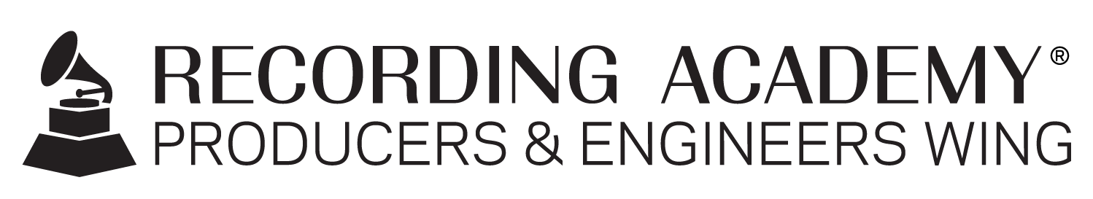

Recording Academy® Producers & Engineers Wing® announces 2023–2024 Steering Committee

Santa Monica, Calif. (DEC. 1, 2023) — The Recording Academy® Producers & Engineers Wing® has announced its 2023–2024 Steering Committee. The Committee consists of a diverse array of music engineers, producers and studio professionals who, building upon the significant legacy established by prior Steering Committees, work to address key issues confronting music production and to promote meaningful technical solutions that help move the music industry forward.

The 2023–2024 Steering Committee is co-chaired by renowned producer/engineers Chuck Ainlay (George Strait, Lyle Lovett, Miranda Lambert, and winner of multiple GRAMMY Awards®, 10 ACMs and two CMAs), and Ebonie Smith (Hamilton Original Cast Recording, Janelle Monáe, Cardi B, Charlie Puth, Ms. Lauryn Hill, the Roots). Smith is also a member of the Recording Academy New York Chapter Board and the founder and president of Gender Amplified Inc., a nonprofit organization providing a platform for the promotion and advancement of women in music production and to identify and motivate the next generation of women music producers. Ainlay is returning as co-chair from last year's committee, while Smith has previously served as a member of the Steering Committee and represented the P&E Wing at numerous industry events. The Committee also includes the following music industry professionals from across the United States: Marcella Araica, Jimmy Douglass, Lynne Earls, Anna Frick, Steve Genewick, Matt Hennessy, Leslie Ann Jones, and Jonathan Yip. Ex officio members include Recording Academy Board Chair Tammy Hurt and Recording Academy CEO Harvey Mason jr.

Ongoing P&E Wing initiatives, spearheaded by the Steering Committee, include promoting, safeguarding and advocating for the rights of creative music professionals in the areas of intellectual property, crediting, revenue streams, and freedom of expression; raising the profile and increasing the understanding of the value of producers and engineers as artistic co-creators in the art and craft of recording; promoting integrity in audio; promoting industry guidelines and best practices regarding proper labeling, archiving, preservation, and storage of master media; supporting music and recording education programs; presenting professional development events and seminars; promoting hearing health and educating about the dangers of volume-induced hearing loss; and promoting communication and relationships between audio professionals, companies, organizations, and educators to foster community and consensus on critical industry-related issues.

Maureen Droney, Vice President, Recording Academy Producers & Engineers Wing, stated, "The 2023–2024 Steering Committee is full of talent and drive and will offer their masterful hand in guiding the direction of the P&E Wing through the next calendar year, while building off the progress made in our ongoing initiatives over the last several years. These individuals are very involved in the day-to-day business of recording, and they are therefore highly capable of speaking and advocating for the audio community with diverse perspectives and insight. As we set the year's agenda, priorities of note include political advocacy in Washington, D.C., California and other states with regards to recording industry issues; ongoing efforts in furthering the ability of streaming services to offer full credits for music consumers' reference; several audio education initiatives; and much more."

Photo file 1: ChuckAinlay.JPG
Photo caption 1: Chuck Ainlay, 2023-2024 Recording Academy® Producers & Engineers Wing® Steering Committee co-chair

Photo file 2: EbonieSmith.JPG
Photo caption 2: Ebonie Smith, 2023-2024 Recording Academy® Producers & Engineers Wing® Steering Committee co-chair

about the recording academy
The Recording Academy represents the voices of performers, songwriters, producers, engineers, and all music professionals. Dedicated to ensuring the recording arts remain a thriving part of our shared cultural heritage, the Academy honors music's history while investing in its future through the GRAMMY Museum®, advocates on behalf of music creators, supports music people in times of need through MusiCares®, and celebrates artistic excellence through the GRAMMY Awards — music's only peer-recognized accolade and highest achievement. As the world's leading society of music professionals, we work year-round to foster a more inspiring world for creators.

For more information about the Recording Academy and its Producers & Engineers Wing, please visit grammy.com and recordingacademy.com or @ProdEngWing on Instagram. For breaking news and exclusive content, follow @RecordingAcad on X, "like" Recording Academy on Facebook, and join the Recording Academy's social communities on Instagram, YouTube, TikTok, and LinkedIn. For media assets, please visit recordingacademy.com/press-room/press-kits.

# # #

contacts

Britta Purcell
Recording Academy
britta.purcell@recordingacademy.com

Robert Clyne
Clyne Media, Inc.
T. 615.662.1616
robert@clynemedia.com

