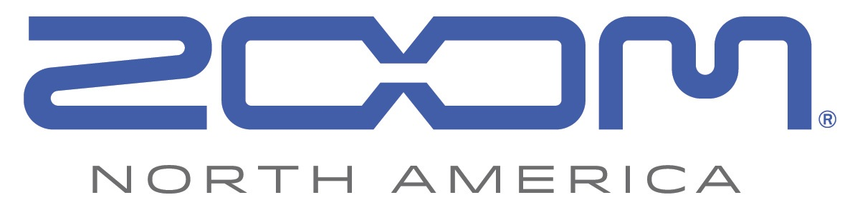
PRESS RELEASE: PARTNERSHIP ANNOUNCEMENT

Zoom Announces New Partnership with Sennheiser

Zoom F8/F4 MultiTrack Field Recorders and Sennheiser AMBEO® VR Microphone Let Creators Record 360-Degree Audio for Video

September 15, 2017 — Zoom Corporation, Japan, is proud to announce a new collaboration with Sennheiser. Both pioneers in audio, Zoom and Sennheiser are pairing up to offer the complete VR production experience within the framework of Sennheiser’s AMBEO® for VR partnership program. With Zoom’s F8 and F4 MultiTrack Field Recorders and Sennheiser’s AMBEO VR Mic, virtual reality professionals and enthusiasts can record high-quality 360-degree audio for video.

The Zoom F8 and F4 offer gain-linking capability, allowing creators to adjust the gain on all four capsules of the Sennheiser AMBEO VR Mic evenly and simultaneously with one knob. This makes monitoring and adjusting audio levels more accessible when recording in the field.

“We are delighted that Zoom has joined the AMBEO for VR partnership program,” said Véronique Larcher, co-director for AMBEO at Sennheiser. “By embedding the AMBEO VR Mic’s A-B converter in the Zoom F8, VR content creators are able to rely on a convenient and easy-to-use combo for VR productions.”

To further streamline workflow with the F8 and F4, Zoom is developing new AMBEO-ready firmware with A-B decoding for properly monitoring signal from the AMBEO mic.

“At Zoom we always take into high consideration new technology for audio recording,” commented Masa Iijima, Zoom Corporation CEO. “VR audio has just started, and we are happy to partner with Sennheiser AMBEO to provide such an innovative VR recording solution to professionals and creators with our F8 and F4 field recorders.”

The firmware updates will be available in late September for F8 and in December 2017 for F4.

Zoom and Sennheiser will be showcasing the F8/F4 and AMBEO VR Mic combination at IBC 2017 in Amsterdam. For more information including specs and images, visit https://zoom-na.com or contact Zoom North America at info@zoom-na.com.

Photo file: Zoom-F8_and_Sennheiser-Ambeo.JPG
Photo caption: The Zoom F8 MultiTrack Field Recorder with the Sennheiser AMBEO® VR Microphone

Image Assets via Dropbox:
https://www.dropbox.com/sh/lhgaa6ojm1djy80/AAAgC_akyQssfmBMhbcBPI7Ba?dl=0

About Zoom North America:
Zoom North America is the U.S. affiliate for products manufactured by the Zoom Corporation (Japan).
The company prides itself on offering its customers the very highest level of service and support.
info@zoom-na.com | Tel: 631-542-5270 | Fax: 631-542-5299

Press Contacts:
Clyne Media, Inc.
Robert Clyne
615-662-1616
Email: robert@clynemedia.com

Frank Doris
631-645-5668
Email: frank@clynemedia.com

