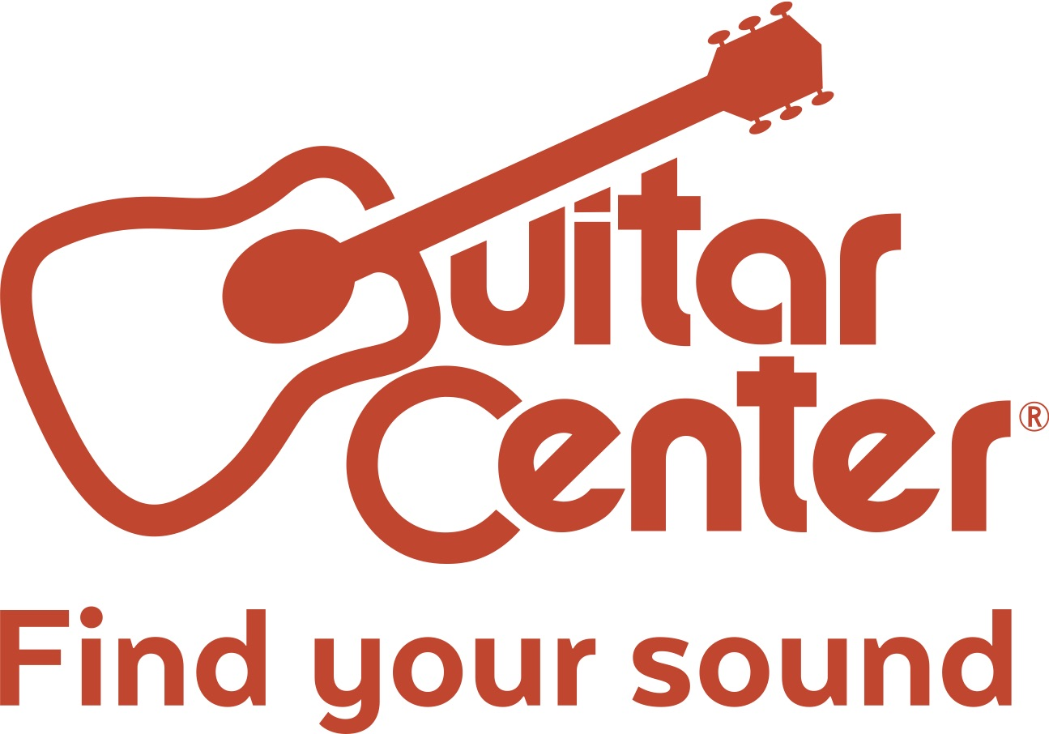

Guitar Center Acquires Audio Visual Design Group (AVDG) as Part of Its Business Solutions Group

Guitar Center’s acquisition of AVDG greatly expands the scope of the retailer’s business-to-business (B2B) capabilities and marks the beginning of a planned aggressive expansion of Guitar Center’s Business Solutions Group

Westlake Village, CA (December 22, 2017) – Guitar Center, the world’s largest instrument retailer, announces the acquisition of the San Francisco Bay Area-based Audio Visual Design Group (AVDG). AVDG will serve as a key element of Guitar Center’s Business Solutions Group and expansion into integrated solutions.

The announcement was made today by Doug Carnell, Guitar Center Vice President of Business Solutions and further underscores Guitar Center’s strategic business plan to expand and position itself for ongoing growth in the coming years. AVDG has distinguished itself in the industry by offering system design and installation in both corporate and residential market sectors, providing Guitar Center an important channel to serve these markets as it continues its outreach into the world of B2B solutions. AVDG will operate as a dedicated arm of the Business Solutions Group, expanding the scope of personalized, account-based services offered by the division.

According to Carnell, “Guitar Center has been seeking opportunities to bolster our Business Solutions Group and we have found an ideal partner in AVDG. This mutually beneficial relationship will provide AVDG’s team the vast resources offered by Guitar Center, while opening up Guitar Center’s Business Solutions Group to opportunities in the commercial and residential market sectors.”

Robert Scharffer, AVDG’s CEO, states, “We are excited to join the Guitar Center organization as part of the Business Solutions Group. We believe that AVDG offers all of our clients more than just AV integrated solutions; we have become their trusted advisor and business partner. Just as Guitar Center is not your typical musical instrument retailer, AVDG is not just another integrator, and as such we want to continue and grow what we have built. Guitar Center will give us access to additional financial and operational resources, offering new avenues of growth and new opportunities to better support our clients.”

Founded in 1996, and with home base locations in both San Rafael and San Jose, California, AVDG is a leading design-build firm specializing in audio-visual systems for commercial and residential spaces worldwide. AVDG has a world-class technical staff considered to be among the best in the industry, uniquely qualified to deliver sophisticated systems that are elegant yet simple to use. The firm has made it its mission to design and install systems tailored to its clients and to provide unparalleled ongoing services and support of these systems. Over 80 people make up AVDG’s staff, which includes programmers, installers, design engineers and technicians from such diverse sectors as gaming, high-tech, financial, legal, health care, education and hospitality. In 2014, AVDG was acknowledged as one of the fastest-growing private companies in the San Francisco Bay Area.

“The business-to-business channel has always been an important sector for our company, and now, with the changes in the marketplace, we’ve decided to apply additional resources to expand our presence to service clientele who are looking for system design and installation of audio, video and lighting solutions and beyond,” said Ron Japinga, President and CEO of Guitar Center. “With this in mind, we are excited to have AVDG join the Guitar Center family and will be looking for other opportunities to grow our brands in the future. This is a natural growth path for our company, because we are unique in being able to leverage our experience in these different product sectors to offer turnkey solutions to our clients.”

About Guitar Center:
Guitar Center is the world’s largest retailer of guitars, amplifiers, drums, keyboards, recording, live sound, DJ and lighting equipment. With more than 280 stores across the U.S. and one of the top direct sales websites in the industry, Guitar Center has helped people make music for more than 50 years. Guitar Center also provides customers with various musician based services, including Guitar Center Lessons, where musicians of all ages and skill levels can learn to play a variety of instruments in many music genres; GC Repairs, an on-site maintenance and repairs service; and GC Rentals, a program offering easy rentals of instruments and other sound reinforcement gear. Additionally, Guitar Center’s sister brands include Music & Arts, which operates more than 150 stores specializing in band & orchestral instruments for sale and rental, serving teachers, band directors, college professors and students, and Musician’s Friend, a leading direct marketer of musical instruments in the United States. With an unrivalled in-store experience, an industry-leading online presence and passionate commitment to making gear easy-to-buy, Guitar Center is all about enabling musicians and non-musicians alike to experience the almost indescribable joy that comes from playing an instrument. For more information about Guitar Center, please visit www.guitarcenter.com.

FOR MORE INFORMATION PLEASE CONTACT:
Robert Clyne | Clyne Media, Inc. | 615.662.1616 | Robert@clynemedia.com
Marisa Bettencourt | Praytell Agency | 925.817.0596 | GCPR@praytellagency.com
Robert Scharffer | AVDG | 1.877.554.2834 | info@avdg.com
Syvetril Perryman | Guitar Center | 818.735.8800 | media@guitarcenter.com

