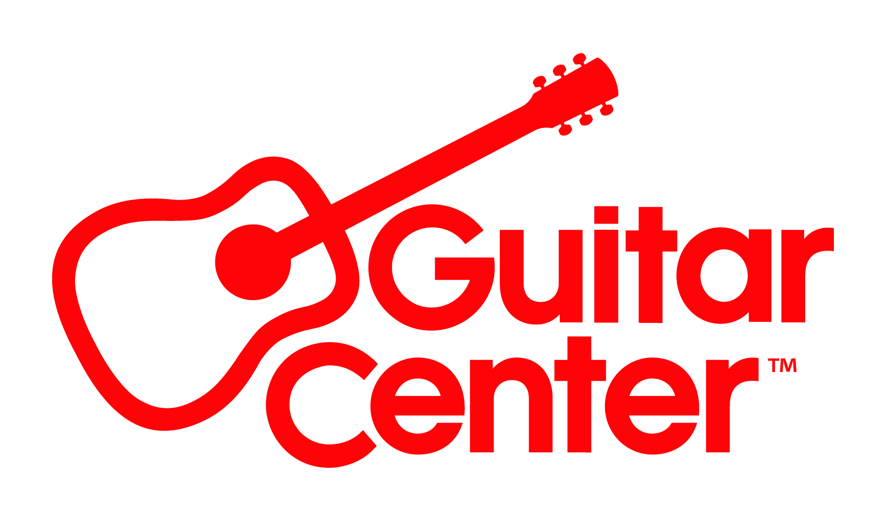
Guitar Center Hires Clinton Wu Vice President of CRM and Customer Data Strategy

New hire positions Guitar Center for continued growth and deeper understanding of its growing customer base

Westlake Village, CA (May 16, 2022) – Guitar Center, the world’s largest musical instrument retailer, announces the appointment of Clinton Wu as the company’s first Vice President of CRM and Customer Data Strategy. Wu will report directly to Jeannine D’Addario, SVP, Chief Marketing & Communications Officer.

Wu joins the Guitar Center company with more than 15 years of experience delivering innovative customer experiences by leading marketing strategies that drive engagement, build loyalty and bring results. He most recently served as Vice President, Head of Digital Business Channels, at Jollibee Foods Corporation, where he grew revenue for all digital business channels by championing a frictionless, end-to-end Customer experience across all touchpoints. He has also served in senior leadership roles for digital marketing at Mattel, Bandai Namco Games, and Activision Blizzard.

At Guitar Center, Wu will deepen the overall direct engagement with Guitar Center’s customer base by overseeing customer data and strategies. He will also work across the organization to create and implement direct marketing strategies. His aim is to expand the company’s capabilities and leverage data to give the organization a complete 360-degree view of its customers and to work to provide an enhanced customer experience with Guitar Center brands.

“Guitar Center continues to enhance and grow its marketing capabilities by seeking out top talent, and Clinton Wu is among the best,” said Jeannine D’Addario, SVP, Chief Marketing & Communications Officer at Guitar Center. “His experience with a diverse range of brands and his deep CRM knowledge make him uniquely positioned to contribute to our long-term growth strategies and complements our talented in-house marketing team. We look forward to working with him to continue our goal of providing Guitar Center customers with best-in-class marketing.”

For more information, visit GuitarCenter.com or Guitar Center on Facebook, Twitter, Instagram and YouTube.

###

Photo file: ClintonWu.JPG
Photo caption: Clinton Wu, Guitar Center Vice President of CRM and Customer Data Strategy

About Guitar Center:
Guitar Center is a leading retailer of musical instruments, lessons, repairs and rentals in the U.S. With nearly 300 stores across the U.S. and one of the top direct sales websites in the industry, Guitar Center has helped people make music for more than 50 years. Guitar Center also provides customers with various musician-based services, including Guitar Center Lessons, where musicians of all ages and skill levels can learn to play a variety of instruments in many music genres; GC Repairs, an on-site maintenance and repairs service; and GC Rentals, a program offering easy rentals of instruments and other sound reinforcement gear. Additionally, Guitar Center’s sister brands include Music & Arts, which operates more than 200 stores specializing in band & orchestral instruments for sale and rental, serving teachers, band directors, college professors and students, and Musician’s Friend, a leading direct marketer of musical instruments in the United States. For more information about Guitar Center, please visit www.guitarcenter.com.

FOR MORE INFORMATION PLEASE CONTACT:
Clyne Media | pr@clynemedia.com
Guitar Center | media@guitarcenter.com
Edelman | GuitarCenter@edelman.com

