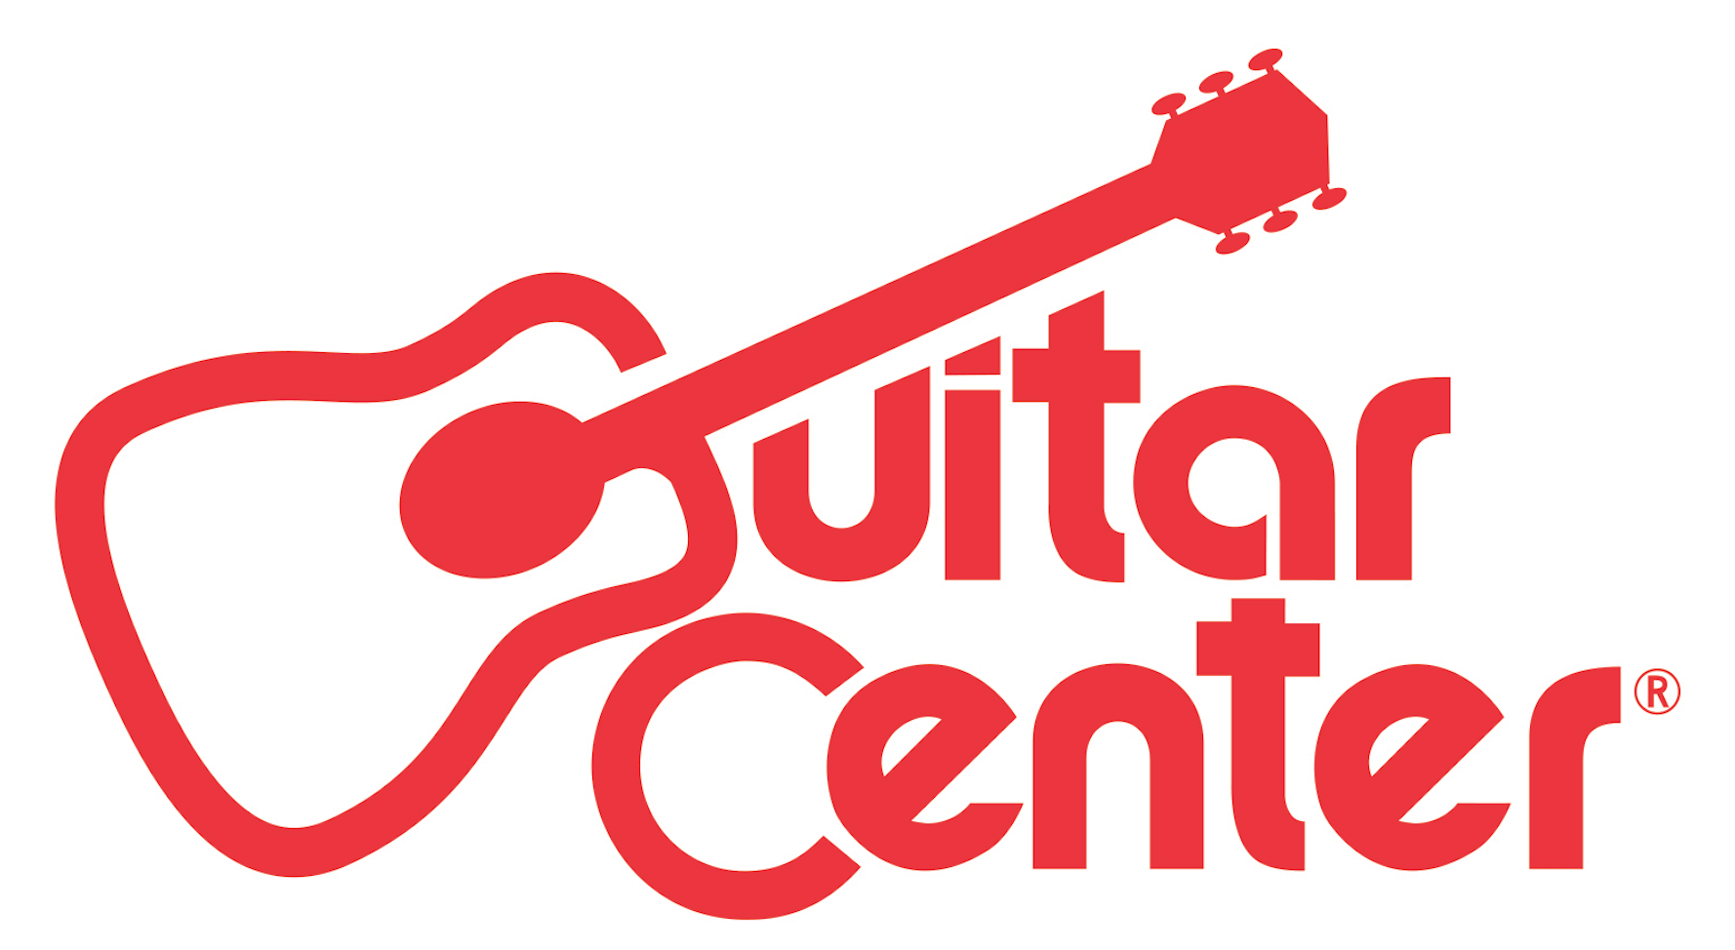

FOR IMMEDIATE RELEASE

Zedd Names Scout as Winner of Guitar Center’s Cover Me, and Announces That Scout’s Winning “I Want You to Know” Remix Will Be Released on September 4 via Interscope Records

ANNOUNCEMENT HIGHLIGHTS:
- The Seattle native caught Zedd’s attention out of nearly 13,000 submissions
- As the winner, Scout receives studio time, mentoring sessions, features with Insomniac and DJ Magazine, new gear, $10,000 cash and more

Los Angeles, CA (September 2, 2015): Multi-platinum GRAMMY® Award-winning artist Zedd announces Tyler Acord, aka Scout, as the winner of Guitar Center’s Cover Me program. Scout, a DJ and producer from Seattle whose remix of Zedd’s hit single “I Want You To Know,” ft. Selena Gomez, stood out from the nearly 13,000 other submissions, will take home a career-altering prize package including studio time, a meeting with Interscope Records, a mentoring session with Blood Company management, a VIP experience at Nocturnal Wonderland Festival, features with Insomniac and DJ Mag USA, new gear and $10,000 cash.

“I was blown away when I heard the Scout remix! It's super musical, sonically really interesting, very unique and has everything I'm looking for when I'm looking for a remix to sign! BIG fan of it,” says Zedd. “In fact, the track impressed me so much that I brought it to my label, and I’m excited to announce that it’s going to be released on Interscope!”

Listen to Scout’s winning submission here: guitarcenter.com/zedd.

Scout’s musical journey began at 13 years old when he started playing turntables, with dreams of one day being a DMC battle champion. It wasn’t until his dad brought him home Sony Acid software that he began making beats, leading him to fall in love with music and pursue studies in theory and songwriting at both Tacoma School of the Arts and Cornish in Seattle. After his studies, Scout moved to Los Angeles, where an internship at Atlantic Records led to a full-time job as an engineer, where he learned the tricks of the trade and was able to work for some of the best writers and producers in the world. With two years of experience behind the board, Scout formed a band called Issues, which offered him the opportunity to tour and play shows around the world. He has since stopped touring with the band in order to fully focus on his true passion: production.

Guitar Center’s Cover Me ft. Zedd Winner Will Receive:
- Studio time with Zedd in Los Angeles, CA
- A mentoring session with Blood Company artist management
- A meeting with Interscope Records
- Features with Insomniac and DJ Mag USA
- A VIP experience at this year’s 20th anniversary Nocturnal Wonderland Festival
- New musical gear and equipment from 8DM, GoPro, Native Instruments, Pioneer, Roland, and QSC
- $10,000 cash

“Guitar Center is committed to supporting musicians, no matter the genre, and we couldn’t be happier to have partnered with Zedd on this EDM program, as he has such a respected presence in the electronic music space. The level of talent that this program drew in was astonishing, and we can’t wait to hear the music production from Scout’s studio collaboration with Zedd.” - Jake Cheung, Manager, Music Marketing and Artist Relations, Guitar Center

About Zedd
Multi-platinum, GRAMMY® award-winning artist Zedd has announced new tour dates on his upcoming True Colors Tour, unleashed by T-Mobile, which kicks off September 6th in Seattle and criss-crosses North America through October 31st. In addition to the noteworthy shows already announced which include stops at the Staples Center in Los Angeles and Madison Square Garden in New York City, Zedd has also added huge dates at UIC Pavillion in Chicago, The Armory in Washington, DC and the Ricoh Coliseum in Toronto, ON. Zedd will be joined by support acts Dillon Francis and Madeon who split direct support duties for the majority of the dates, with Alex Metric opening all shows. What So Not, Alvin Risk, AlunaGeorge and A Trak have been added as special guests throughout the tour. The True Colors Tour features a totally new and re-designed show that has been creatively directed by Zedd and incepted hand-in-hand with the True Colors album. It features 90 minutes of 4K visuals created by renowned visual artist Beeple and is a multi-sensory journey through Zedd's musical and visual mind, told through music, lighting, visuals, and special effects. True Colors was released by Interscope Records on May 19th and debuted at No. 4 on the Billboard Top 200 Albums chart. Zedd executive-produced the album and co-wrote all the songs. True Colors is the follow-up to Zedd’s 2012 debut album Clarity, which spawned five singles, including the Grammy-winning title track, and cemented Zedd as a global star. True Colors’ first single, “I Want You To Know,” featuring Selena Gomez, spent four weeks at No. 1 on Billboard’s Hot Dance/Electronic Songs chart. Zedd’s latest single “Beautiful Now,” featuring Jon Bellion is climbing the chart Top 40 radio hitting #13 this week as well. Born Anton Zaslavski, Zedd has distinguished himself by drawing from his diverse musical training and a background spanning classical to post-hardcore/metal to electro house. He creates detailed, carefully produced compositions that also appeal to audiences outside of the EDM world. After signing with Interscope Records in 2012, Zedd released Clarity to much critical acclaim. The title track climbed to No. 2 at Top 40 radio, went Top 10 on the Billboard Hot 100, and won a 2014 GRAMMY Award for Best Dance Recording. The video has racked up more than 142 million Vevo views, while his platinum follow-up hit “Stay The Night” (ft. Hayley Williams of Paramore) has over 118 million Vevo views and won the 2014 MTV Clubland Video Music Award. Zedd first made waves with a series of remixes of tracks by Skrillex, The Black Eyed Peas, Fatboy Slim, and Lady Gaga. He has headlined at numerous festivals including Coachella, Outside Lands, Bonnaroo, Ultra, Electric Daisy Carnival, Nocturnal, Tomorrowland, Lollapalooza, Electric Zoo, and many more.

About Guitar Center:
Guitar Center is the world’s largest retailer of guitars, amplifiers, drums, keyboards, recording, live sound, DJ, and lighting equipment. With more than 260 stores across the U.S. and one of the top direct sales websites in the industry, Guitar Center has helped people make music for more than 50 years. In addition, Guitar Center’s sister brands includes Music & Arts, which operates more than 120 stores specializing in band & orchestral instruments for sale and rental, serving teachers, band directors, college professors and students, and Musician’s Friend, a leading direct marketer of musical instruments in the United States. With an unrivaled in-store experience, an industry-leading online presence and passionate commitment to making gear easy-to-buy, Guitar Center is all about enabling musicians and non-musicians alike to experience the almost indescribable joy that comes from playing an instrument. For more information about Guitar Center, please visit www.guitarcenter.com.

You can visit our press room at http://www.guitarcenter.com/pages/press-room and send media inquiries to media@guitarcenter.com.

FOR MORE INFORMATION PLEASE CONTACT:
Robert Clyne | Clyne Media, Inc. | 615-662-1616 | robert@clynemedia.com
Sarah Chavey | ANTHEMIC Agency | 323.464.4745 x 806 | sarah@anthemicagency.com
Syvetril Perryman | Guitar Center | 818.735.8800 x 2979 | media@guitarcenter.com

