**Eric Clapton Announces**

**2019 Crossroads Guitar Festival**

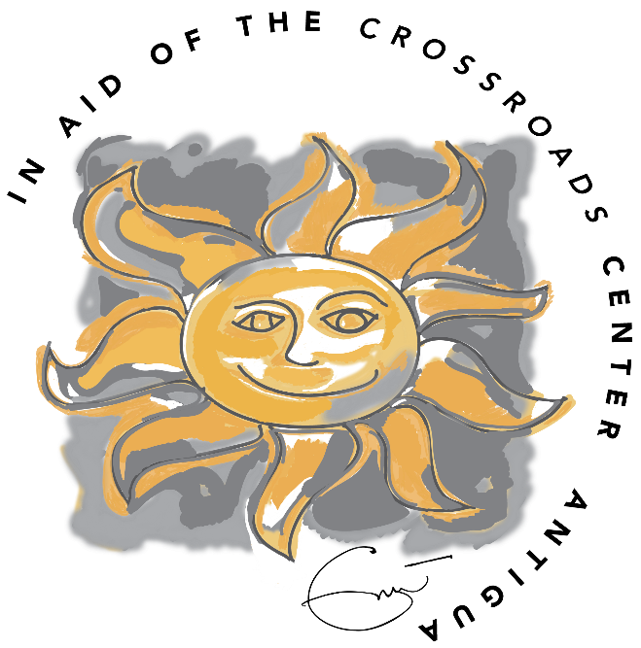

**THE WORLD’S GREATEST GUITAR LEGENDS PERFORMING OVER TWO NIGHTS**

**IN THE CITY THAT HOSTED CLAPTON’S FIRST CROSSROADS GUITAR FESTIVAL**

**DALLAS, TX -- AMERICAN AIRLINES CENTER -- SEPTEMBER 20-21**

**Two-Night Festival to Feature Legendary Music and Collaborations**

*(March 28, 2019)* – Widely considered one of the world’s all-time greatest guitarists and known amongst his peers as a great collaborator, Eric Clapton announced today the fifth installment of the Crossroads Guitar Festival. The Festival, which has become legendary in its own right for hosting performances and impromptu collaborations from the world’s most legendary guitar players, will take place September 20-21 in the city that hosted the first-ever Crossroads Guitar Festival, Dallas Texas. See full listing below of artists performing.

Clapton will gather the past, present and future of guitar music onto one stage for an unparalleled musical event. All profits from the Festival will benefit The Crossroads Centre in Antigua, a treatment and education facility founded by Clapton for chemically dependent persons.

Since its inception, Clapton’s vision for the Crossroads Guitar Festival has been to create an event where his friends and contemporaries can have fun and perform together for the benefit of a good cause. This year’s Festival will feature two-nights of musical performances with once-in-a-lifetime guitar collaborations. Known as pioneers in their field, the roster of artists spans old and new. The audience can expect unrivaled entertainment, brilliant guitar work, surprise guests and impromptu jams that are the hallmark of these performers.

The first Crossroads Guitar Festival, in June 2004 at the Cotton Bowl in Dallas, was an unprecedented collection of guitar icons from blues, rock and contemporary music. The sold-out show was chronicled in a 2-disc DVD that has since gone on to become one of the world’s top-selling music DVD’s. The Crossroads Guitar Festival 2007 and 2010 were the second and third such concerts by Clapton and were staged at Toyota Park in Chicago. Both Festivals were filmed for DVDs and met similar acclaim and achieved multi-platinum status. The fourth Crossroads Guitar Festival in 2013 brought the world’s best guitar players to the world’s most famous arena, Madison Square Garden in New York and met with huge critical acclaim.

In addition to the concerts, the Guitar Center Festival Village will be featured on Victory Plaza adjacent to the arena. Some of the world’s best guitar and gear manufacturers, including Ernie Ball, Fender, Gibson, Martin, PRS, and more, will host interactive exhibits where guitar enthusiasts can plug in and play new products and classic favorites. In addition, Guitar Center Festival Village Stage Presented by Ernie Ball will host master guitar clinics and solo performances by main stage artists, next generation guitar virtuosos, and special surprise guests. The Guitar Center Festival Village will be open from 12pm to 8pm each day and is free to all ticket holders.

**Tickets for the Crossroads Guitar Festival may be purchased as follows: Citi® cardmembers will have first access to purchase presale tickets beginning Tuesday, April 2 at 10am CT through Wednesday, April 3 at 10pm CT. Presale tickets will be available through Citi EntertainmentSM. For complete details, please visit** [**www.citientertainment.com**](http://www.citientertainment.com)**. General Public On-Sale will begin Friday, April 5th at 10am CT via** [**www.ticketmaster.com**](http://www.ticketmaster.com)

**For more info:** [**www.ericclapton.com**](http://www.ericclapton.com) **or** [**www.crossroadsguitarfestival.com**](http://www.crossroadsguitarfestival.com)**.** Donations to the Centre can be made via the donation button on the website.

**CURRENT CROSSROADS FESTIVAL ARTIST LISTING**

***(Note: Two Different Nights of Music. Not All Artists Will Perform Both Nights but Eric Clapton Will Perform Both Nights.)***

Alan Darby

Albert Lee  
Andy Fairweather Low

Billy Gibbons

Bonnie Raitt

Bradley Walker

Buddy Guy Band  
Daniel Santiago

Derek Trucks

Doyle Bramhall II  
Eric Clapton  
Gary Clark Jr.

Gustavo Santaolalla

James Bay  
Jeff Beck

Jerry Douglas  
Jimmie Vaughan

Joe Walsh  
Jonny Lang

Keb Mo

Kurt Rosenwinkel

Los Lobos

Pedro Martins

Peter Frampton

Robert Cray  
Robert Randolph  
Sheryl Crow

Sonny Landreth

Susan Tedeschi

Tom Misch

Vince Gill

**The Crossroads Centre, Antigua**  
Founded in 1998, Crossroads Centre, Antigua was created to provide treatment and education to chemically and alcohol dependent persons, their families and their significant others. Treatment is provided through residential care, family and aftercare programs. The pathway to recovery is founded on the 12 steps and a change in lifestyle. Crossroads Centre, Antigua also operates a 16 bed halfway house in Antigua called the Bevon House and facilitates various ongoing recovery initiatives on the island of Antigua and the Caribbean.   
[www.crossroadsantigua.org](http://www.crossroadsantigua.org)