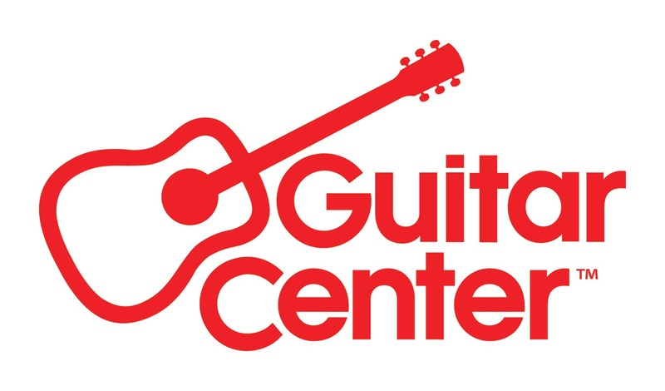

***MEDIA ALERT FOR SATURDAY, AUG 23***

Reminder for Sat 8/23: Guitar Center and DW Drums invite fans to an epic day of clinics, showroom tours, and gear at “DW Factory Day”

Taking place at Drum Workshop’s headquarters in Oxnard, California, and open to the public, this special event will feature one-day-only factory pricing, facility and showroom tours, artist clinics, special events and giveaways

WHO: Guitar Center, the world’s largest musical instrument retailer, partnering with Drum Workshop, Inc. (DW), one of the world’s preeminent manufacturers of drums and drum hardware.

WHAT: “DW Factory Day,” a day-long event open to the public, featuring never-before-seen product, one-day-only pricing (on products from DW, LP, PDP, Remo, Zildjian, Roland and SKB), facility and showroom tours, artist clinics, special events and giveaways, food trucks, and more. Guitar Center will be serving as the exclusive retailer for all gear purchased through the event, offering special pricing on drums and gear available at the event, in-store, online and by phone, Aug. 23 only.

Special guest drummers and judges will include drummers Kenny Aronoff (Joe Satriani, Sammy Hagar), Fausto Cuevas III (Stevie Wonder), Richie Gajate Garcia (Phil Collins, Diana Ross), Roland Gajate Garcia (Camila Cabello, American Idol), Damon Grant (Independent Artists), Daru Jones (Jack White, Pete Rock), Matt O’Connor (Rod Stewart), Stephen Perkins (Jane’s Addiction, Porno for Pyros), Gil Sharone (Marilyn Manson, The Dillinger Escape Plan), Jason Sutter (New York Dolls, Foreigner) and others. Attendees can RSVP for free group drum lessons with renowned drummers Gil Sharone and Jason Sutter. RSVP here.

Factory Day attendees can experience the full factory tour, where they will see the entire process of drum making from start to finish, hear about the 50-plus-year history of the company, see how drum hardware is made and visit the showroom of DW drums.

Another unique opportunity is to have your snare drum tuned up by DW’s master drum tuner, Roland Martinez! Roland hand tunes every DW drum before it leaves the factory. This is free to all attendees, be sure to bring your snare with you!

A high-energy Drum Battle will showcase top local talent, judged by an all-star panel of legendary drummers, including Kenny Aronoff (John Mellencamp, Smashing Pumpkins), Stephen Perkins (Jane’s Addiction), Daru Jones (Jack White), and more. Come cheer on your favorites as they compete for epic prizes!

Doors open at 11:30 a.m. PDT; The day’s program begins at 11:50 with a welcome and introduction of the Drum Battle judges.

WHERE: DW Headquarters, 3450 Lunar Ct., Oxnard, CA 93030.

WHEN: Saturday, August 23, 2025, from 11:30 a.m. to 5 p.m. PDT.

Visit https://www.guitarcenter.com/DW-Factory-Day.gc for more information and the full schedule of events.

FOR MORE INFORMATION PLEASE CONTACT:
Clyne Media | pr@clynemedia.com
Guitar Center | media@guitarcenter.com
###

About Guitar Center:
Guitar Center is the leading retailer of musical instruments, lessons, repairs, and rentals in the U.S. With more than 300 stores across the U.S. and one of the top direct sales websites in the industry, Guitar Center has helped people make music for more than 60 years. Guitar Center also provides customers with various musician-based services, including Guitar Center Lessons, where musicians of all ages and skill levels can learn to play a variety of instruments in many music genres, GC Repairs, an on-site maintenance and repairs service, and GC Rentals, a program offering easy rentals of instruments and other sound reinforcement gear. Additionally, Guitar Center’s sister brands include Music & Arts, which operates more than 250 stores specializing in band & orchestral instruments for sale and rental, serving teachers, band directors, college professors, parents and students, and Musician’s Friend, a leading direct marketer of musical instruments in the United States. For more information about Guitar Center, please visit guitarcenter.com.

Photo file 1: GC_DWFactoryDay_2025.JPG
Photo caption 1: Promotional graphic for DW Factory Day, held by Guitar Center and DW Drums on Saturday, August 23, 2025

