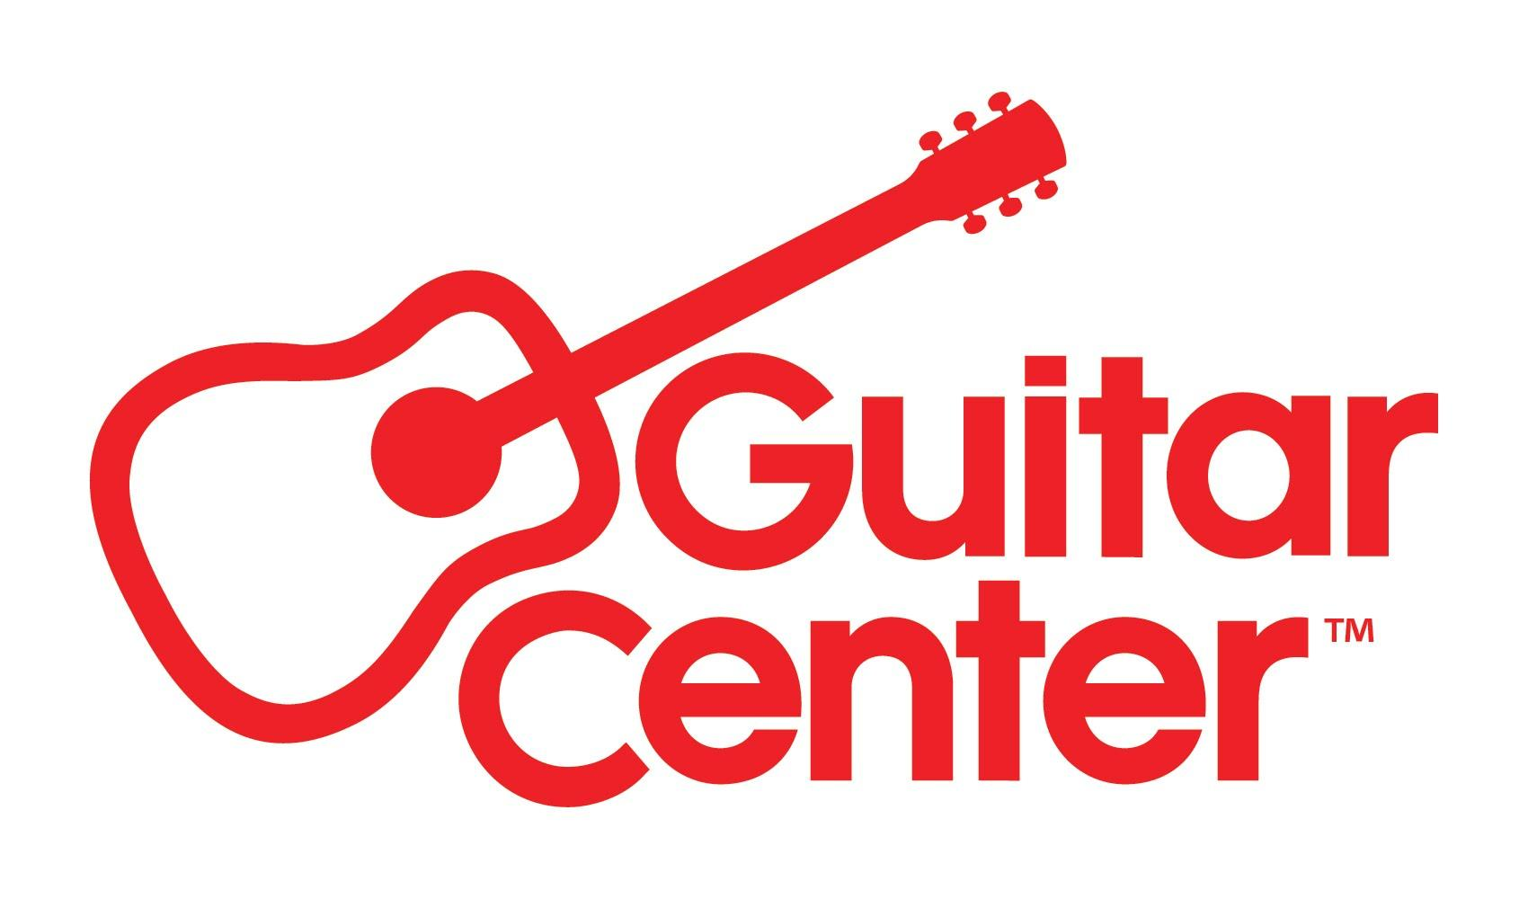
*** MEDIA ALERT ***
Media Contact:
Clyne Media | pr@clynemedia.com
Guitar Center| media@guitarcenter.com

Guitar Center Partners with Drum Workshop for “DW Factory Day” on July 30

WHO: Guitar Center, the world’s largest musical instrument retailer, partnering with Drum Workshop, Inc. (DW), one of the world’s preeminent manufacturers of drums and drum hardware who is celebrating its 50th anniversary, for “DW Factory Day,” taking place at DW’s headquarters in Oxnard, CA.

WHAT: “DW Factory Day,” a day-long event with factory tours, live performances, drum clinics, a drum battle competition, autograph sessions, local food trucks, exclusive one-day pricing on new gear, and thousands of dollars in giveaways (from DW, PDP, Zildjian, Remo & Guitar Center). Guitar Center will be serving as the exclusive vendor for all gear purchased through the event, offering special pricing on DW and PDP drums and gear that will be available at the event, in-store and by phone, July 30 only. Guitar Center Lessons personnel will also be on hand to offer free consultation and lesson services.

DW Factory Day attendees can experience the full factory tour, where they will see the entire process of drum making from start to finish, hear about the 50-year history of the company, see how drum hardware is made and visit the showroom of DW drums. On display are legendary drum kits including the last kit Rush drummer Neil Peart ever played. DW created the R40 drum set to celebrate Neil Peart’s 40 years with Rush, and it’s now on permanent display to honor one of the greatest drummers of all time.

The Drum Battle competition will also be held and is open to all comers (sign up at 10 a.m.; 20 spots available), with prizes from DW, Zildjian & Guitar Center. Judges will include notable drummers John “JR” Robinson, Matt Garstka, Brendan Buckley, Dave Elitch, Gil Sharone, Mark Schulman, Russ Miller, Satnam Ramgotra, Sean Winchester, Steve Ferrone, Toss Panos and Trevor Lawrence Jr.

Performers will include Matt Garstka (Animals as Leaders, CHON) on the outside stage and John Good (DW co-founder) and Chad Wackerman (Frank Zappa, Steve Vai) in “Drum Channel Presents” studio demos. (Tickets for the studio portion available first-come first-served on-site at 9:30 a.m.)

WHERE: DW Headquarters, 3450 Lunar Ct., Oxnard, CA 93030.

WHEN: Saturday, July 30, 2022, from 12 to 5 p.m. PDT (tickets and signups for specific events begin as early as 9:30 a.m.).

Visit https://www.guitarcenter.com/DW-Factory-Day.gc for more information and a detailed itinerary.

###

About Guitar Center:
Guitar Center is a leading retailer of musical instruments, lessons, repairs and rentals in the U.S. With nearly 300 stores across the U.S. and one of the top direct sales websites in the industry, Guitar Center has helped people make music for more than 50 years. Guitar Center also provides customers with various musician-based services, including Guitar Center Lessons, where musicians of all ages and skill levels can learn to play a variety of instruments in many music genres; GC Repairs, an on-site maintenance and repairs service; and GC Rentals, a program offering easy rentals of instruments and other sound reinforcement gear. Additionally, Guitar Center’s sister brands include Music & Arts, which operates more than 200 stores specializing in band & orchestral instruments for sale and rental, serving teachers, band directors, college professors and students, and Musician’s Friend, a leading direct marketer of musical instruments in the United States. For more information about Guitar Center, please visit www.guitarcenter.com.

FOR MORE INFORMATION PLEASE CONTACT:
Clyne Media | pr@clynemedia.com
Guitar Center| media@guitarcenter.com

