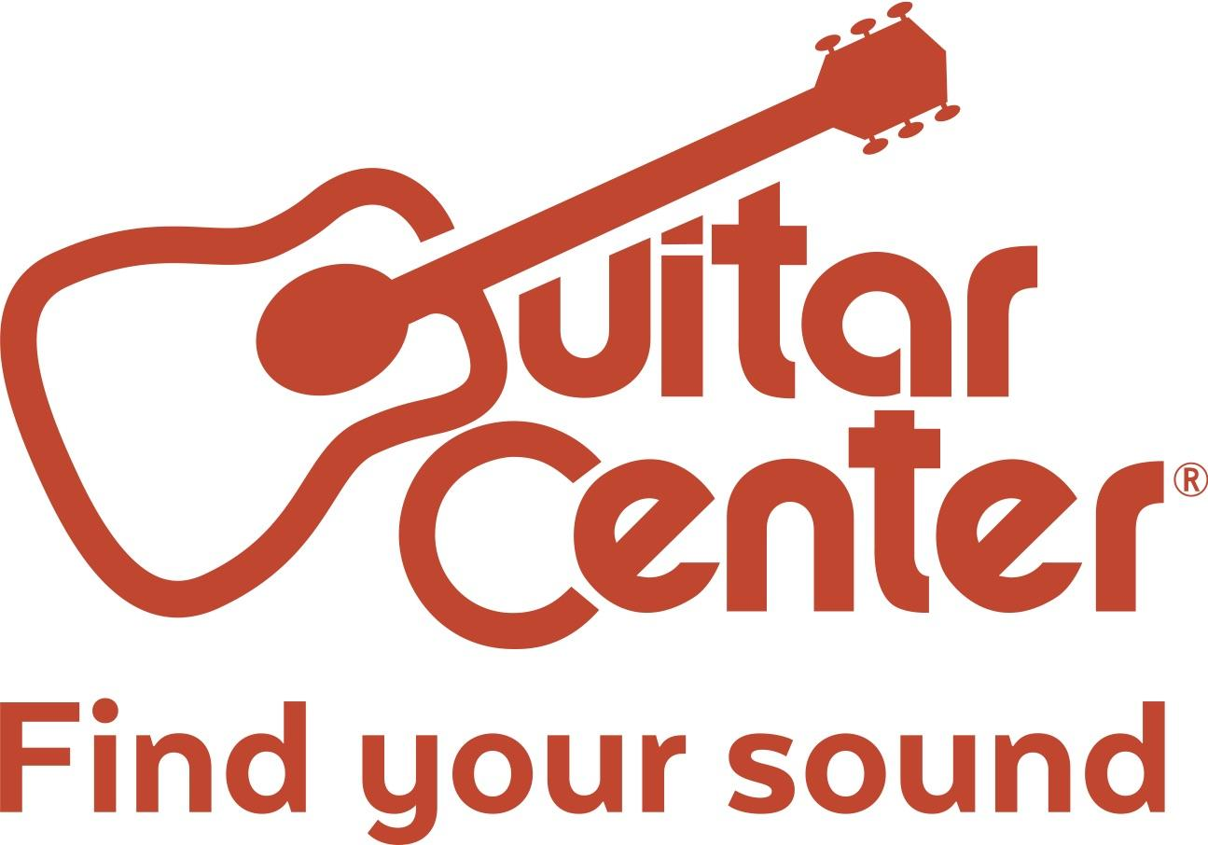

Guitar Center Launches Destination Drum Shop

Destination Drum Shop initiative kicks off in 10 stores nationwide, providing an enhanced assortment of high-end gear and more for drummers and percussionists

Westlake Village, CA (July 20, 2017) – Today, Guitar Center, the world’s largest instrument retailer, announced the launch of the Destination Drum Shop initiative, an elevated assortment of high-end acoustic drum kits, cymbals, electronic drum kits, snare drums, accessories and more that will allow musicians to experience the best selection of gear under one roof. Starting on July 22, Destination Drum Shop will feature ready-to-play top-of-line gear from manufacturers such as DW, Gretsch, Ludwig, Mapex, Pearl, Roland, Sabian, Sonor, Tama, Yamaha, Zildjian and more in 10 locations nationwide.

The new offering is a veritable treasure trove for drum and percussion enthusiasts, featuring a large selection of high-end and limited products, including modern and classic styles, all of which are available for drummers of all skill levels to play, and ultimately find the perfect setup for their unique sound. The selection of gear is the largest assortment of drum inventory in-store from Guitar Center to date that will allow drummers to experience the best brands hands-on.

Providing a shopping experience unlike any other, Guitar Center’s Destination Drum Shop will give drummers the ability to demo some of the world’s most coveted kits and learn more from a dedicated Drum Champion, a designated point person at each Destination Drum Shop location that has advanced training directly from factory specialists, so musicians will receive an individualized and more informed shopping experience.

“Destination Drum Shop further underscores Guitar Center’s ongoing commitment to the drum and percussion market and provides our customers with hands-on access to some of the most comprehensive selection of drum and percussion products to date,” said Glenn Noyes, Director of Merchandise at Guitar Center. “For drum and percussion musicians to have all of the best products from top manufacturers under one roof is truly a ‘kid in a candy shop’ experience for our customers.”

Initially, drummers can discover Destination Drum Shop at the following Guitar Center locations:
● Arlington, TX
● Atlanta, GA
● Chicago, IL
● Hallandale, FL
● Hollywood, CA
● Houston, TX
● La Mesa, CA
● San Antonio, TX
● San Jose, CA
● Union Square, NY

Destination Drum Shop will continue to grow adding more locations going into 2018, providing more drummers around the country a chance to find the perfect kit in addition to product demonstrations, artist meet and greets, clinics, workshops and much more. Drummers can also browse GuitarCenter.com for an even larger selection of mid-to-high-end gear, plus discover exclusive video content, interactive drum set experiences and more great offerings.

###

About Guitar Center:
Guitar Center is the world’s largest retailer of guitars, amplifiers, drums, keyboards, recording, live sound, DJ and lighting equipment. With more than 280 stores across the U.S. and one of the top direct sales websites in the industry, Guitar Center has helped people make music for more than 50 years. Guitar Center also provides customers with various musician based services, including Guitar Center Lessons, where musicians of all ages and skill levels can learn to play a variety of instruments in many music genres; GC Repairs, an on-site maintenance and repairs service; and GC Rentals, a program offering easy rentals of instruments and other sound reinforcement gear. Additionally, Guitar Center’s sister brands include Music & Arts, which operates more than 150 stores specializing in band & orchestral instruments for sale and rental, serving teachers, band directors, college professors and students, and Musician’s Friend, a leading direct marketer of musical instruments in the United States. With an unrivalled in-store experience, an industry-leading online presence and passionate commitment to making gear easy-to-buy, Guitar Center is all about enabling musicians and non-musicians alike to experience the almost indescribable joy that comes from playing an instrument. For more information about Guitar Center, please visit www.guitarcenter.com.

FOR MORE INFORMATION PLEASE CONTACT:
Praytell Agency | guitarcenter@praytellagency.com
Guitar Center | 818.735.8800| media@guitarcenter.com
Clyne Media | 615.662.1616 | pr@clynemedia.com

