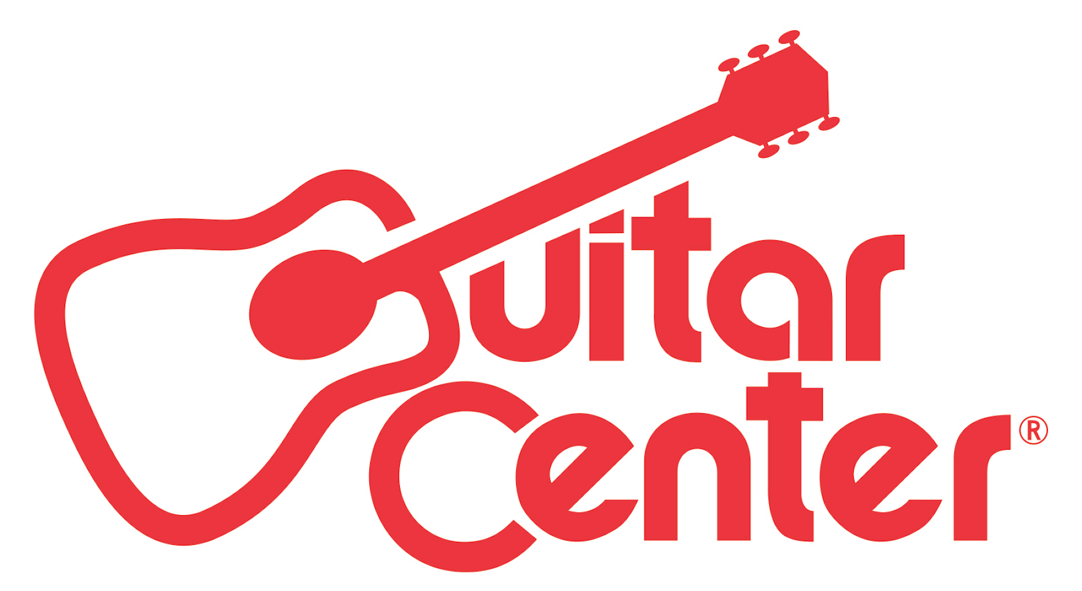

FOR IMMEDIATE RELEASE

Guitar Center Spotlights the Nation’s Best Drummers in the 27th Annual Drum-Off

ANNOUNCEMENT HIGHLIGHTS:

- Guitar Center presents the world’s premier drum competition offering a career-launching prize package worth more than $45,000
- Past Drum-Off winners have gone on to see successful careers, playing with the likes of Prince, Jay-Z, Beyoncé, The Mars Volta and more
- Drum-Off sign-ups are open now at all Guitar Center locations nationwide

Westlake Village, CA (August 3, 2015) – Guitar Center’s Drum-Off, the world’s premier drum competition, launches its 27th annual search for the next great undiscovered drummer. Developed to inspire and support aspiring musicians, the program has grown into a sought-after launching pad for a career as a professional drummer. Past Drum-Off winners have gone on to play with Prince and Beyoncé (Cora Coleman-Dunham), The Mars Volta and Trash Talk (Thomas Pridgen), Jay-Z (Tony Royster Jr.) and many more. As Guitar Center’s longest running artist discovery program, Drum-Off continues to unearth some of today’s top undiscovered drummers and provide an unrivaled platform for exposure.

Starting today, drummers can sign-up for Guitar Center’s Drum-Off at any of the retailer’s locations nationwide. Free and open to drummers across the country, entrants will compete for a chance to win a career-launching grand prize package valued at over $45,000 including cash, gear, endorsement deals, and more.

Learn more about the program here: https://youtu.be/YT3Qgdh-uSQ

Guitar Center’s Drum-Off Grand Prize Winner Will Receive:
- $25,000 Cash
- Roland TD-30KV Electronic Drum Kit and the SPD-SX
- High-End Drum Kit by DW, Tama, Pearl, Gretsch or Yamaha (Winner’s Choice)
- Full set up of drum sticks, cymbals, and drumheads (Winner’s Choice)
- Endorsement Deals from the top drum manufacturers (Winner’s Choice)
- VIP Experience at NAMM 2016
- Studio Time at Converse Rubber Tracks
- Feature in a Guitar Center Buyer’s Guide

How The Competition Works:
Guitar Center’s Drum-Off begins with store preliminary competitions at 251 select Guitar Center locations nationwide. Contestants will be judged on a three minute performance, and one winner from each store finals competition will be chosen to move up to the quarter finals, followed by semi-finals at five store locations. Five winners chosen at the semi-finals will then convene at Club Nokia in Los Angeles, CA, to compete for the grand prize in Guitar Center’s Drum Off finals on January 16, 2016, in front of a live audience and a panel of judges. For more information on rules and regulations please visit: http://guitarcenter.com/drumoff

Watch Guitar Center’s Drum-Off 2014 champion Shariq Tucker and his winning performance here: http://youtu.be/nfdEqi5YMjk

“This program has grown immensely over the past 27 years, and we are continuously impressed with the level of talent that comes out to compete,” says Maria Brown, manager of music and entertainment marketing for Guitar Center. “We are so grateful for how warmly Drum-Off has been welcomed into the community and look forward to celebrating the artistry and talent in the drum world again this year.”

Drum-Off Competition Dates:
- Store Prelims = September 15, 22, 29
- Store Finals = October 6, 2015
- Quarter Finals = October 27, 2015
- Semifinals = November 17, 2015
- Grand Finals = January 16, 2016

In years past, some of the world’s most renowned drummers have participated in and supported Guitar Center’s Drum-Off, including: Terry Bozzio (Frank Zappa, Missing Persons), Aaron Spears (Usher), Dennis Chambers (Parliament/Funkadelic), Chad Smith (Red Hot Chili Peppers), Steve Gadd (Steely Dan), Questlove (The Roots), Travis Barker (Blink-182), Tommy Lee (Motley Crüe), Dave Lombardo (Slayer), Carmine Appice (Ted Nugent, Ozzy Osbourne), John Tempesta (The Cult), Taylor Hawkins (Foo Fighters), Steve Smith (Journey), Josh Freese (Nine Inch Nails, A Perfect Circle), José Pasillas (Incubus), Billy Cobham (Miles Davis), Niko McBrain (Iron Maiden), Stephen Perkins (Jane’s Addiction), Danny Carey (Tool), Brann Dailor (Mastodon), Steve Ferrone (Tom Petty & The Heartbreakers), and more.

Guitar Center Drum-Off is presented by: Roland, Yamaha, Meinl, Remo, Pearl, Vic Firth, DW, LP, Gretsch, Zildjian, Evans, Promark, Sabian, Tama, Drum Channel, GoPro, and Modern Drummer.

Photo file: DrumOff27.JPG
Photo caption: Guitar Center’s 27th Annual Drum-Off

About Guitar Center:
Guitar Center is the world’s largest retailer of guitars, amplifiers, drums, keyboards, recording, live sound, DJ, and lighting equipment. With more than 260 stores across the U.S. and one of the top direct sales websites in the industry, Guitar Center has helped people make music for more than 50 years. In addition, Guitar Center’s sister brands includes Music & Arts, which operates more than 120 stores specializing in band & orchestral instruments for sale and rental, serving teachers, band directors, college professors and students, and Musician’s Friend, a leading direct marketer of musical instruments in the United States. With an unrivaled in-store experience, an industry-leading online presence and passionate commitment to making gear easy-to-buy, Guitar Center is all about enabling musicians and non-musicians alike to experience the almost indescribable joy that comes from playing an instrument. All we sell is the greatest feeling on earth. For more information about Guitar Center, please visit www.guitarcenter.com.

You can subscribe to our RSS newsfeed at http://feeds.feedburner.com/GuitarCenterPressroom, visit our press room at http://gc.guitarcenter.com/pressroom/ and send media inquiries to media@guitarcenter.com.

FOR MORE INFORMATION PLEASE CONTACT:
Sarah Chavey | ANTHEMIC Agency | 323.464.4745 x 806 | sarah@anthemicagency.com
Robert Clyne | Clyne Media, Inc. | 615-300-4555 | robert@clynemedia.com
Syvetril Perryman | Guitar Center | 818.735.8800 x 2979 | media@guitarcenter.com

