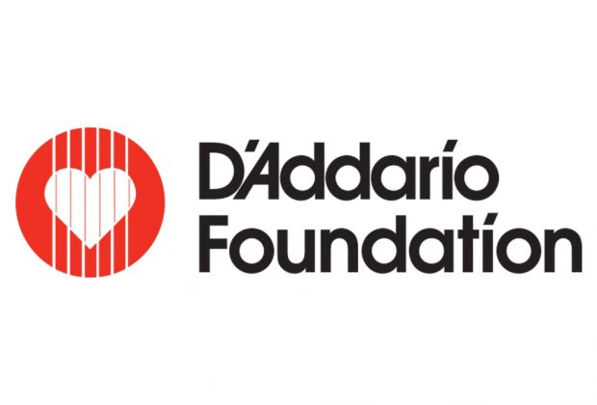

Guitar Center and The D’Addario Foundation Raise Money for International Women’s Day 2019

Westlake Village, CA (March 19, 2019) – On Friday, March 8, 2019, Guitar Center and The D’Addario Foundation teamed up for International Women’s Day to raise money for the Music Education for Girl’s Initiative. Historically, women and girls have been underrepresented in the music industry and still fight to be recognized today. This initiative was created to help change this gender imbalance by providing the resources and guidance girls need to study music.

On this day, 50% of the proceeds from all D’Addario products sold at Guitar Center and on guitarcenter.com were donated to the D’Addario Foundation. Paired with individual donations received, a grand total of over $45,000 was raised to dedicate toward this initiative.

This new funding will go toward a number of opportunities for young women the D’Addario Foundation supports, including free instrument instruction, college scholarships, and all-female programming.

“The D’Addario Foundation is incredibly appreciative of the positive response and support for this initiative,” says Suzanne D’Addario Brouder, Director of The D’Addario Foundation. “We are thrilled to continue to build on this valuable partnership with Guitar Center to collectively further efforts to support and encourage more young women in music. Together we can continue to make a meaningful difference.”

To learn more about the D’Addario Foundation and Music Education for Girls initiative, visit daddariofoundation.org.

###

About the D’Addario Foundation: The D’Addario Foundation bridges the gap in our education system to bring access to quality music education programs providing free or very affordable instruments and instruction. Believing that music is part of a well-rounded education, D’Addario invests in programs planted in local communities, dedicated to making a long-term impact. Foundation-supported programs emphasize mentoring that builds leadership skills. The D’Addario Foundation has dedicated millions of dollars over the last 30 years, making it possible for countless children to have a meaningful music education. For more information go to daddariofoundation.org.

The D’Addario Foundation believes in the power of music to unlock creativity, boost self-confidence, and enhance academics. D’Addario also reinforces its role as a social and environmental leader with initiatives such as Playback and PlayPlantPreserve.

D'Addario & Company, Inc.
D’Addario is the world's largest manufacturer of musical instrument accessories, marketed under several product brands: D’Addario Fretted, D’Addario Orchestral, D’Addario Woodwinds, Promark Drumsticks, Evans Drumheads, and Puresound Snare Wires. A family-owned and operated business with roots dating back to the 17th century, D’Addario now has over 1,100 employees worldwide, and manufactures 95% of its products in the U.S. while utilizing Toyota's Lean manufacturing principles. D'Addario musical accessories are distributed in 120 countries, serve more than 3,300 U.S. retailers, all major e-commerce sites, and are the preferred choice of musicians worldwide such as, Keith Urban, Zak Brown, Brandi Carlile, Dave Matthews, Gary Clark Jr., Chris Thile, Ry Cooder, Joe Satriani, Julia Fischer, Anderson .Paak, Kacey Musgraves and more.

Media Contact - D’Addario & Co, Inc.
Natalie Morrison (natalie.morrison@daddario.com)
www.daddario.com

About Guitar Center:
Guitar Center is a leading retailer of musical instruments, lessons, repairs and rentals in the U.S. With 290 stores across the U.S. and one of the top direct sales websites in the industry, Guitar Center has helped people make music for more than 50 years. Guitar Center also provides customers with various musician-based services, including Guitar Center Lessons, where musicians of all ages and skill levels can learn to play a variety of instruments in many music genres; GC Repairs, an on-site maintenance and repairs service; and GC Rentals, a program offering easy rentals of instruments and other sound reinforcement gear. Additionally, Guitar Center’s sister brands include Music & Arts, which operates more than 150 stores specializing in band & orchestral instruments for sale and rental, serving teachers, band directors, college professors and students, and Musician’s Friend, a leading direct marketer of musical instruments in the United States. For more information about Guitar Center, please visit www.guitarcenter.com.

FOR MORE INFORMATION PLEASE CONTACT:
Clyne Media | 615.662.1616 | pr@clynemedia.com
Guitar Center | 818.735.8800 | media@guitarcenter.com
Edelman | 323.761.6523 | GuitarCenter@edelman.com

