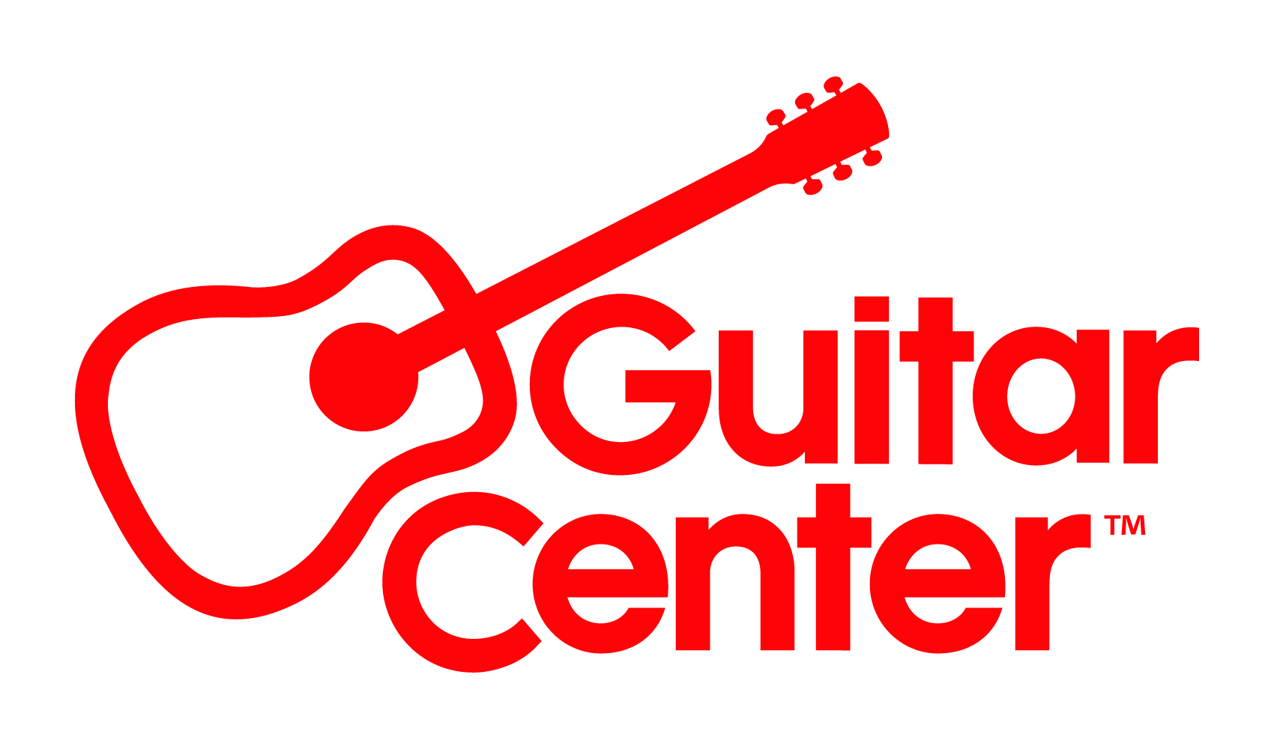
Guitar Center Hires Angelia Powell as Vice President of Real Estate

New hire supports Guitar Center’s ongoing growth and store development

Westlake Village, CA (June 14, 2022) – Guitar Center, the world’s largest musical instrument retailer, announces the appointment of Angelia Powell as Vice President of Real Estate. In her new role, Powell will be responsible for the leadership and strategy driving store development and growth throughout the organization. She will focus on the ongoing analysis, selection and negotiation of new and current store sites, relocation, replacement expansion, store initiatives, and oversight over the company’s corporate real estate. Powell will report to Tim Martin, Guitar Center Executive Vice President and Chief Financial Officer.

Powell has over 30 years of experience in the retail real estate, design, and construction industry, working with companies like The Limited, Eddie Bauer, The Disney Store, Lululemon Athletica, Williams-Sonoma, and Comcast/Xfinity. Most recently, she was the Vice President of Development and Construction for Convene, a hospitality company in New York City. She has also worked on the landlord side of the business, leasing existing and new ground-up development projects.

“As Guitar Center continues to grow, the real estate aspect of our business is crucial,” said Tim Martin, Guitar Center Executive Vice President and Chief Financial Officer. “Angie is uniquely positioned to support our growth initiatives with an eye upon the issues surrounding site selection, facility footprint, projected financials and everything that goes into consideration in terms of our physical stores. We welcome Angie and look forward to working closely with her.”

For more information, visit GuitarCenter.com or Guitar Center on Facebook, Twitter, Instagram and YouTube.

###

Photo file: AngiePowell.JPG
Photo caption: Angelia “Angie” Powell, Guitar Center Vice President of Real Estate

About Guitar Center:
Guitar Center is a leading retailer of musical instruments, lessons, repairs and rentals in the U.S. With nearly 300 stores across the U.S. and one of the top direct sales websites in the industry, Guitar Center has helped people make music for more than 50 years. Guitar Center also provides customers with various musician-based services, including Guitar Center Lessons, where musicians of all ages and skill levels can learn to play a variety of instruments in many music genres; GC Repairs, an on-site maintenance and repairs service; and GC Rentals, a program offering easy rentals of instruments and other sound reinforcement gear. Additionally, Guitar Center’s sister brands include Music & Arts, which operates more than 200 stores specializing in band & orchestral instruments for sale and rental, serving teachers, band directors, college professors and students, and Musician’s Friend, a leading direct marketer of musical instruments in the United States. For more information about Guitar Center, please visit www.guitarcenter.com.

FOR MORE INFORMATION PLEASE CONTACT:
Clyne Media | pr@clynemedia.com
Guitar Center | media@guitarcenter.com
Edelman | GuitarCenter@edelman.com

