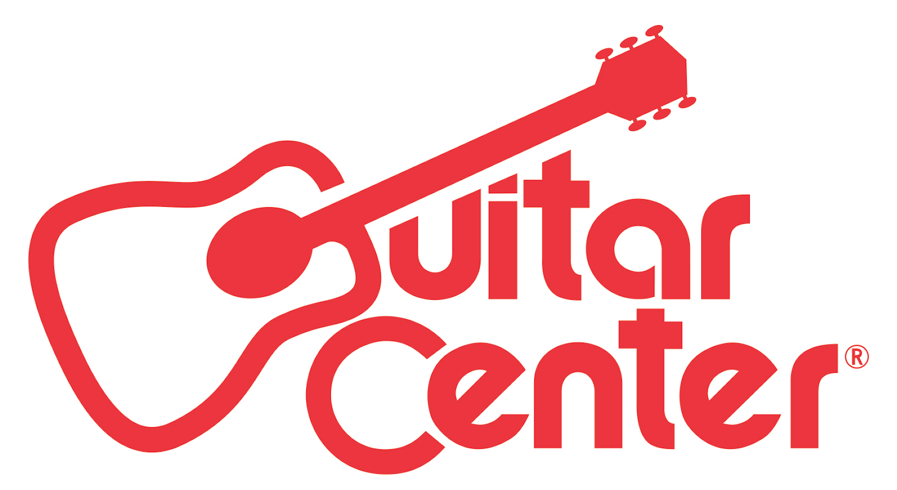

FOR IMMEDIATE RELEASE

Guitar Center Teams with GRAMMY® Award-Winning Musician Vince Gill to Launch a Nationwide Search for Undiscovered Guitarists

ANNOUNCEMENT HIGHLIGHTS:
- Winner will open for Vince Gill on one of his U.S. Tour performances, record a single with Justin Niebank (Taylor Swift, Keith Urban), meet with Universal Music Group, and take home new gear, $10,000 cash and more
- One of Guitar Center’s many programs designed to support emerging musicians, OnStage with Vince Gill opens for submissions February 1, 2016
- Vince Gill’s new album, Down to My Last Bad Habit, is available beginning February 12, 2016

Los Angeles, CA (February 1, 2016): Guitar Center has partnered with GRAMMY® Award-winning country music legend Vince Gill to present OnStage with Vince Gill. Now in its fifth installment, the artist discovery program offers undiscovered guitarists career-launching opportunities, and this year’s installment gives the winner the chance to open for Gill on one of his U.S. tour performances, record a single with GRAMMY award-winning producer Justin Niebank (who has produced records for the likes of Gill, Sheryl Crow and Keith Urban), and take home new gear, $10,000 cash and more.

How to Enter: Starting today, undiscovered guitarists across the United States are invited to submit their version of Vince Gill’s new single “Take Me Down” at guitarcenter.com/onstage. Gill will hand-pick five finalists from the submissions to perform live at a grand finals event in Los Angeles, where one grand prize winner will be named.

Guitar Center OnStage with Vince Gill winner will receive:
- An opening slot at one of Vince Gill’s U.S. Tour performances
- A single produced by GRAMMY award-winning producer Justin Niebank (Vince Gill, Taylor Swift, Keith Urban)
- A meeting with Universal Music Group
- $10,000 cash
- New gear from Boss, D’Addario, Dunlop, Fender, Martin, Planet Waves and Shure
- A feature with Guitar World magazine

Gill recently announced he will release his new album, Down to My Last Bad Habit, on February 12, 2016, marking Gill’s first solo album since 2011’s Guitar Slinger. February will also see Gill reunite with Lyle Lovett for a 13-city tour of acoustic shows. For a full list of tour dates, news, images and more, visit www.VinceGill.com.

Guitar Center OnStage exemplifies the retailer’s ongoing commitment to developing unique programming that provides musicians with the opportunity and exposure to further their success. Previous editions of Guitar Center OnStage featured Jane’s Addiction, Slash, Mötley Crüe and KISS, with Mötley Crüe’s winning band, The Last Vegas, going on to win iTunes critics’ 2009 “Rock Single of the Year” with their hit single “I’m Bad.”

"I had no hesitations when Guitar Center approached me about this opportunity to give back to the musical community and support undiscovered artists. There's something very exciting about hearing new talent and knowing that I now have the ability to give them a helping hand and guide their young careers. I can't wait to hear how people cover my new single, and I look forward to hearing submissions!"
-Vince Gill

“Guitar Center’s OnStage offers unsigned musicians a platform to get their music heard by legendary artists. Vince Gill is a country music icon with 20 GRAMMYs and countless recognitions for his songwriting, producing and performance work. It’s thrilling to see an artist of his caliber give back to the musical community by providing emerging artists what they need most – an opportunity.”
-Jake Cheung, manager of music marketing and artist relations at Guitar Center

-30-

Photo file: GC_OnStage_VinceGill.JPG
Photo caption: Guitar Center OnStage with Vince Gill promotional graphic.

About Vince Gill:
Down to My Last Bad Habit marks Gill’s first solo album since 2011’s Guitar Slinger. In 2013, The Oklahoma native partnered with famed steel guitarist Paul Franklin on Bakersfield as a tribute to the “Bakersfield” sound of Buck Owens and Merle Haggard. With 20 GRAMMY Awards to his credit, Gill has emerged as country music’s most eloquent and impassioned champion. He is both a world-class guitar picker and a wide-ranging songwriter whose compositions earned him entry into the Nashville Songwriters Hall of Fame in 2005 and the Country Music Hall of Fame in 2007. Gill has produced albums for LeAnn Rimes, Amy Grant as well as Ashley Monroe and has made guest appearances on over 500+ albums including Barbra Streisand, Eric Clapton, Willie Nelson, Dolly Parton, George Jones and more.

About Guitar Center:
Guitar Center is the world’s largest retailer of guitars, amplifiers, drums, keyboards, recording, live sound, DJ, and lighting equipment. With more than 270 stores across the U.S. and one of the top direct sales websites in the industry, Guitar Center has helped people make music for more than 50 years. In addition, Guitar Center’s sister brands includes Music & Arts, which operates more than 140 stores specializing in band & orchestral instruments for sale and rental, serving teachers, band directors, college professors and students, and Musician’s Friend, a leading direct marketer of musical instruments in the United States. With an unrivaled in-store experience, an industry-leading online presence and passionate commitment to making gear easy-to-buy, Guitar Center is all about enabling musicians and non-musicians alike to experience the almost indescribable joy that comes from playing an instrument. For more information about Guitar Center, please visit www.guitarcenter.com.

You can visit our press room at http://www.guitarcenter.com/pages/press-room and send media inquiries to media@guitarcenter.com.

FOR MORE INFORMATION PLEASE CONTACT:
Natania Reed | ANTHEMIC Agency | 323.464.4745 x 806 | natania@anthemicagency.com
Syvetril Perryman | Guitar Center | 818.735.8800 x 2979 | media@guitarcenter.com
Robert Clyne | Clyne Media, Inc. | 615-662-1616 | Robert@clynemedia.com

