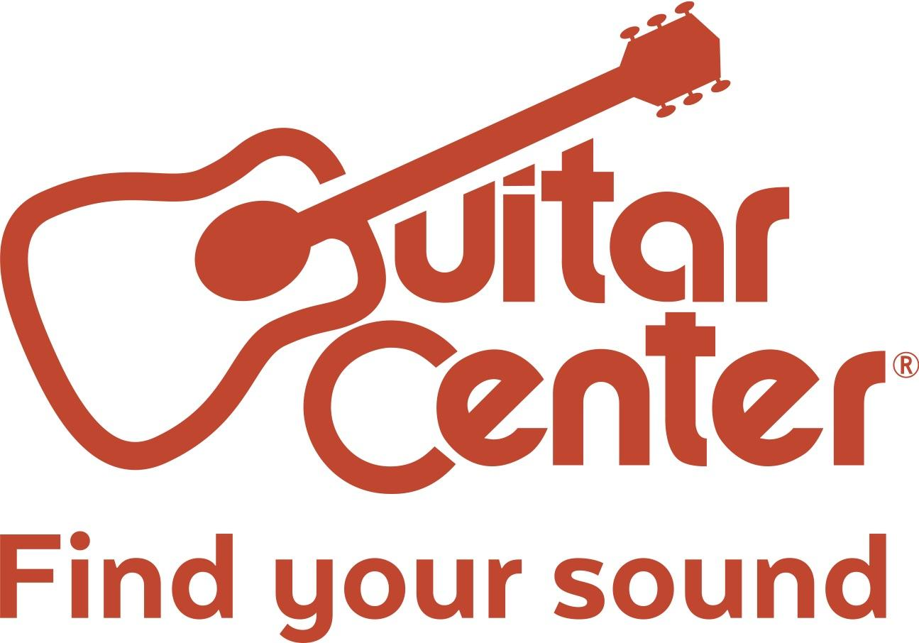

*** MEDIA ALERT ***

Media Contact:
Praytell Agency
GCPR@praytellagency.com

The Final Five Take the Stage at Guitar Center’s Sixth Annual Singer-Songwriter Grand Finale

On March 24 in Los Angeles, five finalists hand-selected by GRAMMY® Award-winning songwriter and producer RedOne will showcase their talent for a chance to win a career-altering grand prize

What: Out of nearly 10,000 submissions from across the country, the top five undiscovered songwriters in the country have been selected in Guitar Center's Sixth Annual Singer-Songwriter search. On March 24 at the Troubadour in West Hollywood, the five finalists will compete at the private Grand Finale event hosted by YouTube music sensation Clara C. At the Grand Finale, GRAMMY® Award-winning producer RedOne (Lady Gaga, Jennifer Lopez, Usher) will choose just one winner. Guitar Center’s Singer-Songwriter program gives aspiring artists a chance to share their music with the world and land a once-in-a-lifetime opportunity to work with RedOne and Australian singer-songwriter Cody Simpson.

Who: The following five finalists have been selected to perform live in front of RedOne, Cody Simpson and industry leaders alike at the Grand Finale on March 24:

- Edwina Maben (Centennial, CO)
- James Jannetty (Sherman Oaks, CA)
- John Russell (Savannah, GA)
- Kailey Abel (Claremore, OK)
- Rachel Wong (Tualatin, OR)

When: Friday, March 24, at 7:30 PM
- Run of Show
  - 7:30 PM - Doors
  - 8:00 PM - Opening Act Featuring SSW5 Winner Kate Brady and Streetlight Cadence
  - 8:30 PM - Top 5 Finalists Perform
  - 9:30 PM - Performance by Cody Simpson
  - 9:45 PM - Winner Announced by RedOne

Where: The Troubadour - 9081 Santa Monica Blvd, West Hollywood, CA 90069

The winner of Guitar Center’s Sixth Annual Singer-Songwriter will receive a career-launching Grand Prize that Includes:

- $25,000 Cash
- 4-song EP produced by RedOne
- One-on-One Mentorship with Cody Simpson
- Performance slot on Jimmy Kimmel Live!
- Showcase performance at the 2018 NAMM Show in Anaheim
- New gear from top instrument retailers
- A feature in American Songwriter Magazine
- Global distribution through AWAL

RSVP:
- The Singer-Songwriter finale is invite-only. If interested in attending to cover or to speak with RedOne, Cody Simpson or the finalists, please RSVP to GCPR@praytellagency.com.

About Guitar Center: Guitar Center is the world’s largest retailer of guitars, amplifiers, drums, keyboards, recording, live sound, DJ, and lighting equipment. With more than 270 stores across the U.S. and one of the top direct sales websites in the industry, Guitar Center has helped people make music for more than 50 years. In addition, Guitar Center’s sister brands include Music & Arts, which operates more than 140 stores specializing in band & orchestral instruments for sale and rental, serving teachers, band directors, college professors and students, and Musician’s Friend, a leading direct marketer of musical instruments in the United States. With an unrivalled in-store experience, an industry-leading online presence and passionate commitment to making gear easy-to-buy, Guitar Center is all about enabling musicians and non-musicians alike to experience the almost indescribable joy that comes from playing an instrument. For more information about Guitar Center, please visit www.guitarcenter.com.
You can visit our press room at http://www.guitarcenter.com/pages/press-room, and send media inquiries to media@guitarcenter.com.

Media attendance welcome. Please RSVP here: Praytell Agency | GCPR@praytellagency.com

###

