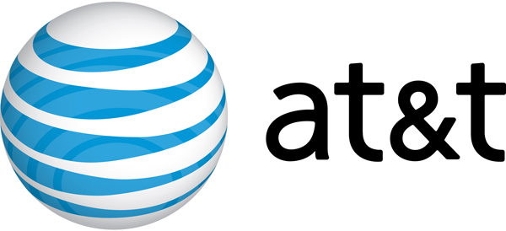
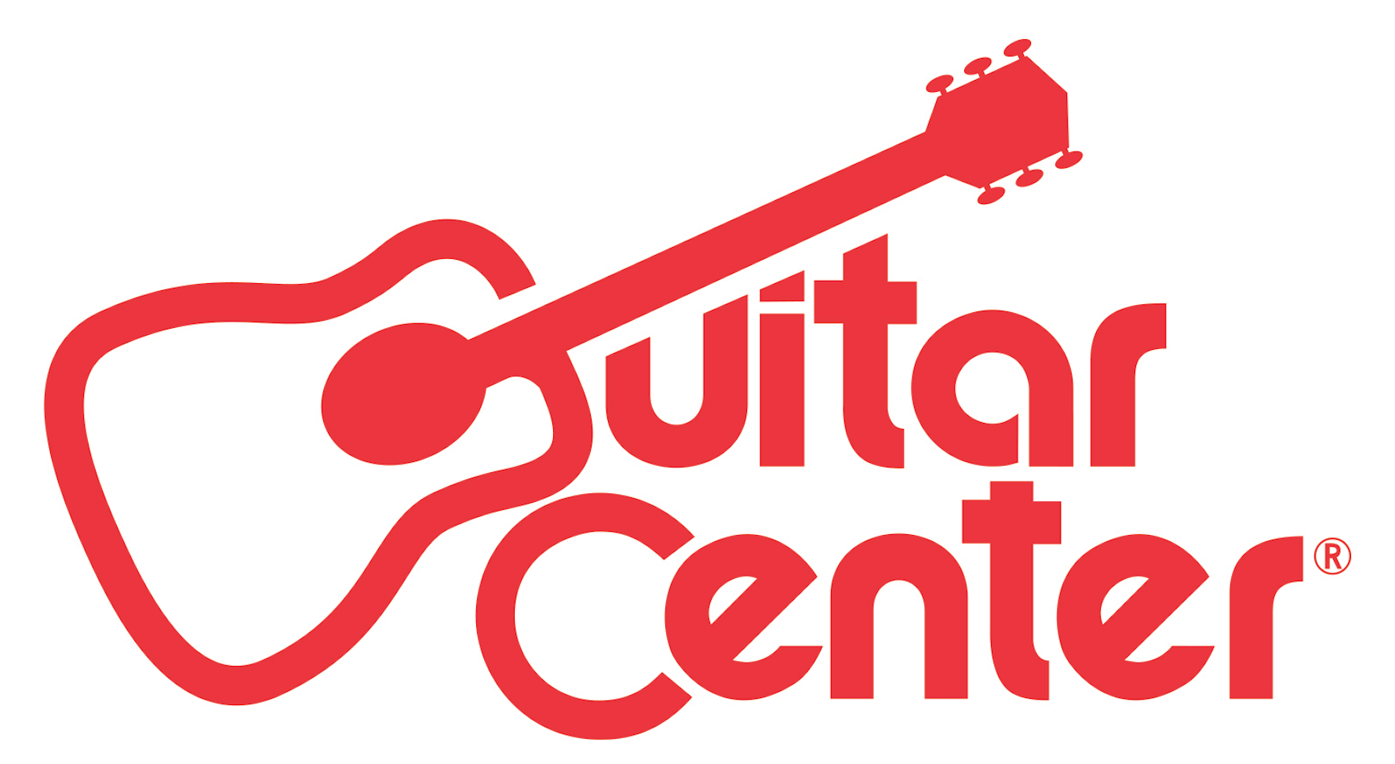

FOR IMMEDIATE RELEASE

AUDIENCE® NETWORK’s GUITAR CENTER SESSIONS SEASON 11 FEATURES JAMES TAYLOR, CHICAGO, JASON DERULO, MERLE HAGGARD AND MORE

10 NEW EPISODES BRING THE SERIES TO A MILESTONE 100 EPISODES

ANNOUNCEMENT HIGHLIGHTS:
- Telly Award-winning series hosted by influential music tastemaker Nic Harcourt continues to provide top-quality music television programming in stunning high definition and surround sound
- Season 11 to debut Nov. 13 at 9 PM ET/PT on AUDIENCE® Network (DIRECTV ch. 239 or AT&T U-verse TV ch. 1114).
Los Angeles, CA (November 2, 2015): Guitar Center and AT&T have announced Season 11 of the retailer’s award-winning music television series Guitar Center Sessions presented by JBL. The series will return on November 13 with 10 new episodes available Friday nights at 9 p.m. ET exclusively on AUDIENCE® Network (DIRECTV ch. 239 or AT&T U-verse TV ch. 1114).

A testament to the quality content and dedicated fan base, Guitar Center Sessions Season 11 sees the series hit 100 episodes. To mark this milestone, the season features a staggering lineup of artists including legendary acts like James Taylor and Chicago, country powerhouses Merle Haggard and Jerrod Niemann, international pop stars Jason Derulo and Sean Kingston, talented singer-songwriters The White Buffalo and Matisyahu, and buzzworthy indie acts Metric and St. Lucia.

Guitar Center Sessions Season 11 Schedule:
November 13, 2015 James Taylor
November 20, 2015 Metric
November 27, 2015 The White Buffalo
December 4, 2015 Matisyahu
December 11, 2015 Sean Kingston
December 18, 2015 Merle Haggard
January 8, 2016 Chicago
January 15, 2016 Jason Derulo
January 22, 2016 Jerrod Niemann
January 29, 2016 St. Lucia
Guitar Center Sessions provides award-winning music television content to DIRECTV and AT&T U-verse customers, presenting exclusive live performances in stunning HD** and 5.1 surround sound. In addition to show-stopping performances, each episode features intimate interviews conducted by renowned journalist Nic Harcourt, offering rare insights into the celebrated careers of these icons and the inspirations behind their music. Born out of Guitar Center’s desire to deliver high quality music programming to music fans nationwide, the series has since gone on to featured artists as diverse and iconic as Peter Gabriel, Soundgarden, Snoop Dogg, LINKIN PARK, OneRepublic, Phantogram, Joan Jett, The Smashing Pumpkins, Jimmy Cliff, Damon Albarn, Social Distortion and more.

“As a musical instrument retailer, it is incredibly important that we connect with our customer base in a way that inspires and celebrates the art of musicianship. The fact that we’ve now recorded 100 episodes is proof that ‘Guitar Center Sessions’ has done just that – connected with music fans in a very real and authentic way that has the ability to withstand the test of time. We are incredibly proud of our team and grateful to all of the talented musicians who have been a part of this journey.”
-Brian Berman, Vice President of Marketing, Guitar Center

-30-

*AT&T products and services are provided or offered by subsidiaries and affiliates of AT&T Inc. under the AT&T brand and not by AT&T Inc.
** To access HD programming, HD television and equipment required.

Photo file: Sessions_JamesTaylor.JPG
Photo caption: James Taylor, performing as part of Guitar Center Sessions’ season 11.

About AT&T
AT&T Inc. (NYSE:T) helps millions around the globe connect with leading entertainment, mobile, high speed Internet and voice services. We’re the world’s largest provider of pay TV. We have TV customers in the U.S. and 11 Latin American countries. In the U.S., our wireless network has the nation’s strongest 4G LTE signal and most reliable 4G LTE. We offer the best global coverage of any U.S. wireless provider*. And we help businesses worldwide serve their customers better with our mobility and highly secure cloud solutions.

Additional information about AT&T products and services is available at http://about.att.com. Follow our news on Twitter at @ATT, on Facebook at http://www.facebook.com/att and YouTube at http://www.youtube.com/att.

Signal and reliability strength claims based on nationwide carriers’ 4G LTE. Signal strength claim based ONLY on avg. 4G LTE signal strength. 4G LTE not available everywhere.

*Global coverage claim based on offering discounted voice and data roaming; LTE roaming; voice roaming; and world-capable smartphone and tablets in more countries than any other U.S. based carrier. International service required. Coverage not available in all areas. Coverage may vary per country and be limited/restricted in some countries.

About AUDIENCE® Network:
Always Original. Always Smart. Always Bold. Never Ordinary. AUDIENCE is a unique and exclusive television experience available only to DIRECTV and AT&T U-verse subscribers. The channel first made its mark by partnering with NBC to produce and air three additional seasons of the Emmy Award-winning series Friday Night Lights and then became the exclusive home of the Emmy Award-winning drama Damages, starring Glenn Close and Rose Byrne. AUDIENCE continues its commitment to original, provocative content with a growing slate of critically acclaimed original series including the MMA drama Kingdom, starring Frank Grillo and Nick Jonas; the suspense-drama ROGUE, starring Thandie Newton and Cole Hauser; Full Circle: Chicago Payback, written by Keith Huff and starring Calista Flockhart, Eric McCormack, Rita Wilson, and Terry O’Quinn; and Neil LaBute’s second project with the network, Billy & Billie, starring Adam Brody and Lisa Joyce. AUDIENCE is also home to acclaimed original documentaries including The Fighting Season, a first hand account at the deadliest year in our nation’s longest war, Executive Produced by Ricky Schroder. Sports fans will find live, daily sports and entertainment news from two renowned sports journalists with The Dan Patrick Show and The Rich Eisen Show. Plus, viewers can enjoy exclusive concerts by today’s hottest artists on Guitar Center Sessions and intimate interviews with top talent like Matt Damon and Jessica Chastain on Off Camera with Sam Jones. It’s original entertainment you won’t see anywhere else. For more info, please visit directv.com/audience

About Guitar Center:
Guitar Center is the world’s largest retailer of guitars, amplifiers, drums, keyboards, recording, live sound, DJ, and lighting equipment. With more than 260 stores across the U.S. and one of the top direct sales websites in the industry, Guitar Center has helped people make music for more than 50 years. In addition, Guitar Center’s sister brands includes Music & Arts, which operates more than 140 stores specializing in band & orchestral instruments for sale and rental, serving teachers, band directors, college professors and students, and Musician’s Friend, a leading direct marketer of musical instruments in the United States. With an unrivaled in-store experience, an industry-leading online presence and passionate commitment to making gear easy-to-buy, Guitar Center is all about enabling musicians and non-musicians alike to experience the almost indescribable joy that comes from playing an instrument. For more information about Guitar Center, please visit www.guitarcenter.com.

You can visit our press room at http://www.guitarcenter.com/pages/press-room and send media inquiries to media@guitarcenter.com.

FOR MORE INFORMATION PLEASE CONTACT:
Robert Clyne | Clyne Media, Inc. | 615-662-1616| Robert@clynemedia.com
Sarah Chavey | ANTHEMIC Agency | 323.464.4745 x 806 | sarah@anthemicagency.com
Syvetril Perryman | Guitar Center | 818.735.8800 x 2979 | media@guitarcenter.com

