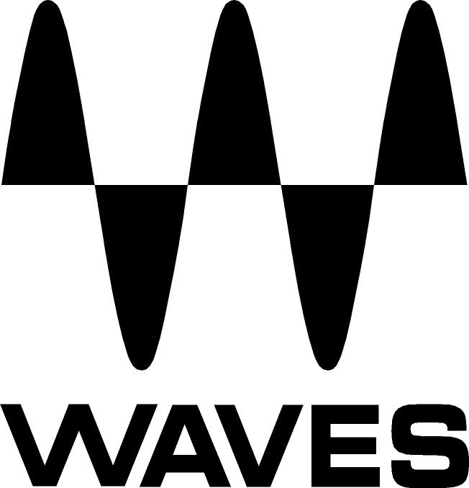

PRESS RELEASE
Contact: Neilson/Clyne
Tel: (615) 662-1616
Fax: (615) 662-1636

FOR IMMEDIATE RELEASE

WAVES TAKES CENTER STAGE WITH WAVES LIVE BUNDLE

— New Waves Bundle for Digidesign’s D-Show/Venue Console —

121st AES CONVENTION, SAN FRANCISCO, CA, October 6, 2006 — Waves has long been regarded as the leading developer of digital audio processing tools. With the release of the new Live Bundle, Waves makes its world-renowned processors available for live sound applications and takes another step forward in the digital music revolution.

This is a brand new way to use Waves. 27 recording and broadcast legends, like the L2 Ultramaximizer, C4 MultiBand and MaxxBass®, have been precision-engineered and optimized especially for Digidesign’s D-Show and D-Show Profile consoles. Other processors featured in the Live Bundle include the C1 Parametric Compander and S1 Stereo Imager as well as the entire award-winning Renaissance Series.

Now, live sound engineers and sound designers who are seeking the very best signal processing available can take advantage of the same tools used on hit records and major motion pictures the world over.

The complete Live Bundle includes: AudioTrack, C1 Parametric Compander, C4 MultiBand, DeEsser, Doppler, Doubler, Enigma, L1 Ultramaximizer™, L2 Ultramaximizer™, MaxxBass, MetaFlanger, MondoMod, PAZ Analyzer, PS22 Stereo Maker, Q10 Paragraphic Equalizer, Renaissance Axx, Renaissance Bass, Renaissance Channel, Renaissance Compressor, Renaissance DeEsser, Renaissance Equalizer, Renaissance Reverb, Renaissance Vox, S1 Stereo Imager, SuperTap, TransX Transient Shaper and TrueVerb.

“We’re excited about bringing the Waves sound to the live arena,” said Gilad Keren, CEO of Waves Ltd. “This collection allows artists to enjoy the same power and precision of our studio and broadcasting tools in a live setting.”

...ends 229 words

About Waves Ltd.:
Waves is a leading provider of audio DSP solutions for professional, broadcast, and consumer electronics audio markets. Waves has ten years of expertise in the development of psycho-acoustic signal processing algorithms that leverage knowledge on the human perception of hearing to radically improve perceived sound quality. Waves’ award-winning processors are utilized to improve sound quality in the creation of the world’s most popular music, movie soundtracks, and multimedia titles. Waves offers computer software solutions and hardware plus software solutions for the professional and broadcast markets. Waves also offers semiconductor with embedded software solutions under the Maxx brand for the consumer electronics audio applications. Waves’ Maxx technology dramatically enhances audio performance in consumer applications and has been licensed to several leading companies, including Motorola and Microsoft. For more information, visit the Waves web site at http://www.waves.com.

Other brand and product names may be trademarks of the respective companies with which they are associated.

Waves Contacts:
North America Offices:
Waves, Inc., 306 West Depot Avenue, Suite 100, Knoxville, TN 37917;
Tel: 865-909-9200, Fax: 865-909-9245, Email: info@waves.com, Web: http://www.waves.com

Corporate Headquarters Israel:
Waves Ltd., Azrieli Center, The Triangle Tower, 32nd Floor, 132 Derech Petach-Tikva,
Tel-Aviv 67027, Israel; Tel: 972-3-608-4000, Fax: 972-3-608-4056, Email: info@waves.com,
Web: http://www.waves.com

Waves Public Relations:
Neilson/Clyne, Inc., 169-B Belle Forest Circle, Nashville, TN 37221;
Tel: 615-662-1616, Fax: 615-662-1636, Email: rclyne@neilsonclyne.com,
Web: http://www.neilsonclyne.com

Waves is exhibiting at booth #936 during the 121st AES Convention in
San Francisco, CA.

