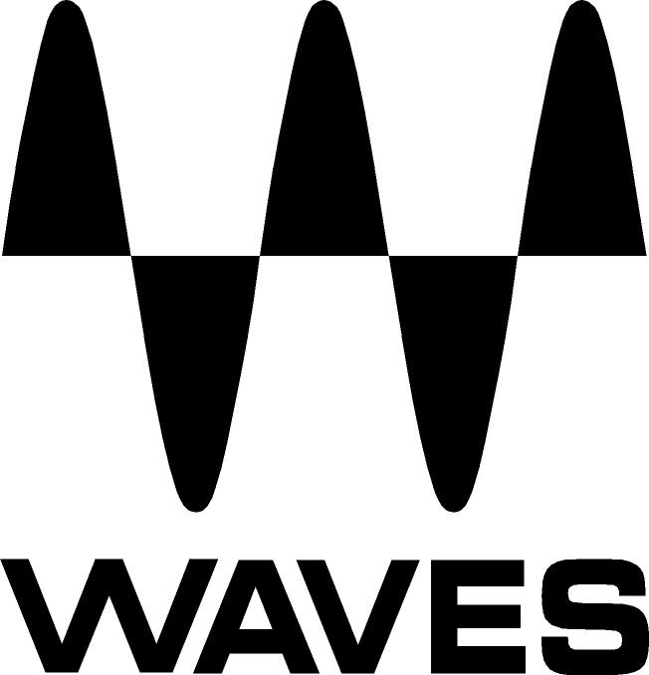

PRESS RELEASE
Contact: Neilson/Clyne
Tel: (615) 662-1616
Fax: (615) 662-1636

FOR IMMEDIATE RELEASE

WAVES ANNOUNCES MAXXVOLUME™

— New professional all-in-one dynamics processing plug-in from Waves —

121st AES CONVENTION, SAN FRANCISCO, CA, October 6, 2006 — The world’s leading developer of digital audio signal processing tools, Waves, has announced the release of a powerful new dynamics processor — MaxxVolume™.

The first plug-in of its kind, MaxxVolume offers all essential dynamics processing in one convenient tool. Combining technologies from Waves' acclaimed L2 Ultramaximizer™, C1 Parametric Compander, Renaissance Vox and Renaissance Compressor, MaxxVolume is useful for virtually every conceivable production situation, especially when time is of the essence. It is ideal for music recording and production as well as broadcasting, perfect for taming vocals and controlling instrument levels.

Featuring both high and low level compression, gating and leveling (auto gain control), MaxxVolume assembles the very best dynamics algorithms from Waves’ world-renowned line of professional audio tools.

“MaxxVolume is the plug-in you go to when you need all your dynamics functions in one place,” said Gilad Keren, CEO of Waves Ltd. “We’re sure audio professionals will appreciate the versatile power of this new processor.”
...ends 154 words

About Waves Ltd.:
Waves is a leading provider of audio DSP solutions for professional, broadcast, and consumer electronics audio markets. Waves has ten years of expertise in the development of psycho-acoustic signal processing algorithms that leverage knowledge on the human perception of hearing to radically improve perceived sound quality. Waves’ award-winning processors are utilized to improve sound quality in the creation of the world’s most popular music, movie soundtracks, and multimedia titles. Waves offers computer software solutions and hardware plus software solutions for the professional and broadcast markets. Waves also offers semiconductor with embedded software solutions under the Maxx brand for the consumer electronics audio applications. Waves’ Maxx technology dramatically enhances audio performance in consumer applications and has been licensed to several leading companies, including Motorola and Microsoft. For more information, visit the Waves web site at http://www.waves.com.

Other brand and product names may be trademarks of the respective companies with which they are associated.

Waves Contacts:
North America Offices:
Waves, Inc., 306 West Depot Avenue, Suite 100, Knoxville, TN 37917;
Tel: 865-909-9200, Fax: 865-909-9245, Email: info@waves.com, Web: http://www.waves.com

Corporate Headquarters Israel:
Waves Ltd., Azrieli Center, The Triangle Tower, 32nd Floor, 132 Derech Petach-Tikva,
Tel-Aviv 67027, Israel; Tel: 972-3-608-4000, Fax: 972-3-608-4056, Email: info@waves.com,
Web: http://www.waves.com

Waves Public Relations:
Neilson/Clyne, Inc., 169-B Belle Forest Circle, Nashville, TN 37221;
Tel: 615-662-1616, Fax: 615-662-1636, Email: rclyne@neilsonclyne.com,
Web: http://www.neilsonclyne.com

Waves is exhibiting at booth #936 during the 121st AES Convention in
San Francisco, CA.

